PROJECT-4

“Jenkins master-slave

Configuration”

Team work

**Batch-3**

***1.Vamsi***

***2. Rakesh***

***3. Sagar***

**Method-1**

* Create one master and five slave nodes and install nginx (Slave-1), httpd (Slave-2), SonarQube (Slave-3), tomcat (Slave-4) and deploy any one Static application in any one of the web servers (httpd & nginx) (Slave-5).

**Method-2**

* Create one master and five slave nodes and deploy python web applications through manually (Slave-1), bash script (Slave-2), terraform (Slave-3) and deploy java-based application through manually (Slave-4) and bash script (execute shell) (Slave-5).

**Method -3**

* **Vamsi** Create one master and Slave-5 and Nishwanth creates 1st and 2nd slave nodes **in same AWS account** and Rakesh creates 3rd and 4th slaves same AWS account and Rakesh deploy word press with bash script(slave-1) and Rakesh deploy word press with Docker Compose file (slave-2), and Sagar deploy word press with Terraform (slave-3) and Sagar deploy the word press with poll-scm, build periodically, webhooks (slave-4) and **Vamsi** deploy the word press with k8’s (slave-5) **with in the different AWS Accounts.**

**Method -4**

* **Sagar** Create one master and Slave-5 and Vamsi creates 1st and 2nd slave nodes **in same AWS account** and Rakesh creates 3rd and 4th slaves same AWS account and Vamsi deploy word press with bash script(slave-1) and Vamsi deploy word press with Docker Compose file (slave-2), and Rakesh deploy word press with Terraform (slave-3) and Rakesh deploy the word press with poll-scm, build periodically, webhooks (slave-4) and **Sagar** deploy the word press with k8’s (slave-5) **with in the different AWS Accounts.**

**METHOD-5**

* **Rakesh** Create one master and Slave-5 and Sagar creates 1st and 2nd slave nodes **in same AWS account** and Vamsi creates 3rd and 4th slaves same AWS account and Sagar deploy word press with bash script(slave-1) and Sagar deploy word press with Docker Compose file (slave-2), and Vamsi deploy word press with Terraform (slave-3) and Vamsi deploy the word press with poll-scm, build periodically, webhooks (slave-4) and **Rakesh** deploy the word press with k8’s (slave-5) **with in the different AWS Accounts.**

Method -3

VAMSI Create one master and Slave-5 and rakesh creates 1st and 2nd slave nodes in same AWS account and sagar creates 3rd and 4th slaves same AWS account and rakesh deploy word press with bash script(slave-1) and SAGAR deploy word press with Docker Compose file (slave-2), and sagar deploy word press with Terraform (slave-3) and sagar deploy the word press with poll-scm, build periodically, webhooks (slave-4) and vamsi deploy the word press with k8’s (slave-5*) .*

* Go to AWS console login with credentials.
* Now create 6 instances (1 Master, 5 Slave ).
* **Create Master instance and 5th slave instance in VAMSI account.**
* **Create 1st and 2nd slave by RAKESH in VAMSI account.**
* 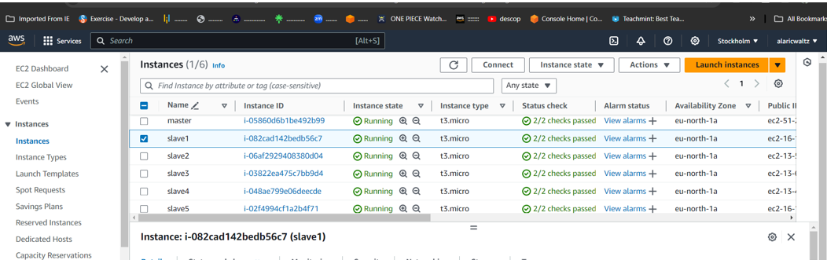**Create 3rd and 4th slave by SAGAR in VAMSI account**
* Now connect the master instance to the any CLI terminal

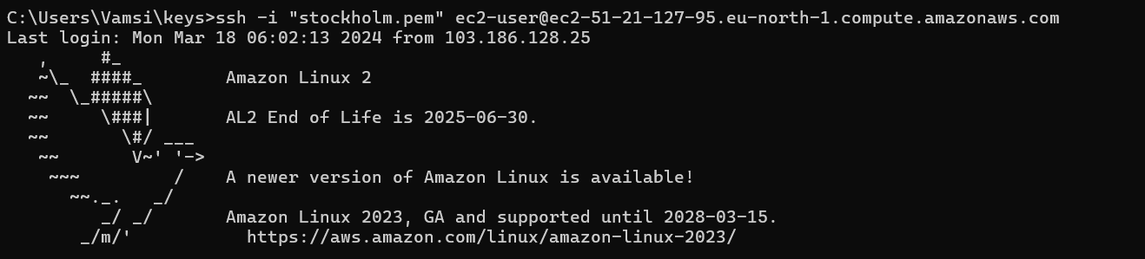

* Change the name of the instance using commands as **sudo hostname master.**
* use the ssh-keygen for the security layer
  + After creation of ssh-keygen, it generates private and public keys. With the help of newly generated public key, make Master-Slave configuration.
* Before that install run time into all the slave instances.
* Copy and paste the public key in slave instances at; cd .ssh/ 🡪 ls 🡪 sudo vi authorized­_keys

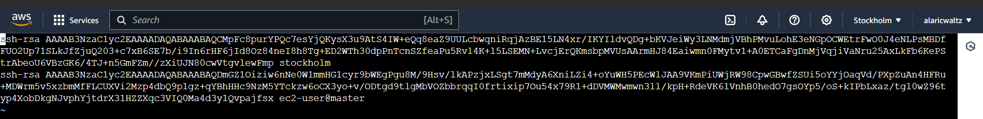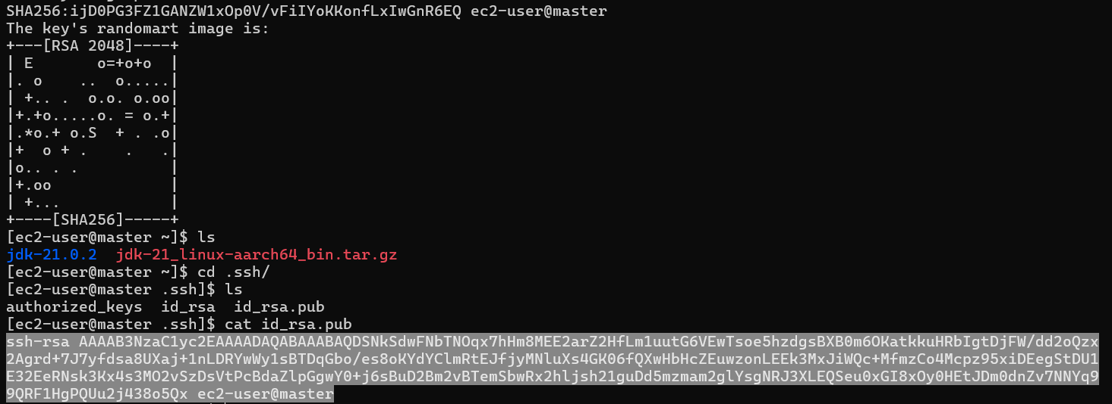

* Like this, paste the public key in all the slave instances.
* Now install Jenkins
* **sudo wget -O /etc/yum.repos.d/jenkins.repo \**

**https://pkg.jenkins.io/redhat-stable/jenkins.repo**

* **sudo rpm --import https://pkg.jenkins.io/redhat-stable/jenkins.io-2023.key**
* **sudo yum -y upgrade**
* **sudo yum install fontconfig java-17* -y**
* **sudo yum -y install jenkins**
* **sudo systemctl daemon-reload**
* **sudo systemctl start jenkins**
* **sudo systemctl enable jenkins**
* **sudo systemctl status Jenkins**
* 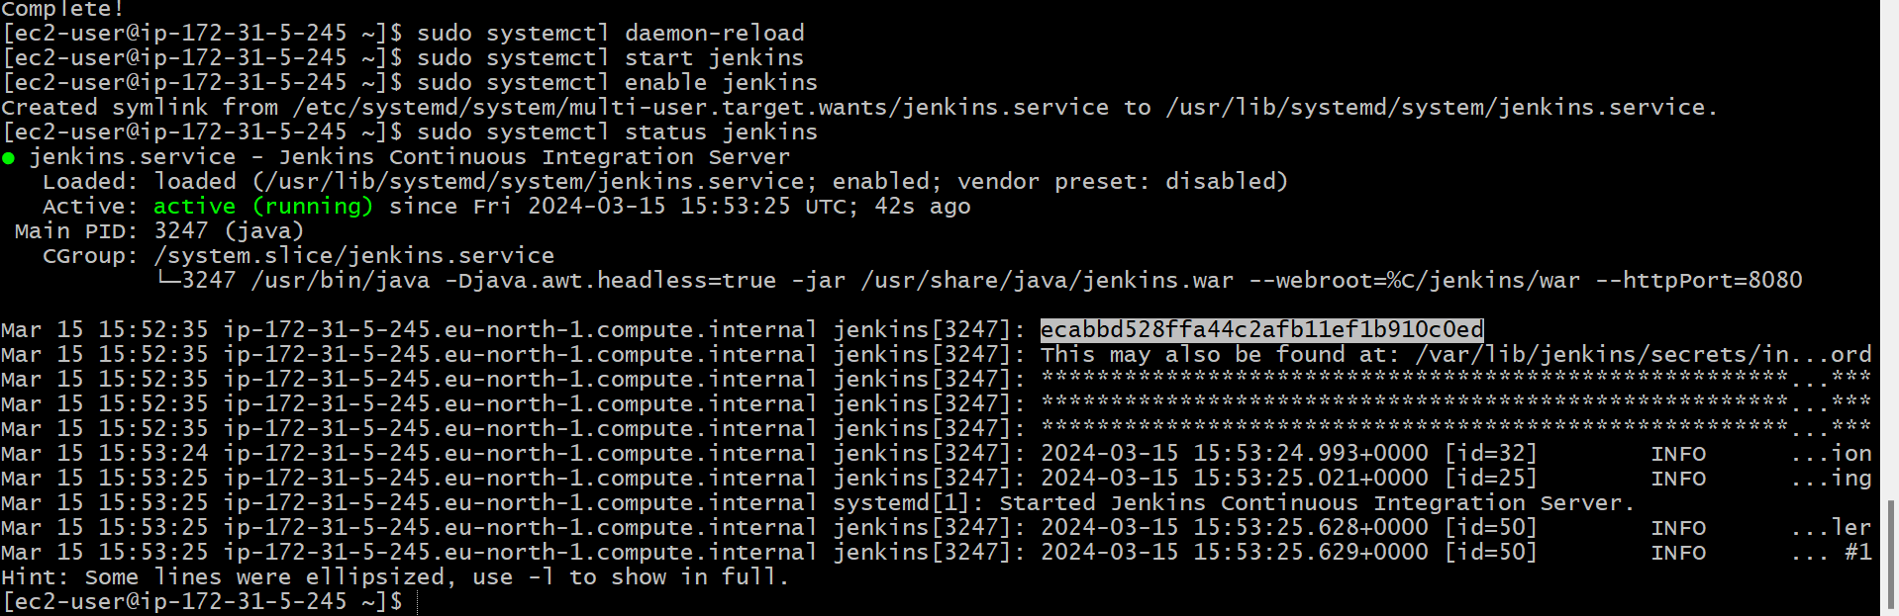Now copy the key and paste it in Jenkins unlock page.
* Now, copy paste the public IP address along with port 8080 and unlock Jenkins with admin password.
* Now, make master-slave configuration by creating worker nodes in Jenkins.
* Jenkins 🡪 manage Jenkins 🡪 Nodes

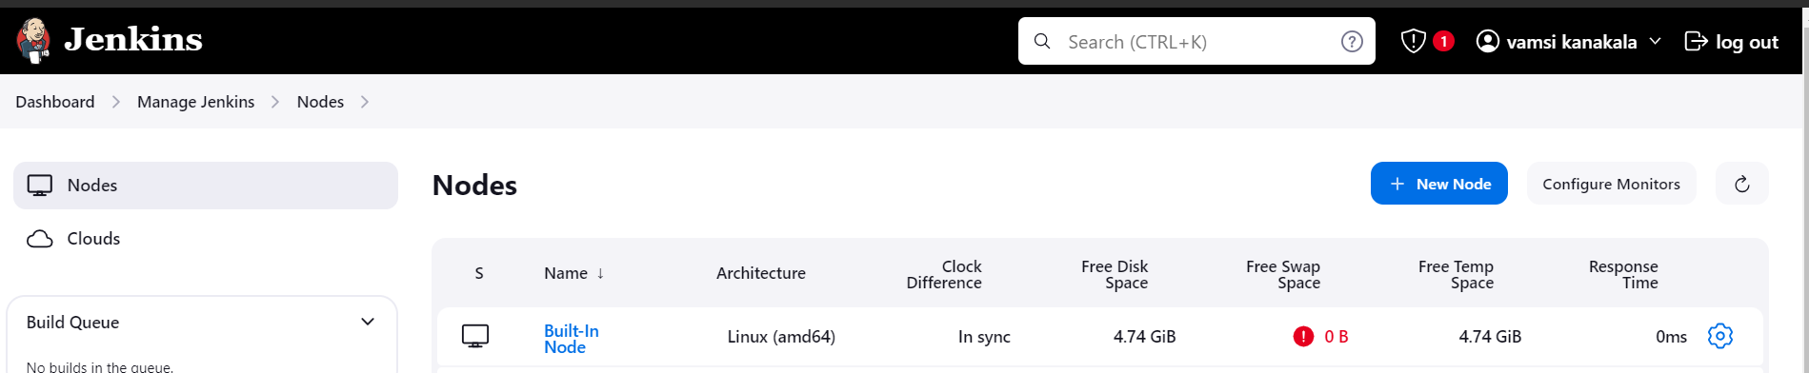

* Install run time java-17* in every slave-servers.
* Now create 5 slave nodes and name them as **Slave1, Slave2, Slave3, Slave4, Slave5.**
* Now name the node, select the no.of executors , Remote root directory as **/home/ec2-user¸**now label as name of the server , usage as much as possible, launch method as **via SSH**, host as **public IP of the instance,** in credentials add **id_rsa** name it , host key as **manually trusted key verification strategy,** availability **as online as much as possible** and save it.

**SLAVE1**

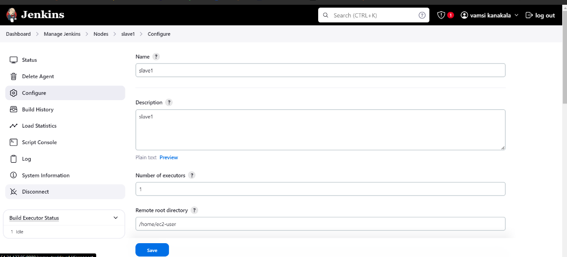

* launch method as **via SSH**, host as **public ip of the instance,** in credentials add **id_rsa** name it.
* 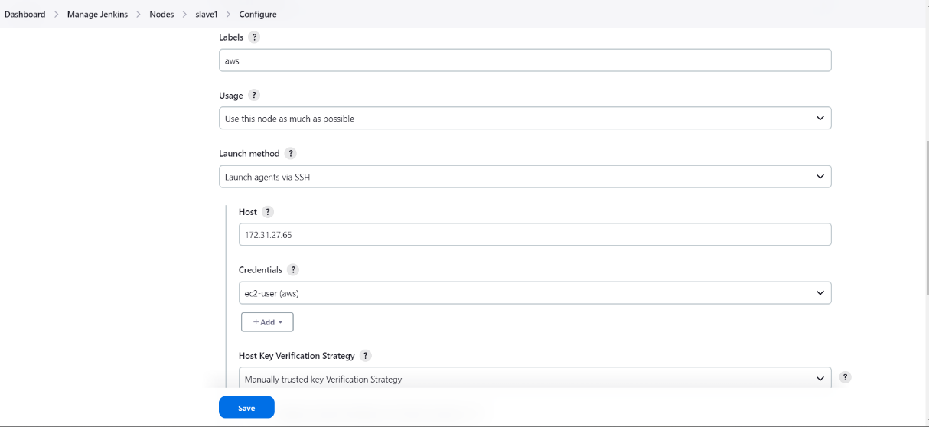Host key as **manually trusted key verification strategy,** availability **as online as much as possible** and save it.

**FOR SLAVE-2,3,4,5**

* same repeat the same process for rest all the slave servers. Just change the labels as slave1,slave2,slave3,slave4,slave5. And replace the host by slaves public IP-address.
* 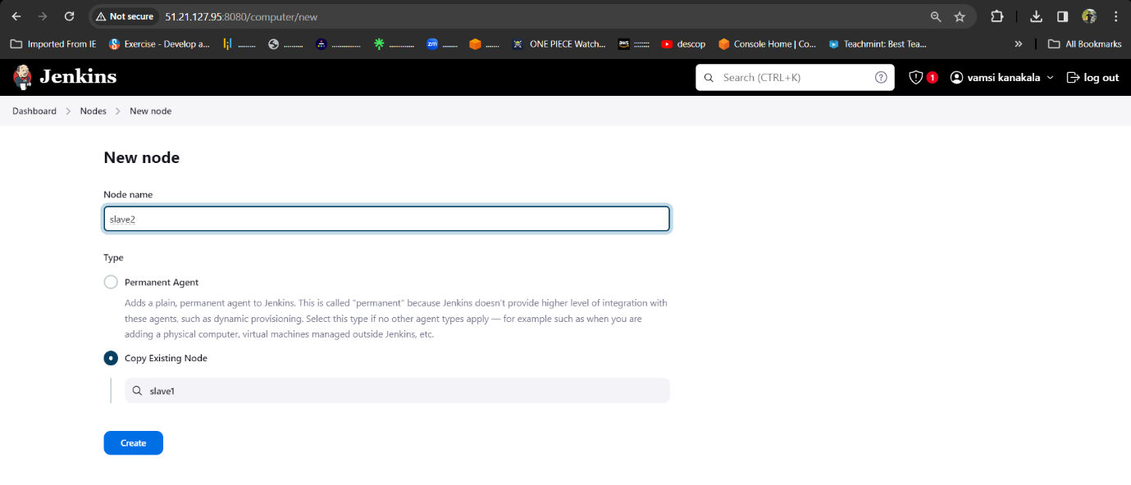 Now check the created nodes in dashboard.

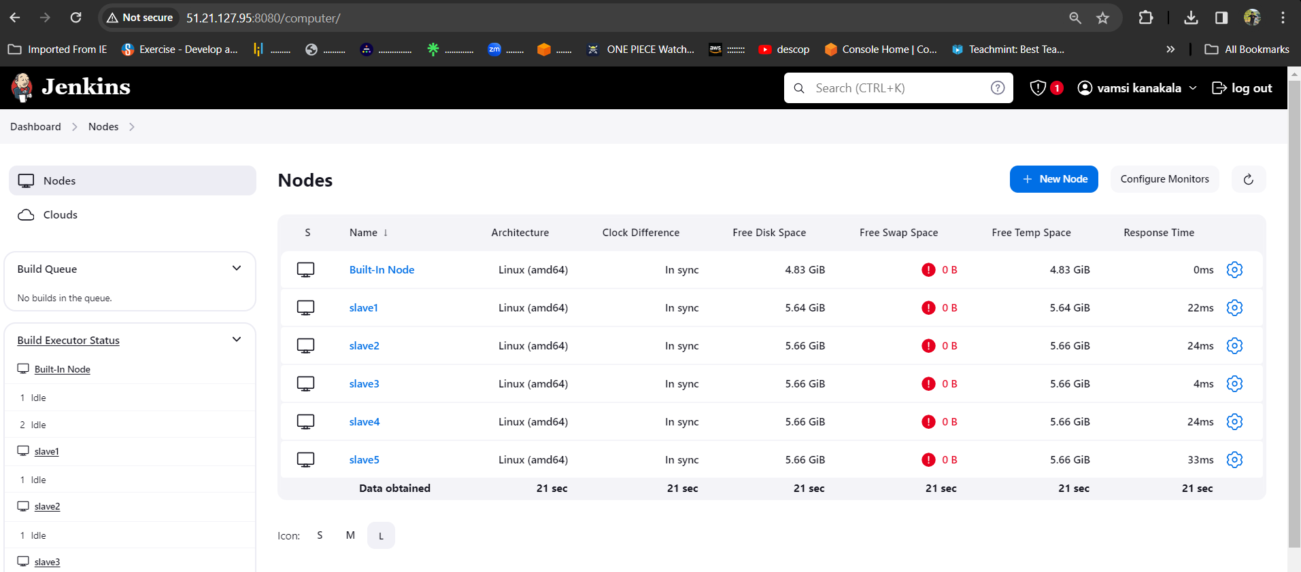

* Maser-Slave configuration is successful and all the servers are online.
* Now create job for the slave servers and name them as **Slave1, Slave2, Slave-3, Slave4, Slave5.**
* jobs we create in slaves are
* **Slave-1 = deploy word press with bash script**
* **Slave-2 = deploy word press with Docker Compose file**
* **Slave-3 = deploy word press with Terraform**
* **Slave-4 = deploy the word press with poll-scm, build periodically, webhooks**
* **Slave-5 = deploy the word press with k8’s**

**SLAVE-1**

* Select new item > name the job > select freestyle project

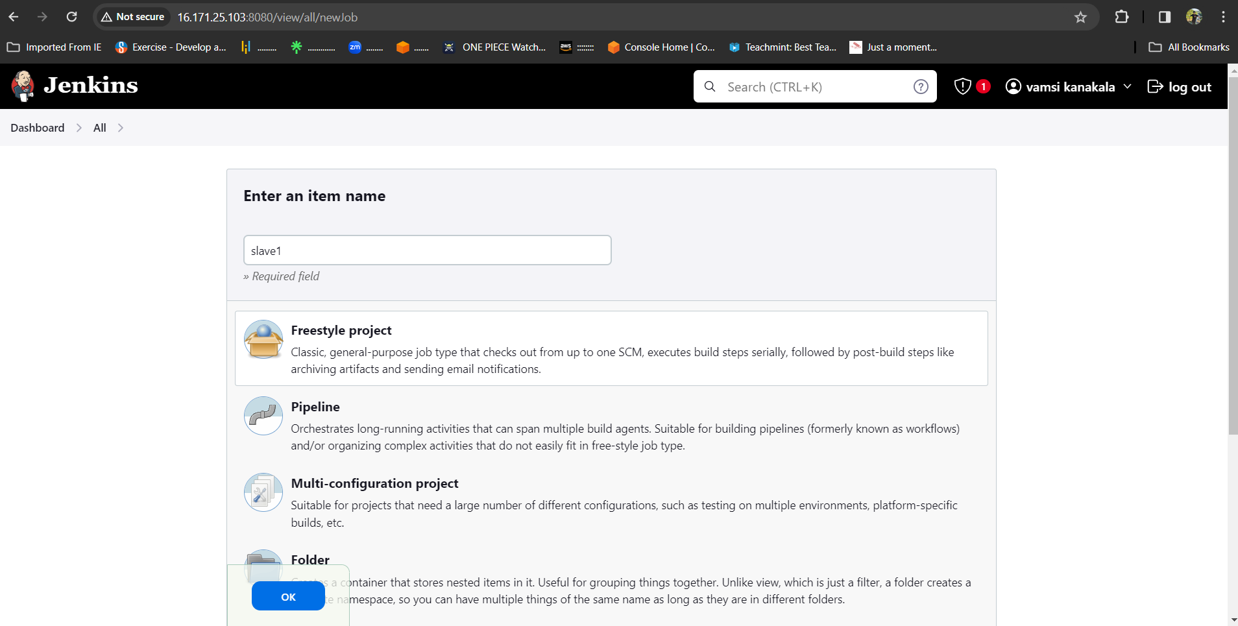

* Now select the option **Restrict where the project can be run** select the Slave1 node which we created.

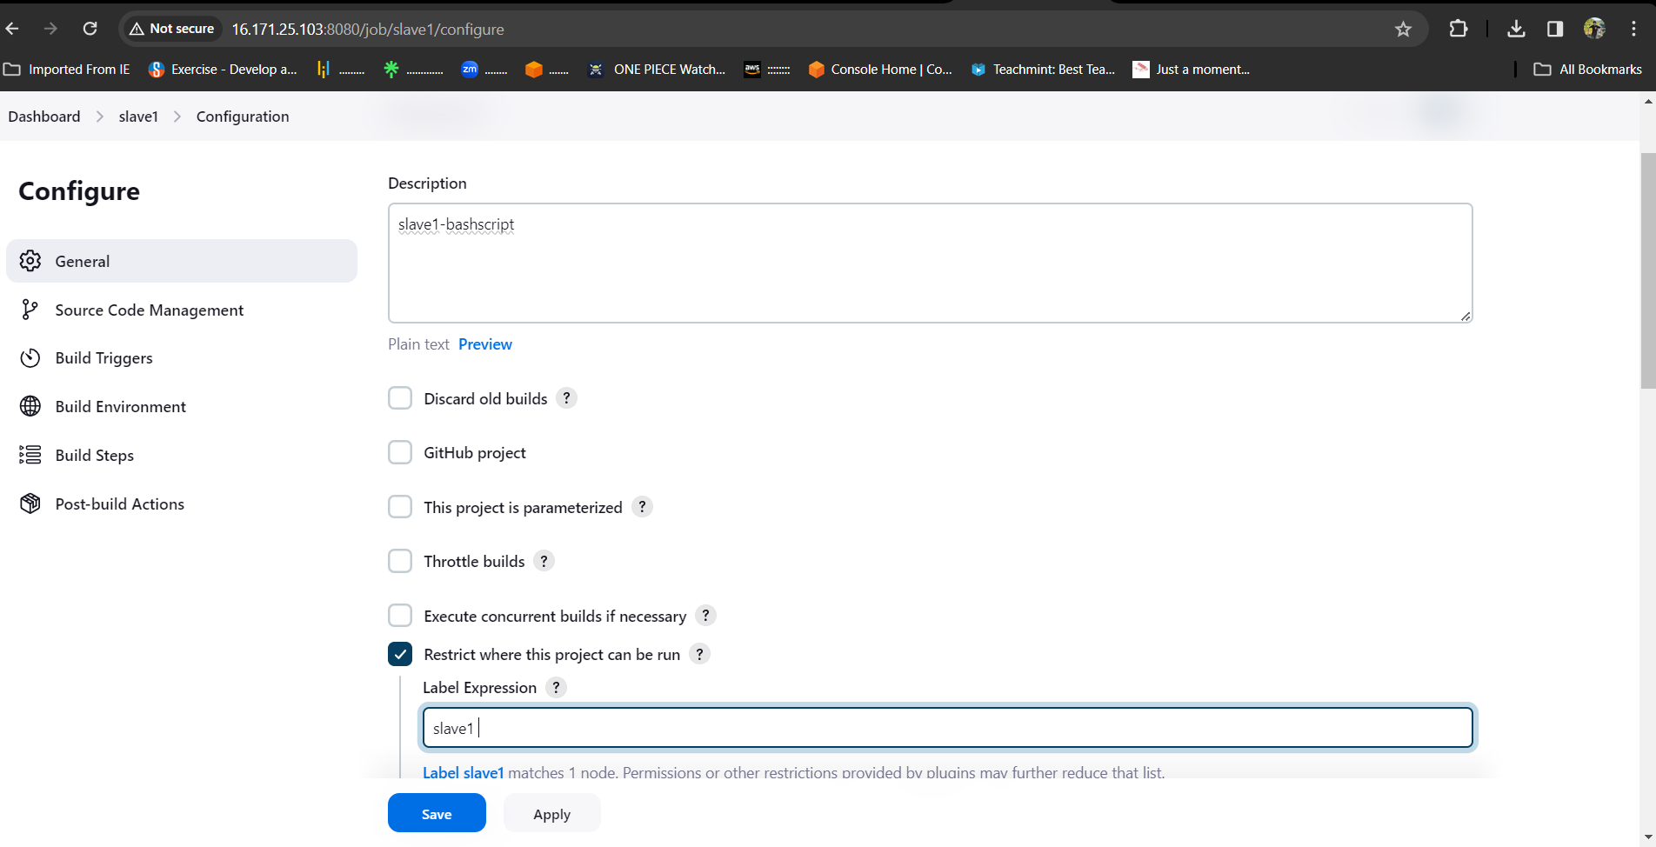

* Here we wrote the bash-script and pushed it into the git-hub account manually so pull the git repo and execute the script

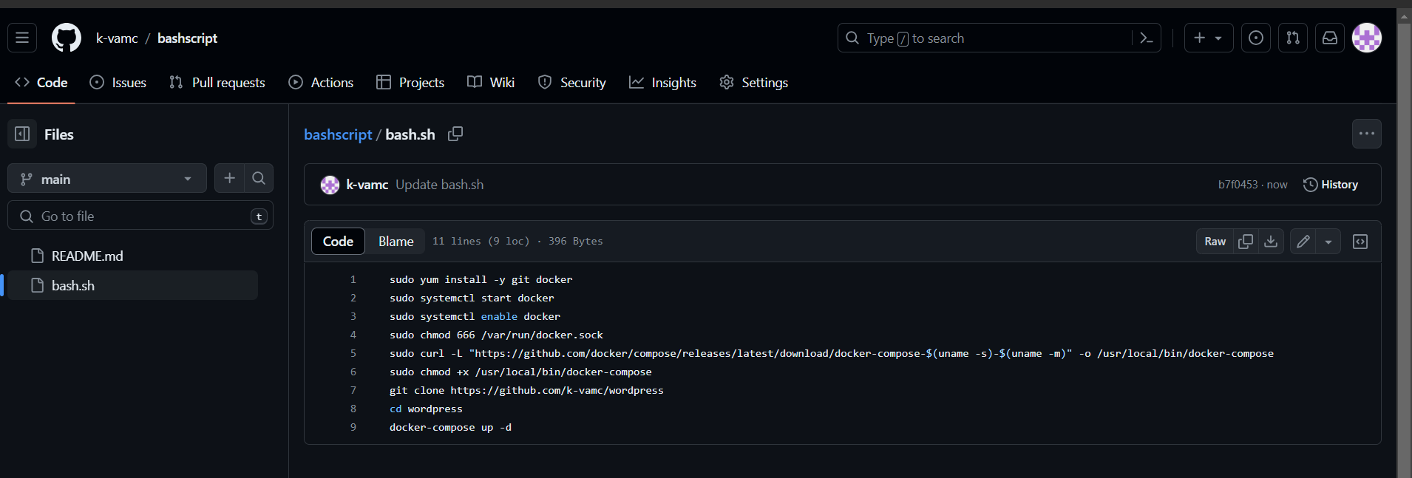

Now in build steps give commands to install git and clone the git repo in source code manager, 777 permissions to .sh file and execution command for .sh file.

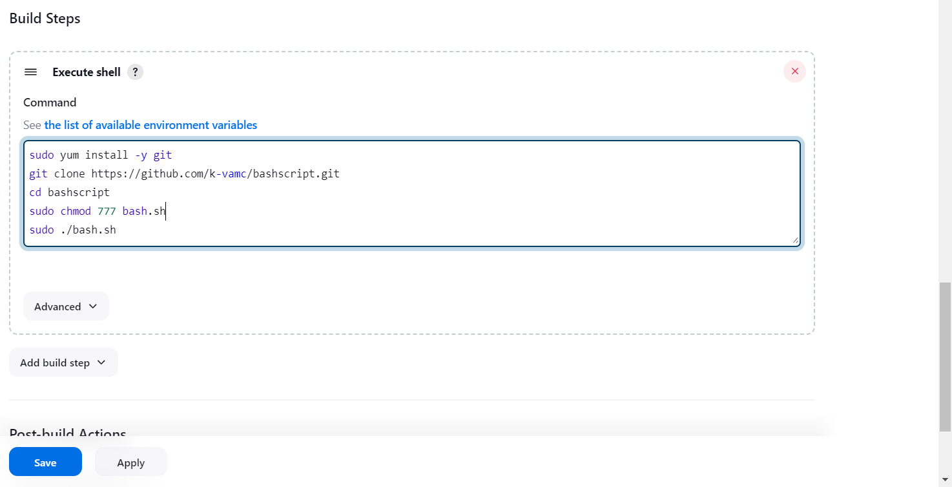

* After completion save the job and tap on build it will be success, here is the console output.

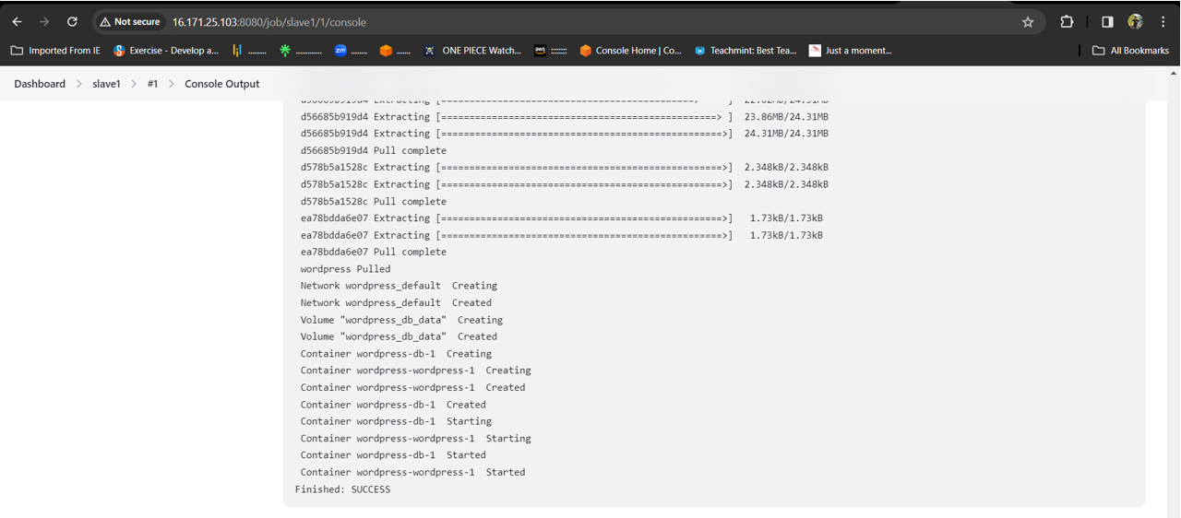

* After success go to AWS account copy the slave-1 pubic ip and browse.

After browsing we will be directed to the official landing page of WORDPRESS

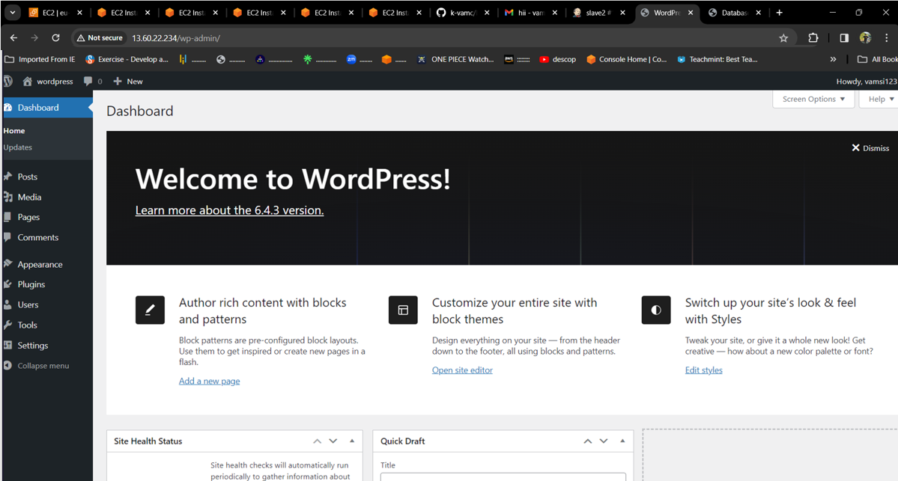

**SLAVE-2**

* 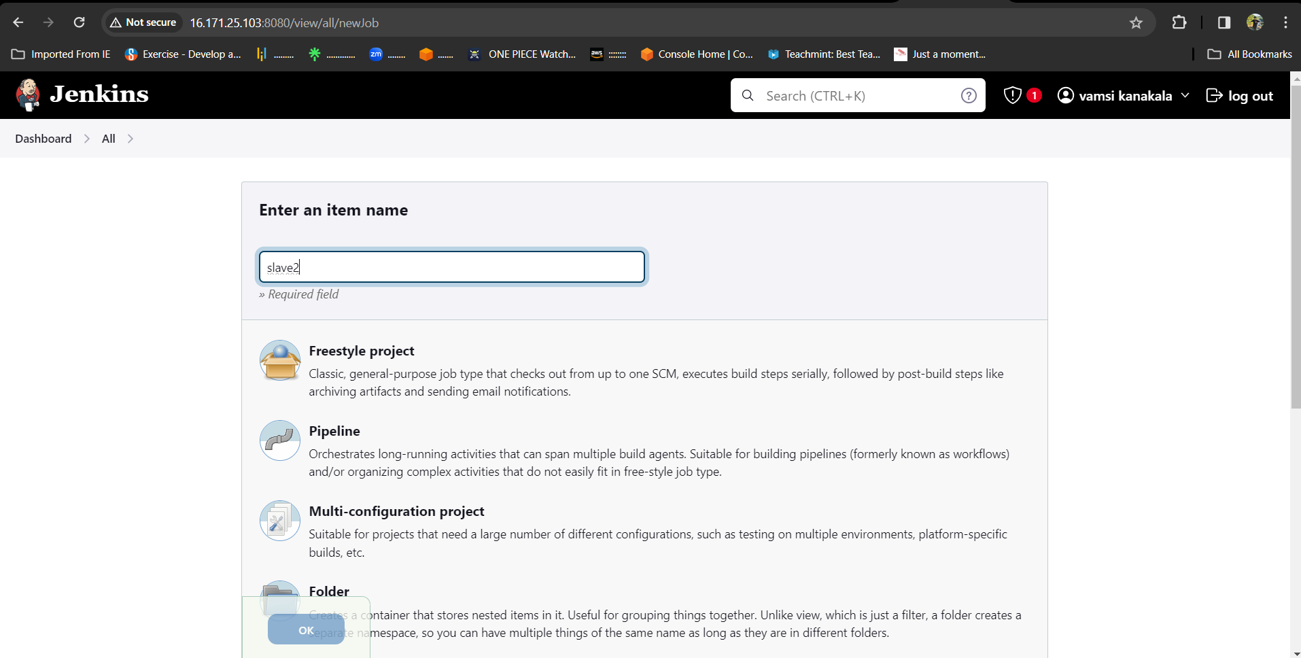Select new item > name the job > select freestyle project.
* Now select the option **Restrict where the project can be run** select the Slave2 node which we created.

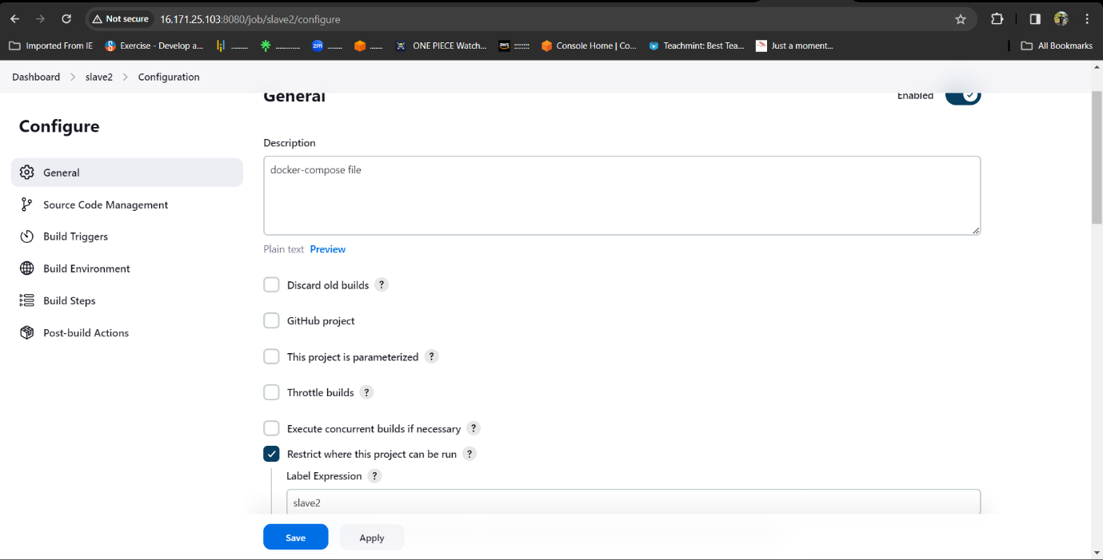

* Here we write the bash-script in the execute shell.

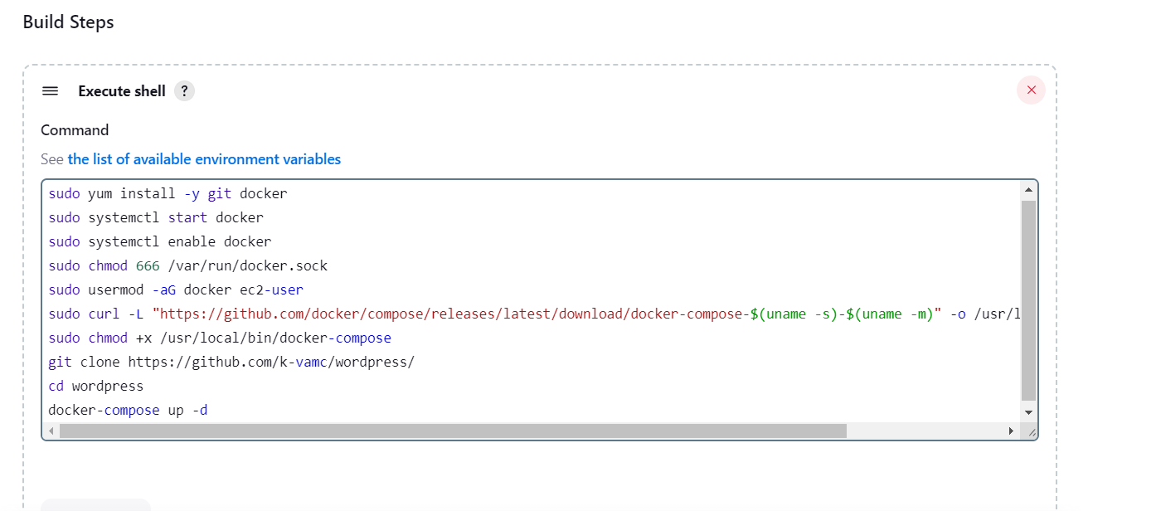

* After completion save the job and click on build no, it will be success.
* here is the console output.

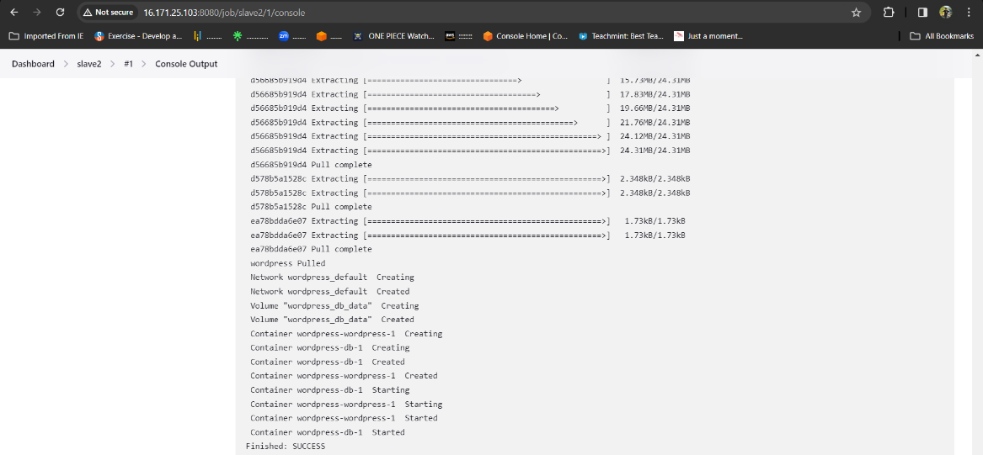

* After success go to AWS account copy the slave2 pubic IP address and browse.
* After browsing we will be directed to the official landing page of WORDPRESS.

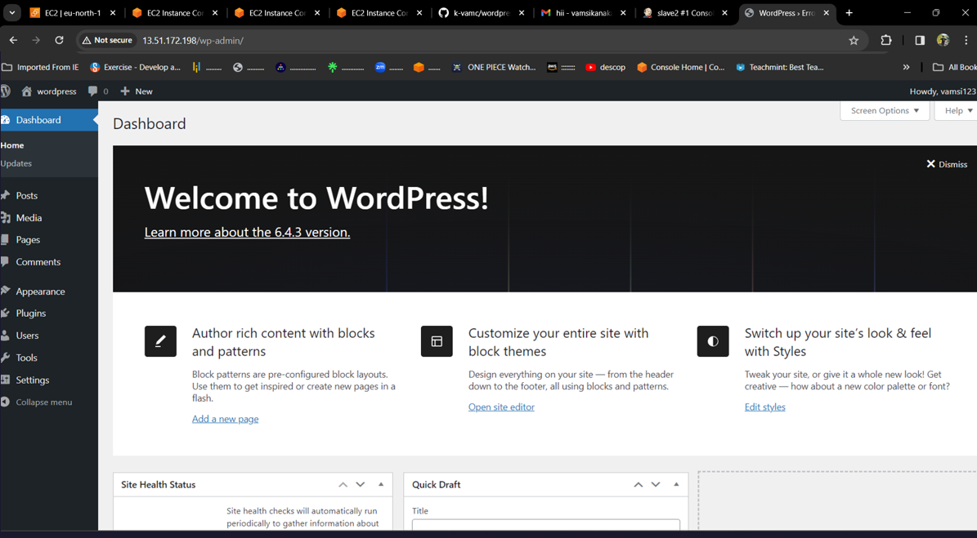

**SLAVE-3**

* Select new item > name the job > select freestyle project.

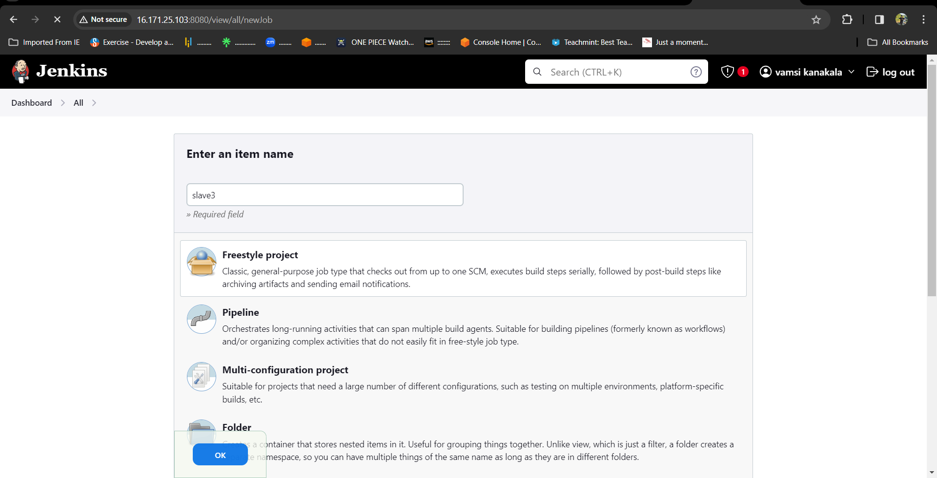

* Now select the option **Restrict where the project can be run** select the Slave-3 node which we created.

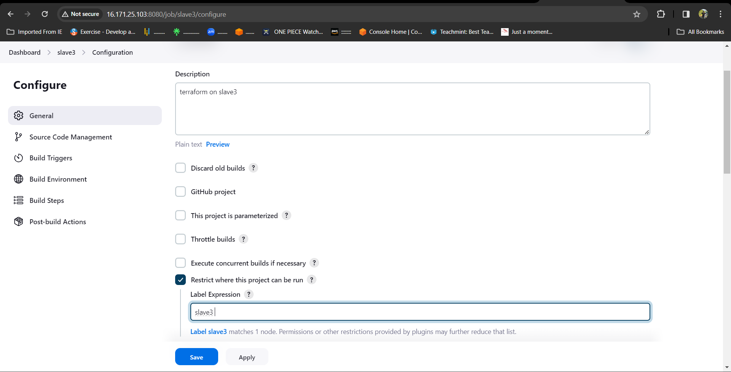

* Here we write the script and execute commands of terraform in the execute shell.

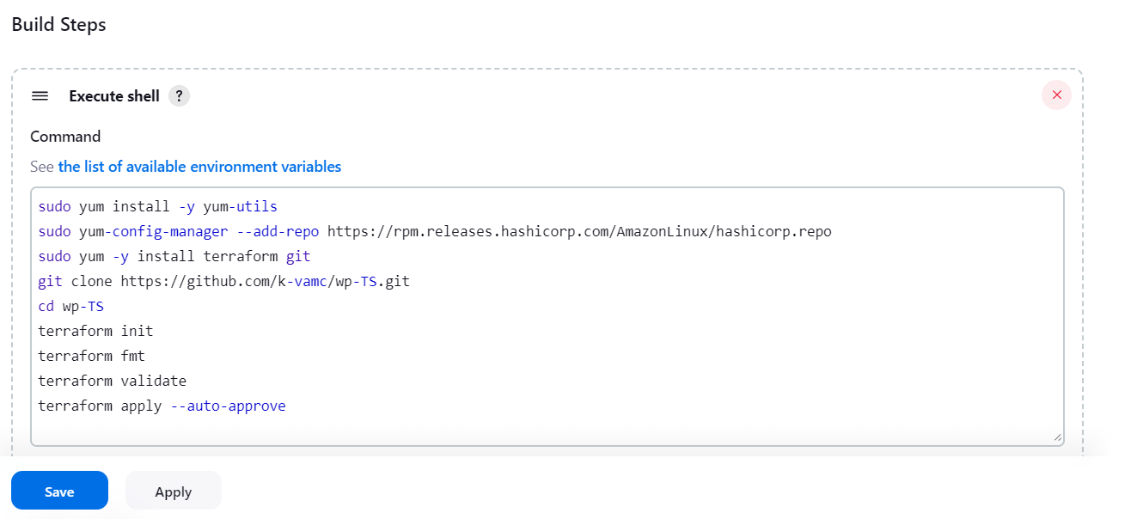

* After SAVE and BUILD the JOB,it will be success.
* here is the console output.

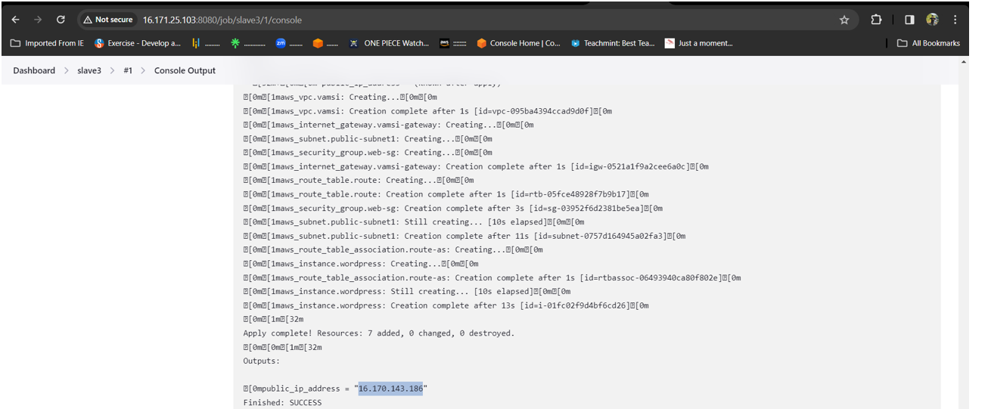

* From terraform scripts it gives newly created instance’s public IP-address.
* Now, copy and browse the IP address we will be directed to the official landing page of WORDPRESS.

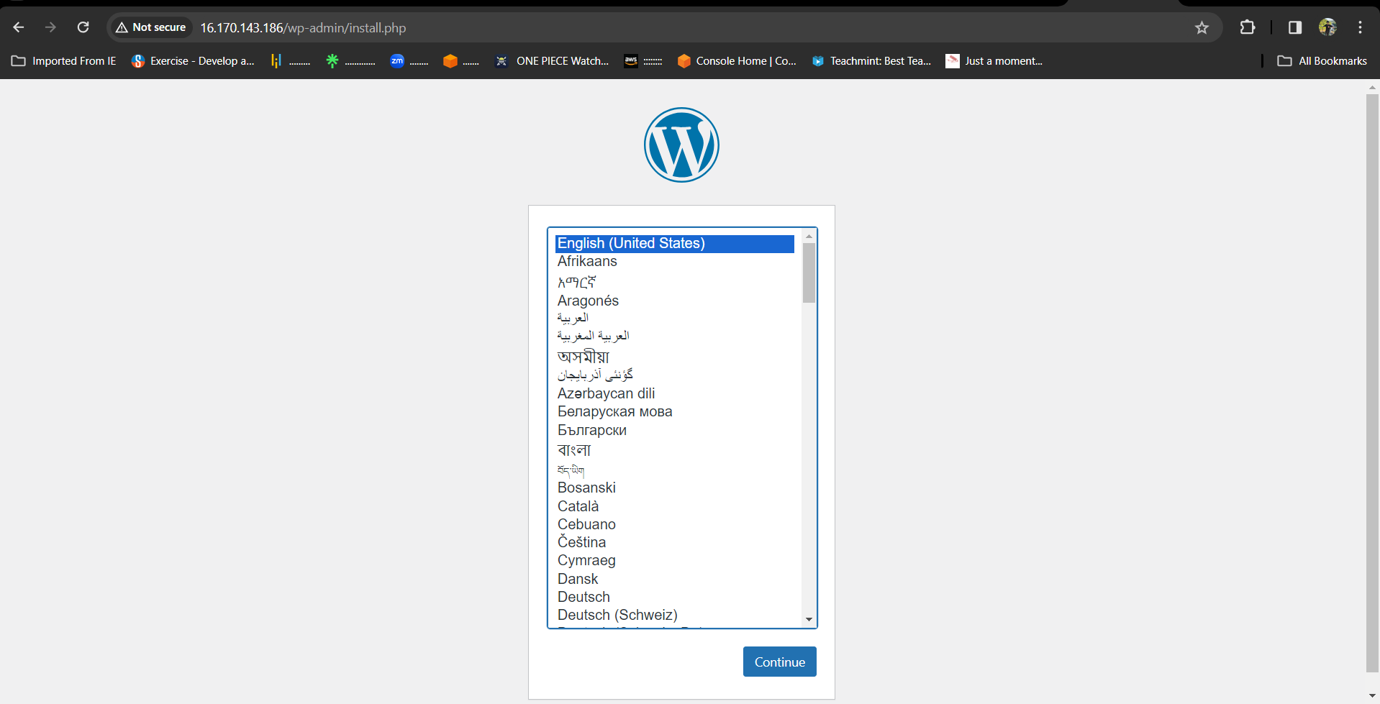

**SLAVE-3**

* Select new item > name the job > select freestyle project

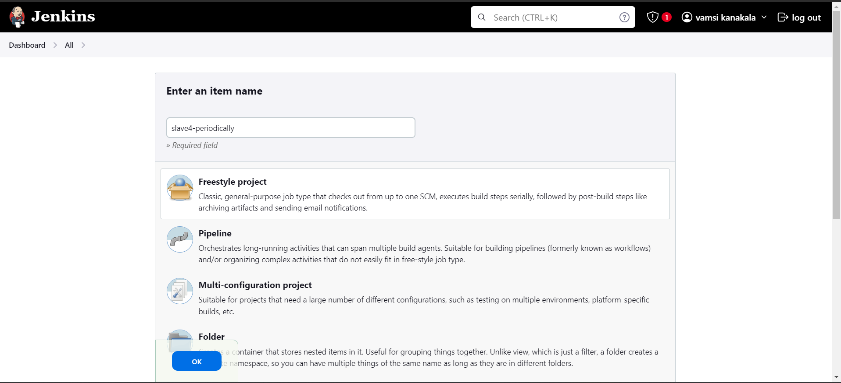

* Now select the option **Restrict where the project can be run** select the Slave-4 node which we created.

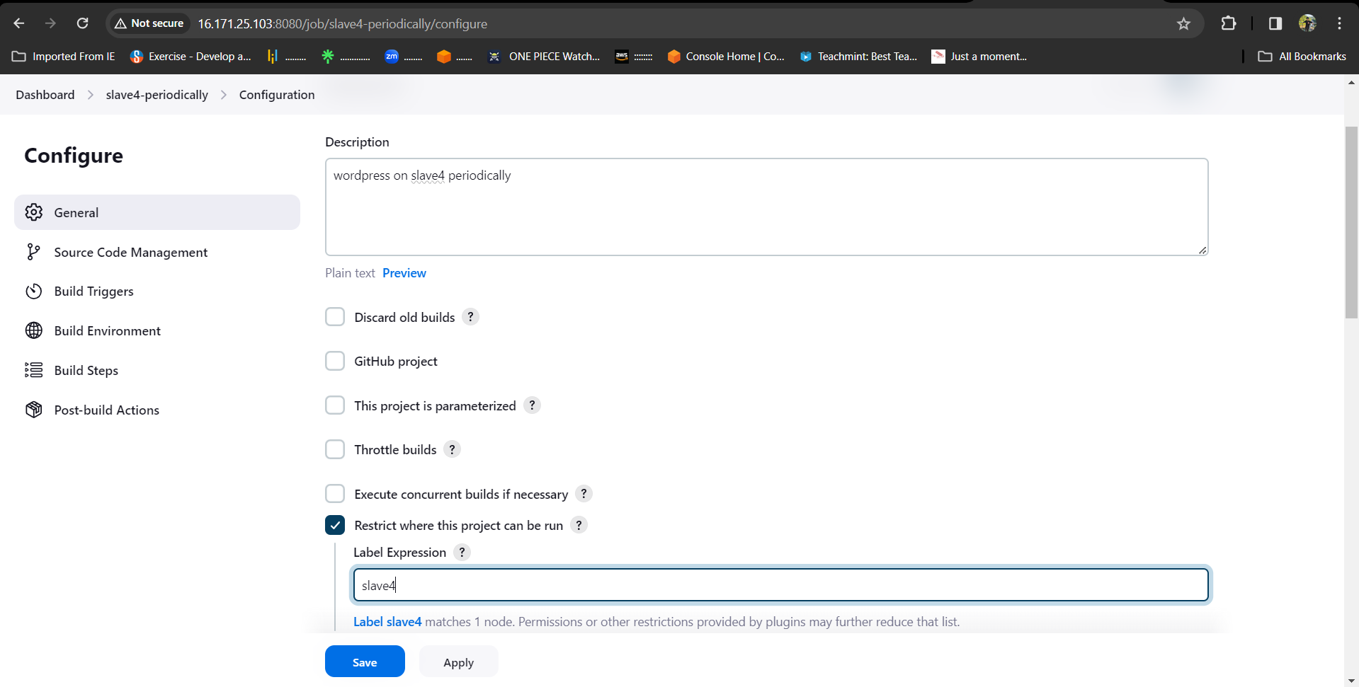

* Now in build triggers select **build periodically** option and give timing as

**\* * * * \*** means every minute every hour every day & month of the year.

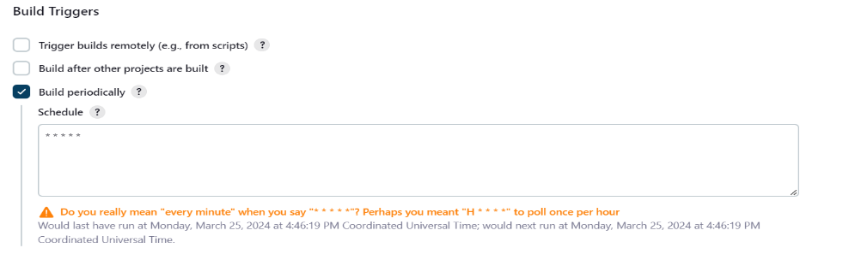

* Here we write the bash-script in the execute shell.

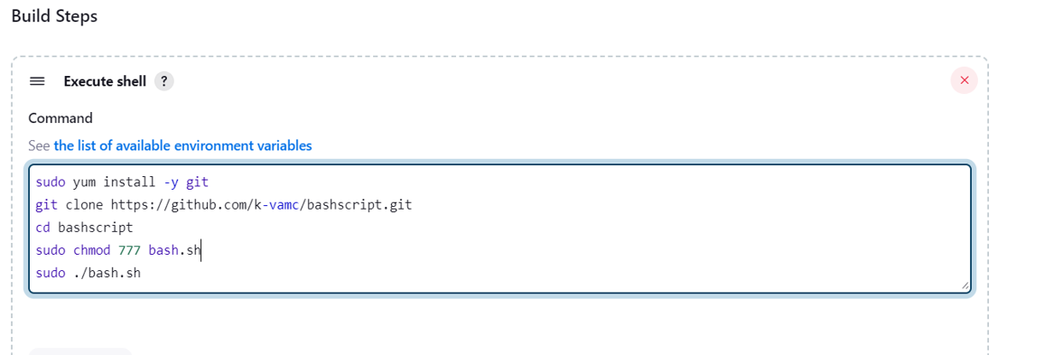

* After completion save the job and tap on build it will be success , here is the console output.

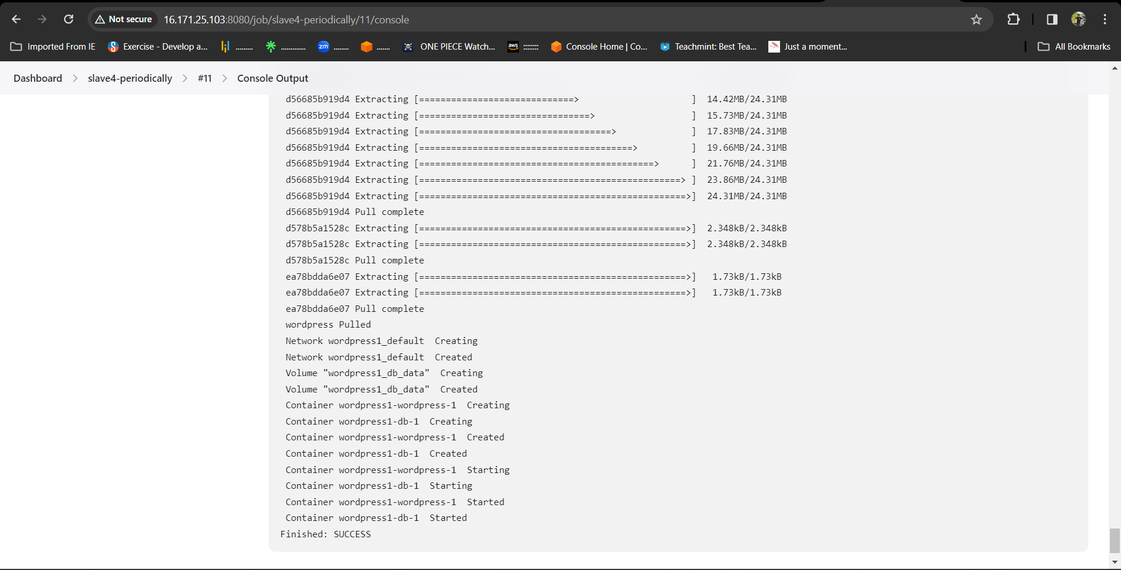

* After success go to AWS account copy the slave-4 pubic ip and browse.
* After browsing we will be directed to the official landing page of WORDPRESS

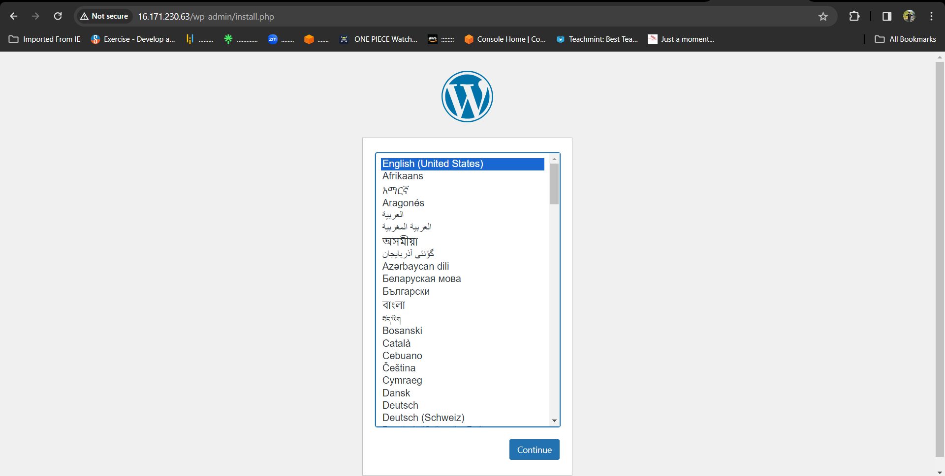

**POLL SCM**

* Now in build triggers select poll scm option and give timing as **\* * * * \*** means every minute every hour every day & month of the year.

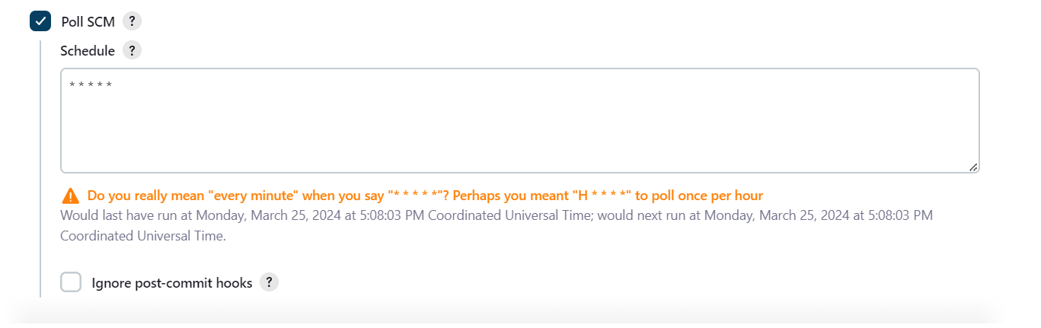

* Save it now in github make a change in any of the file or create a dummy file It will automatically trigger and build the job directly.

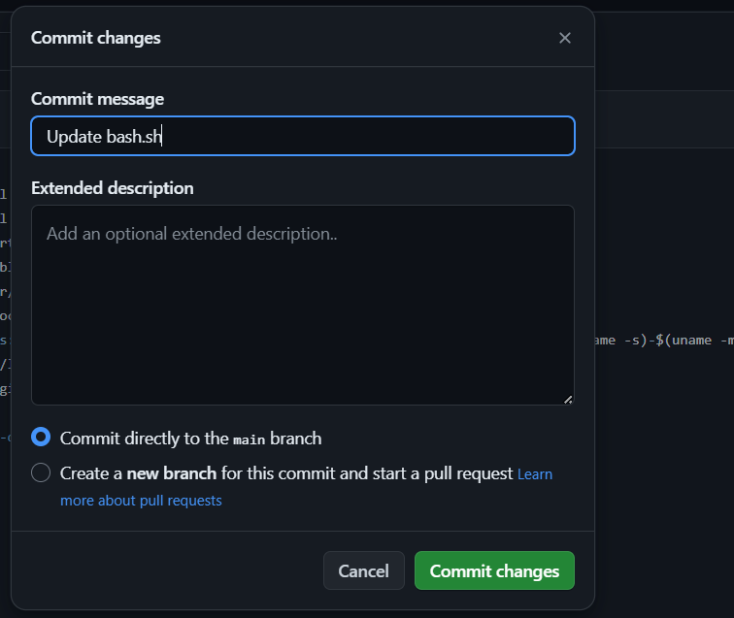

* It has same console output and same public IP to browse.

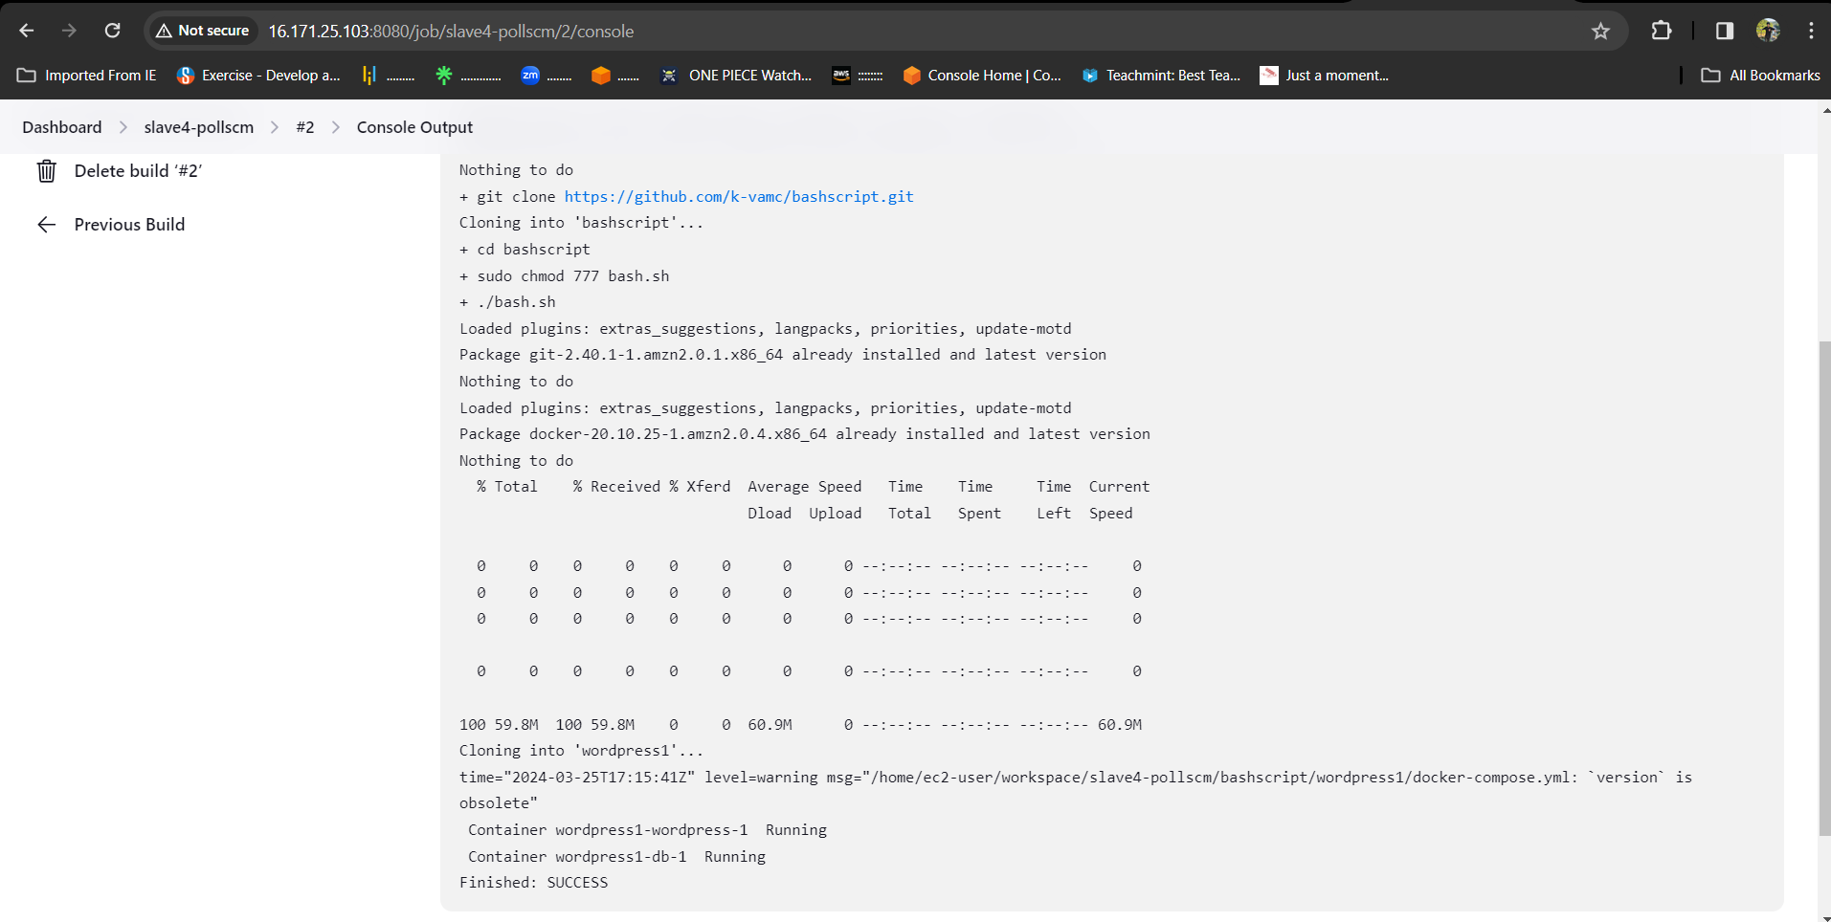

**WEBHOOK**

* Now in build triggers select GitHub hook trigger for Git scm polling.

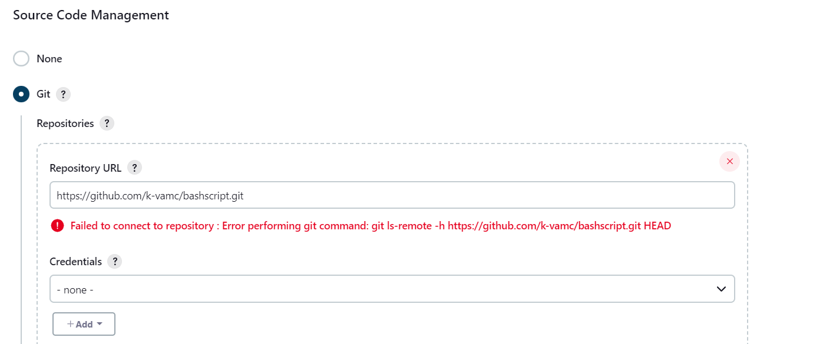

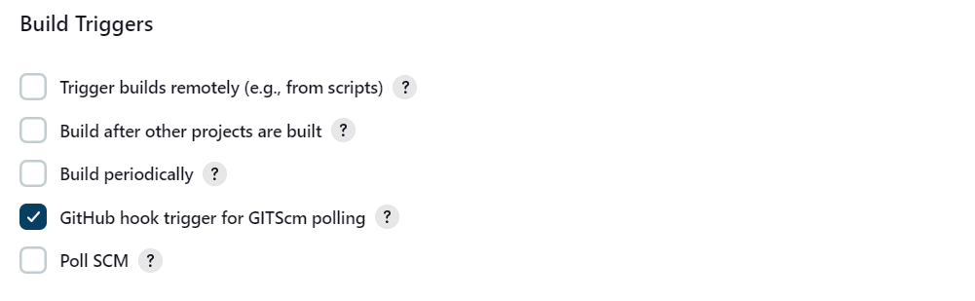

* Go to GitHub and select the repository and go to settings there we will find webhooks option and give payload as Jenkins URL select it and add webhooks.

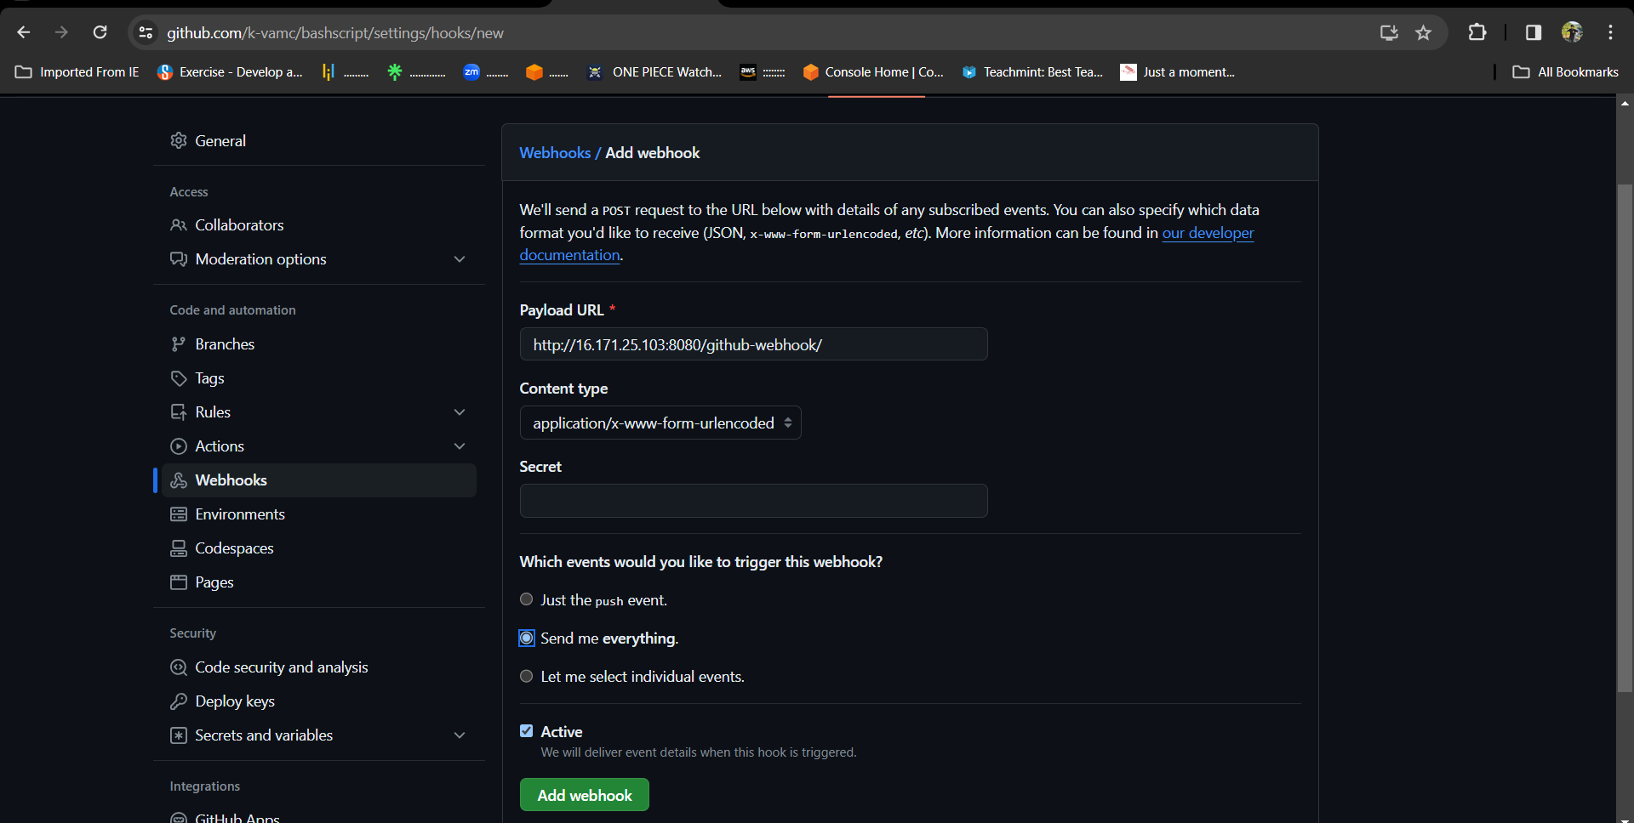

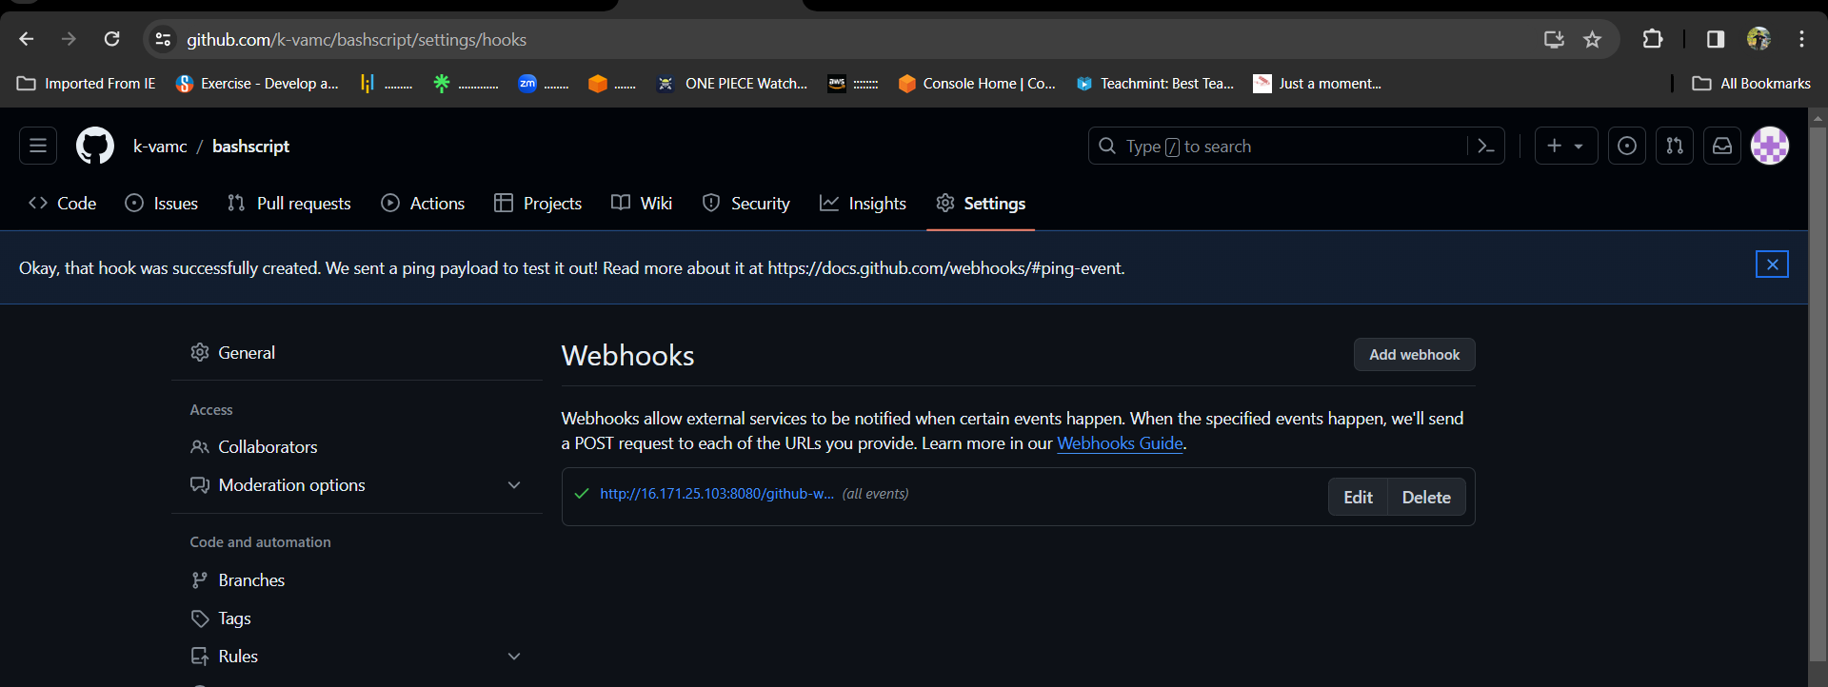

* Save it now in GitHub make a change in any of the file or remove a dummy file It will automatically trigger and build the job directly.
* 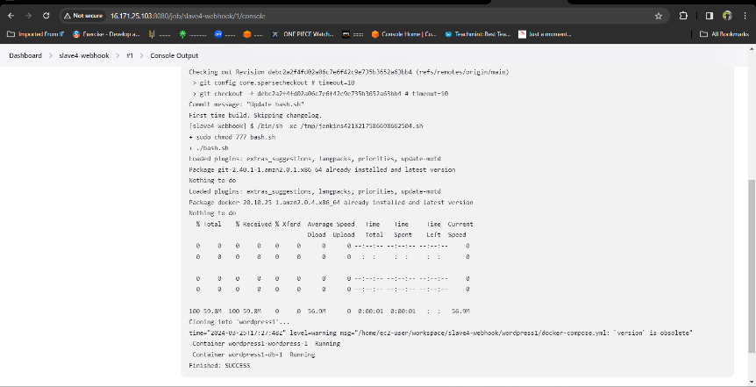It has same console output and same public IP to browse.



**Slave-5**

* Select new item > name the job > select freestyle project

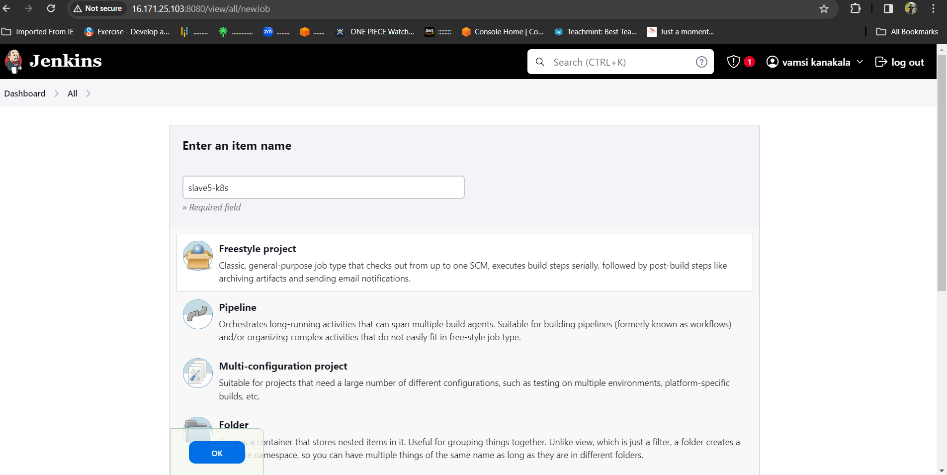

* Now select the option **Restrict where the project can be run** select the Slave-3 node which we created.

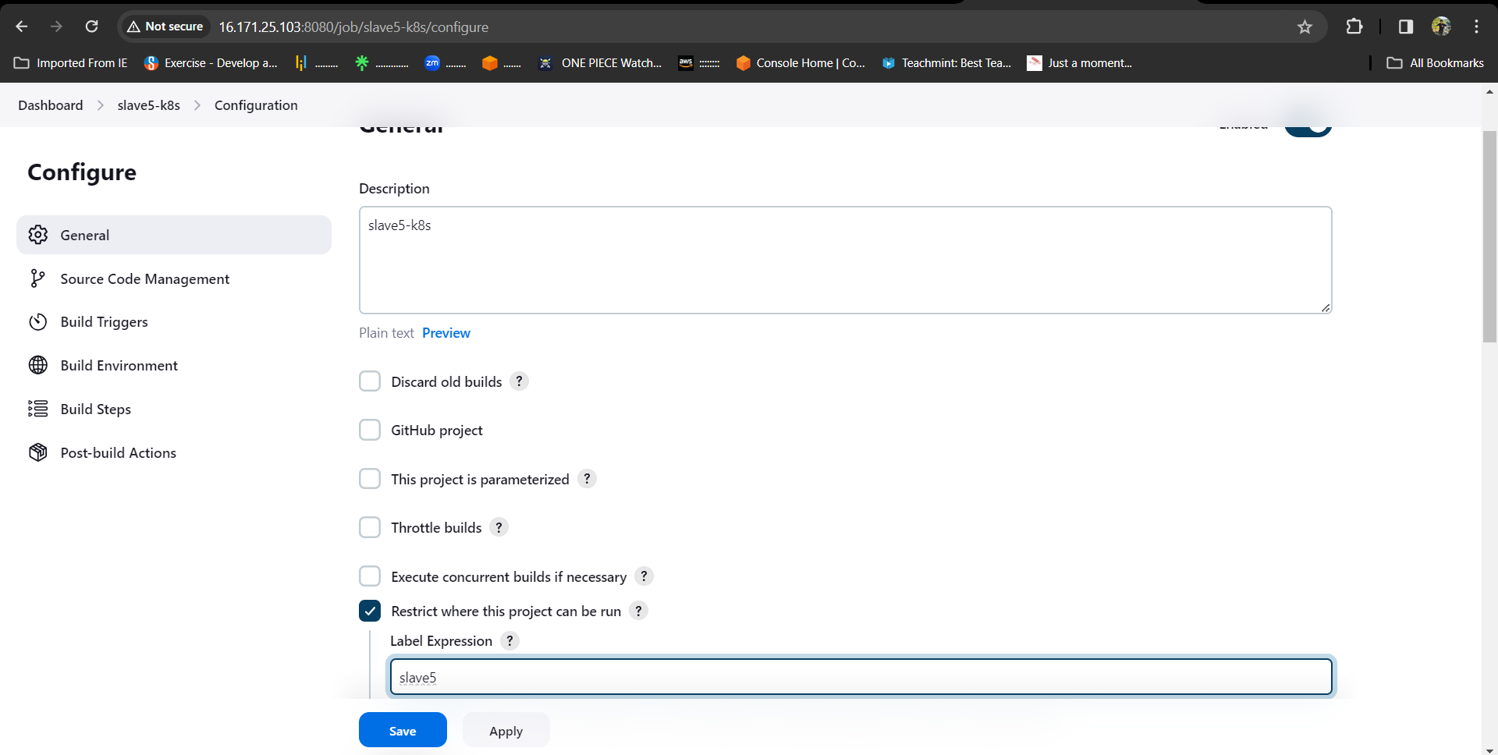

* Now in build steps give commands to install Kubernetes and kops,

And create s3 bucket, configure the cluster details we want to create in one job.

* For that go to amazon console attach the IAM role which have admin access for Slave-5 instance.

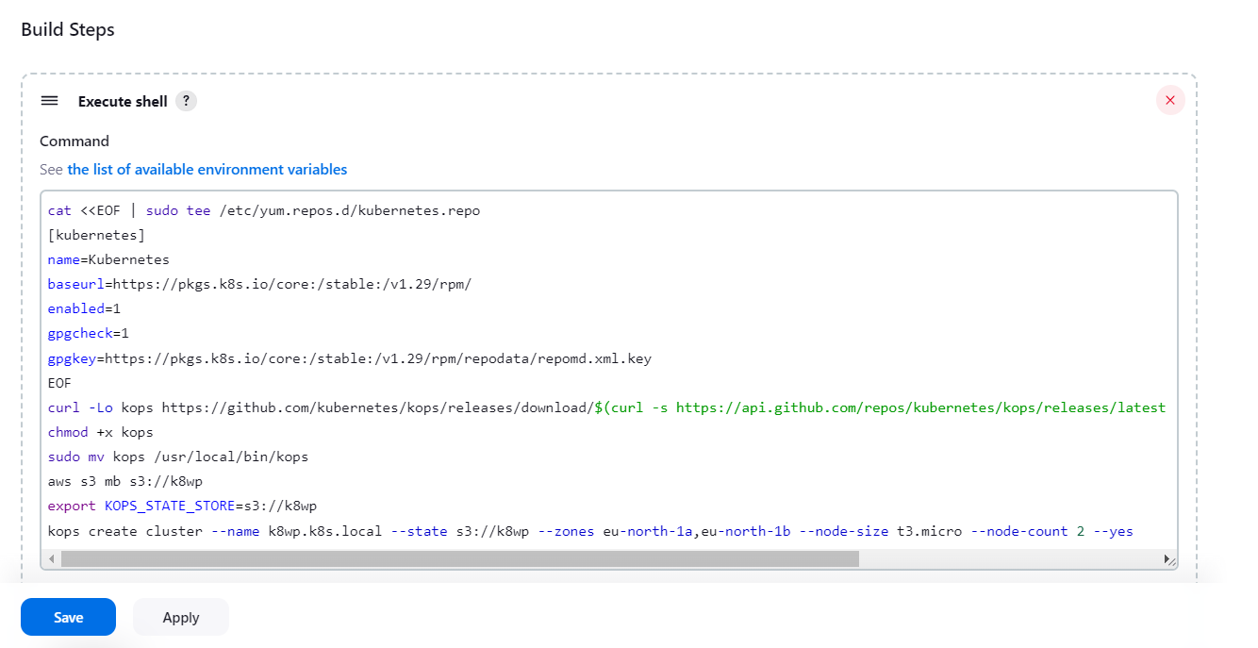

**save and build the job.**

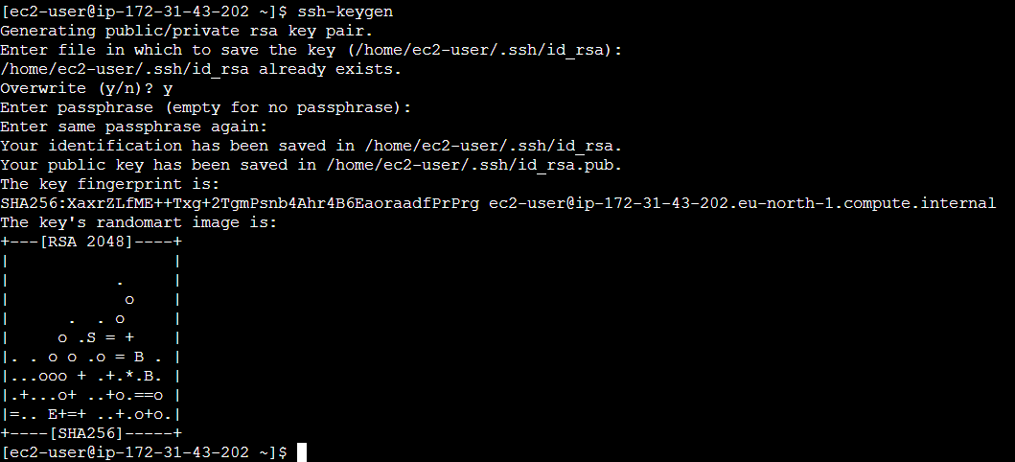

* After writing the commands build the job and see the console output, and wait for the cluster creation it will take minimum of 10minutes.

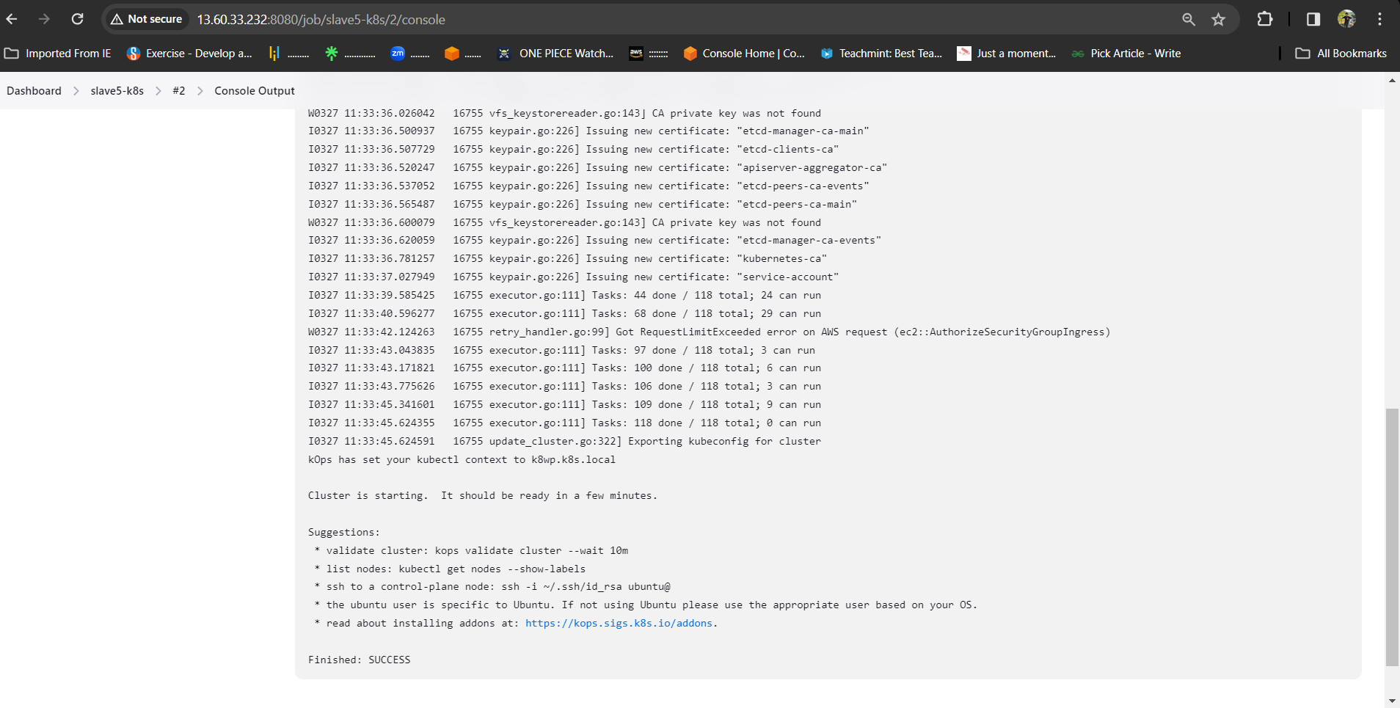

* Now create a new job for deployment unit and service layer and select the option **Restrict where the project can be run** select the Slave5 node which we created.

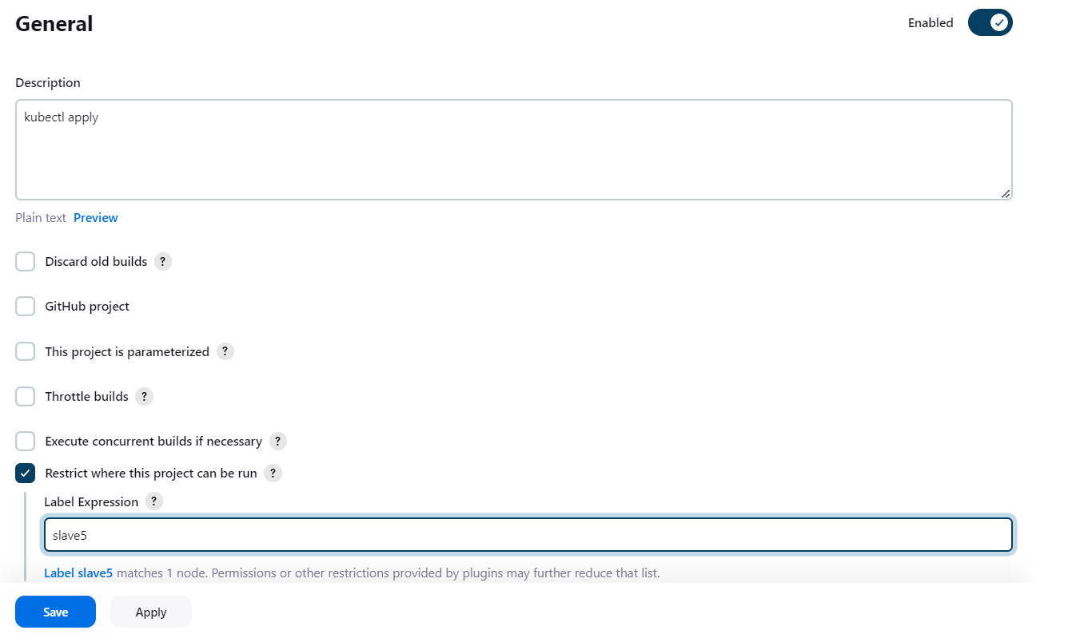

* In build steps select execute shell
* install git and git clone the repository of the deployment and service files, which is already created in our git-hub account.

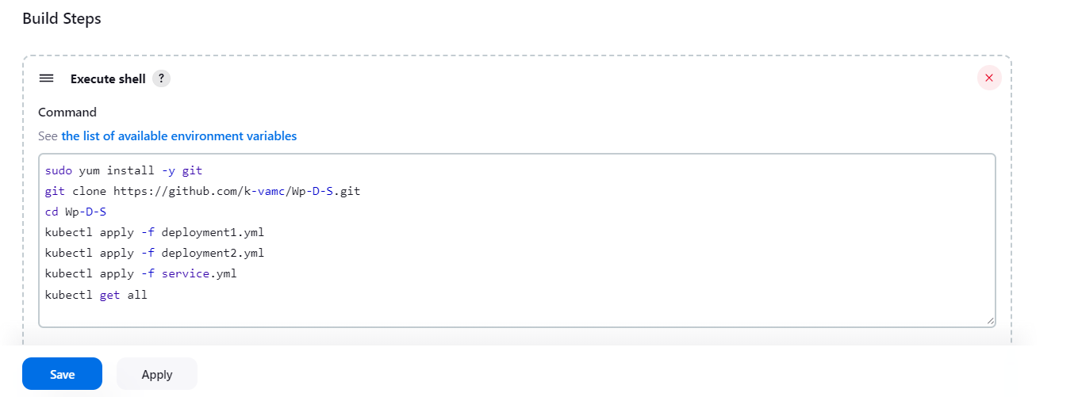

* After waiting of 10minutes build this job in which we gave **.yaml** files.
* Here is the successful installation and apply of deployment and service files.

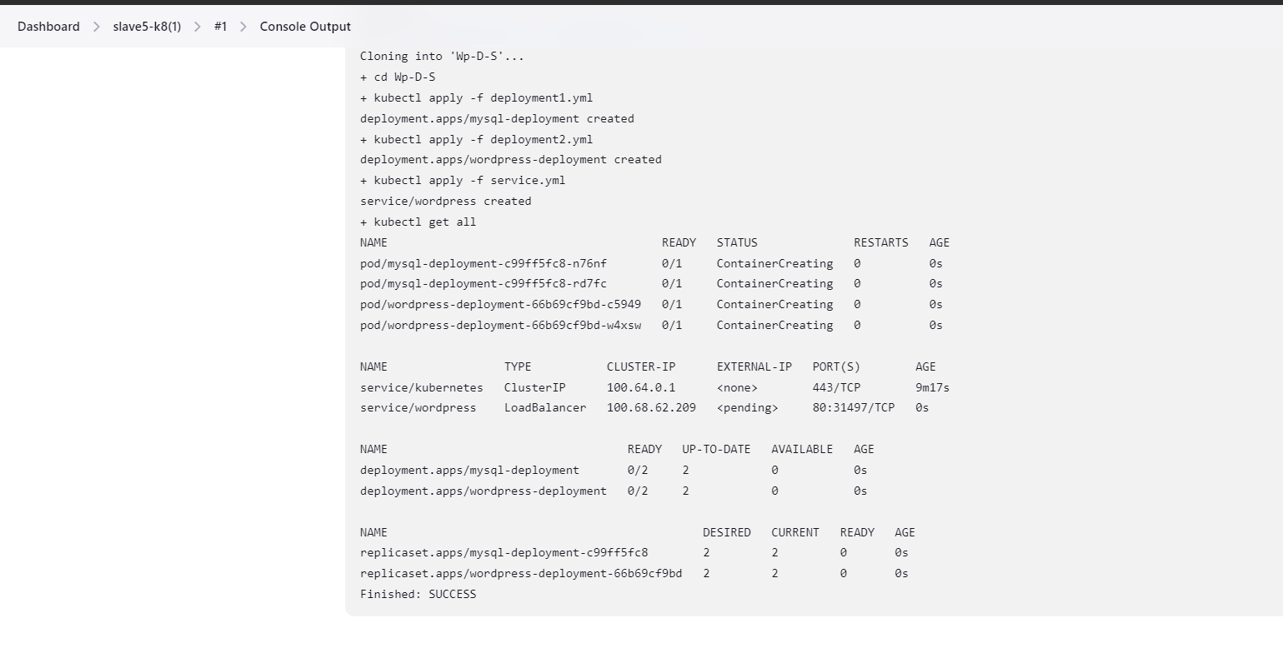

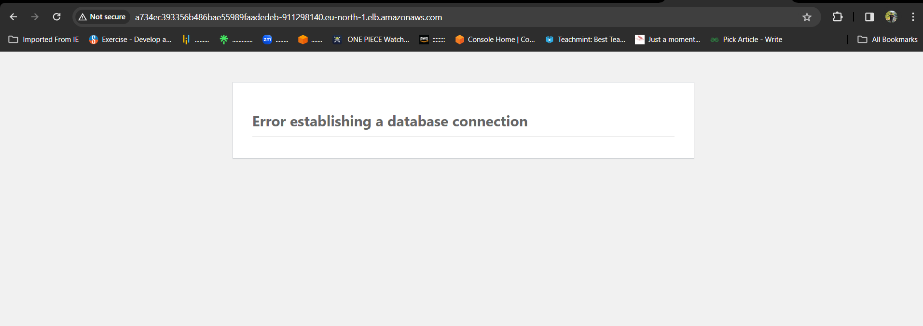

Method -4

SAGAR Create one master and Slave-5 and

RAKESH creates 1st and 2nd slave nodes in same AWS account and VAMSI creates 3rd and 4th slaves IN same AWS account and vamsi deploy word press with bash script(slave-1) and vamsi deploy word press with Docker Compose file (slave-2), and RAKESH deploy word press with Terraform (slave-3) and RAKESH deploy the word press with poll-scm, build periodically, webhooks (slave-4) and rakesh deploy the word press with k8’s (slave-5*).*

* Go to AWS console login with credentials.
* Now create 6 instances (1 Master, 5 Slave).
* **Create Master instance and 5th slave instances by SAGAR in SAGAR Account.**
* **Created 1st and 2nd slave by VAMSI in SAGAR Account.**
* **Created 3rd and 4th slave by RAKESH in SAGAR Account.**

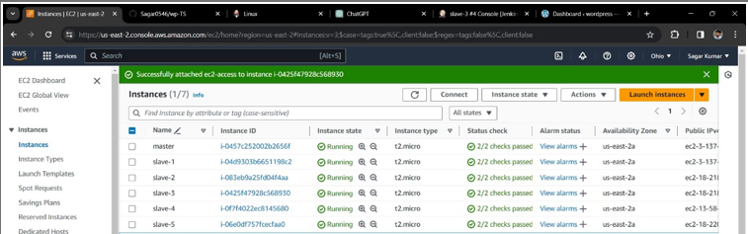

* Now connect the master instance to the GITbash terminal.
* Change the name of the instance using commands as

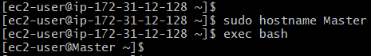

* use the ssh-keygen for the security layer.

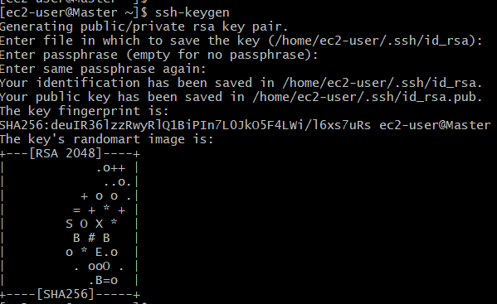

* After creation of ssh-keygen, it generates private and public keys.



* With the help of newly generated public key, make Master-Slave configuration.
* Now connect the slaves server to terminal and do Master-Slave configuration for every Slave servers.
* Copy the public key of the master server and save in slaves authorized_keys.
* Like this, paste the public key in all the slave instances.
* Now install Jenkins
* **sudo wget -O /etc/yum.repos.d/jenkins.repo \**

**https://pkg.jenkins.io/redhat-stable/jenkins.repo**

* **sudo rpm --import https://pkg.jenkins.io/redhat-stable/jenkins.io-2023.key**
* **sudo yum -y upgrade**
* **sudo yum install fontconfig java-17* -y**
* **sudo yum -y install jenkins**
* **sudo systemctl daemon-reload**
* **sudo systemctl start jenkins**
* **sudo systemctl enable jenkins**
* **sudo systemctl status Jenkins**
* Now copy the key and paste it in Jenkins unlock page.

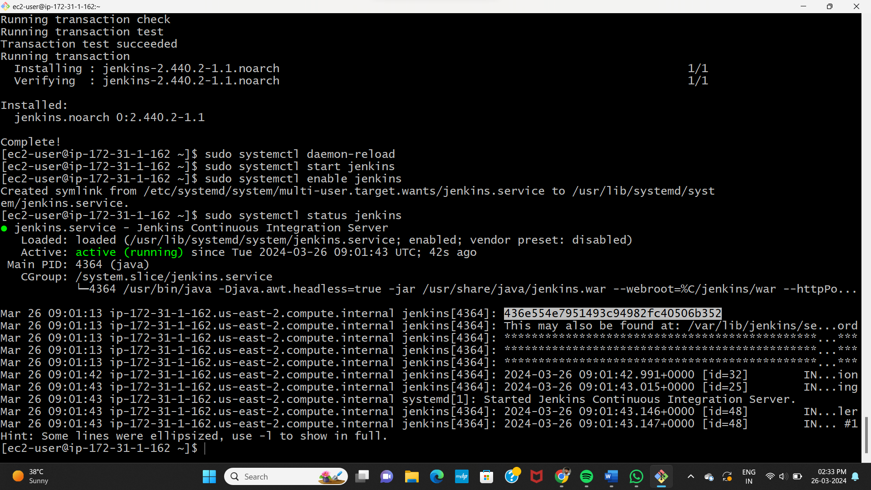

* Now, copy paste the public IP address along with port 8080 and unlock Jenkins with admin password.
* Now, make master-slave configuration by creating worker nodes in Jenkins.
* Jenkins 🡪 manage Jenkins 🡪 Nodes

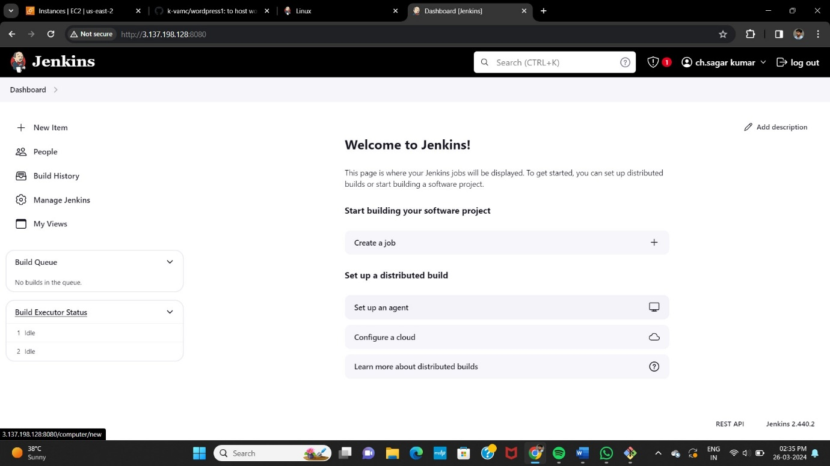

* Install run time java-17* in every slave-servers.
* Now create 5 slave nodes and name them as **Slave1, Slave2, Slave3, Slave4, Slave5.**
* Now name the node, select the no.of executors , Remote root directory as **/home/ec2-user¸**now label as name of the server , usage as much as possible, launch method as **via SSH**, host as **public IP of the instance,** in credentials add **id_rsa** name it , host key as **manually trusted key verification strategy,** availability **as online as much as possible** and save it.

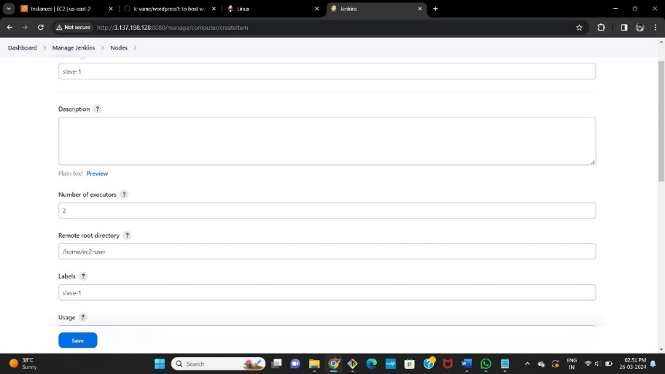 **Slave-1**

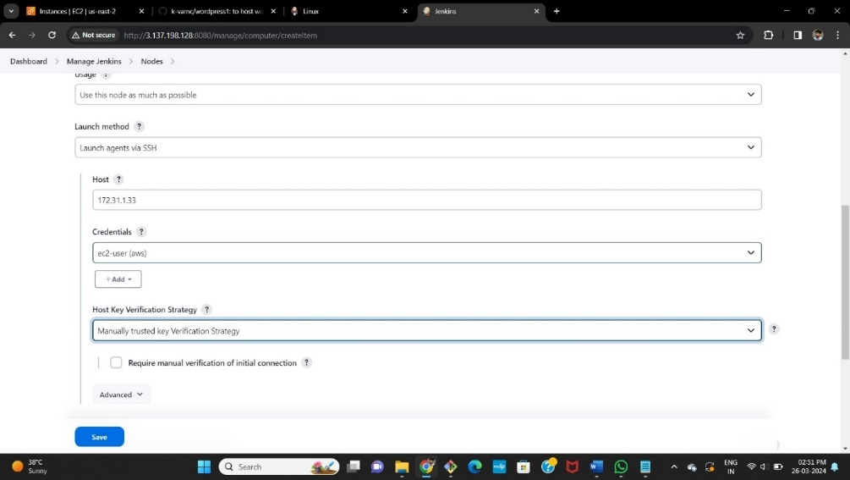

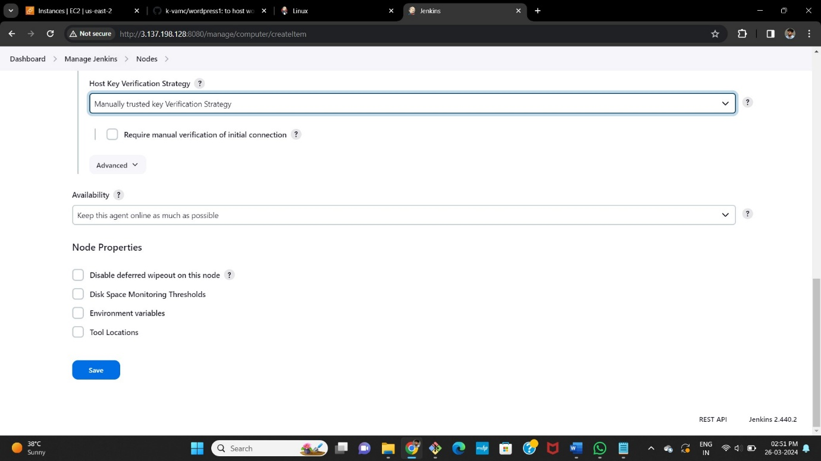

**FOR SLAVE-2,3,4,5**

* same repeat the same process for rest all the slave servers. Just change the labels as slave-1,slave-2,slave-3,slave-4,slave-5. And replace the host by slaves public IP-address.
* Now check the created nodes in dashboard.

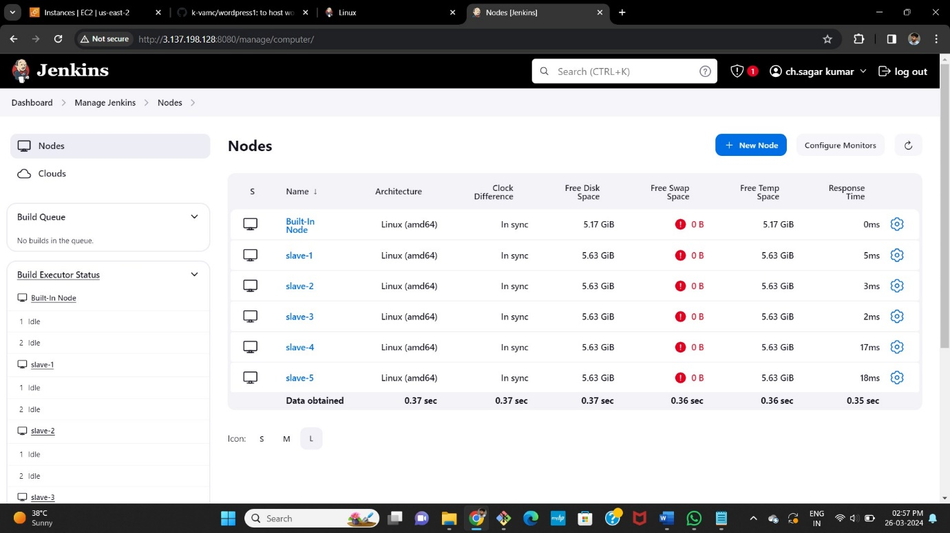

* Maser-Slave configuration is successful and all the servers are online.
* Now create job for the slave servers and name them as **Slave1, Slave2, Slave-3, Slave4, Slave5.**
* jobs we create in slaves are
* **Slave-1** = deploy word press with bash script by **VAMSI**
* **Slave-2** = deploy word press with Docker Compose file BY **VAMSI**
* **Slave-3** = deploy word press with Terraform BY SAGAR
* **Slave-4** = deploy the word press with poll-scm, build periodically, webhooks BY **SAGAR**
* **Slave-5** = deploy the word press with k8’s BY **RAKESH**

**SLAVE-1**

* Select new item > name the job > select freestyle project

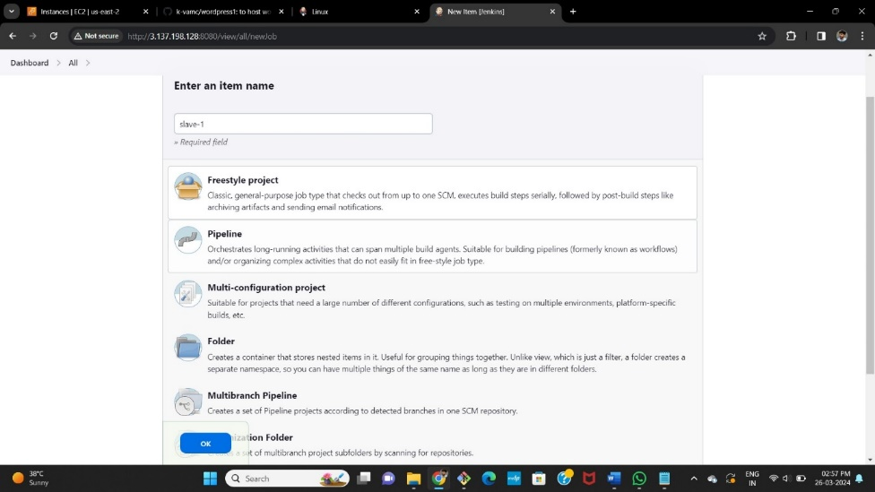

* Now select the option **Restrict where the project can be run** select the Slave1 node which we created.

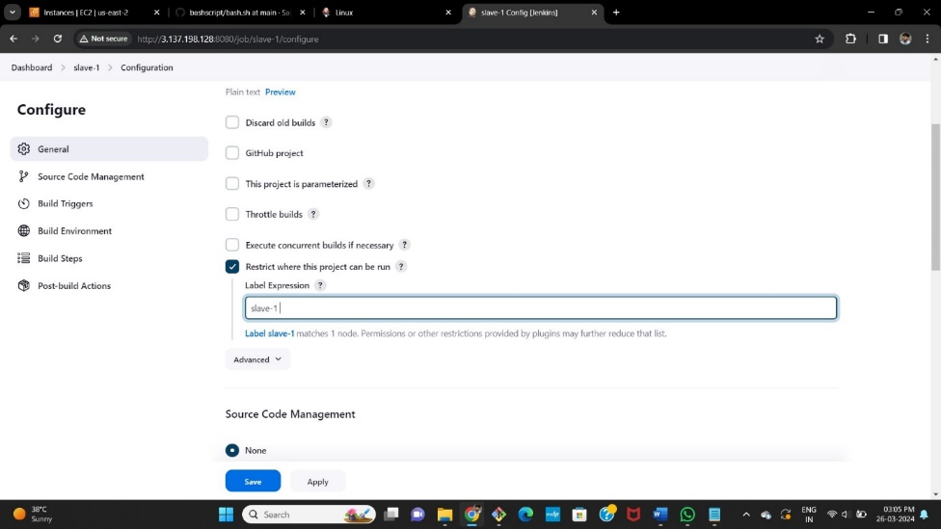

* Here we wrote the bash-script and pushed it into the git-hub account manually so pull the git repo and execute the script



Now in build steps give commands to install git and clone the git repo in source code manager, 777 permissions to .sh file and execution command for .sh file.

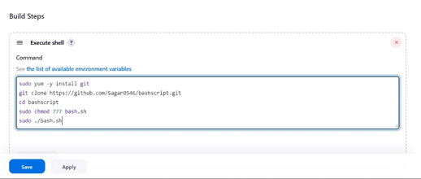

* After completion save the job and tap on build it will be success, here is the console output.

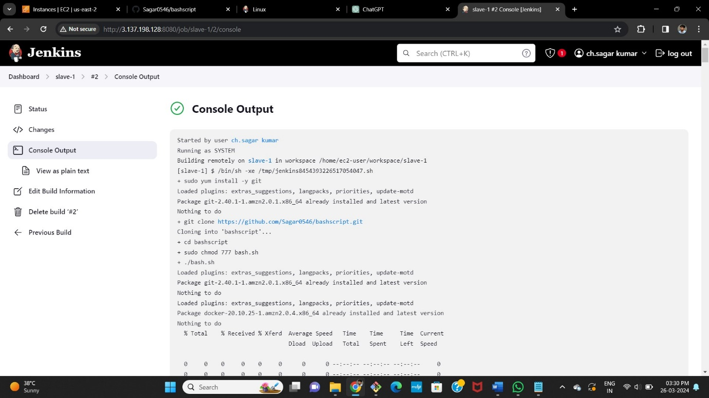

* After success go to AWS account copy the slave-1 pubic ip and browse.

After browsing we will be directed to the official landing page of WORDPRESS.

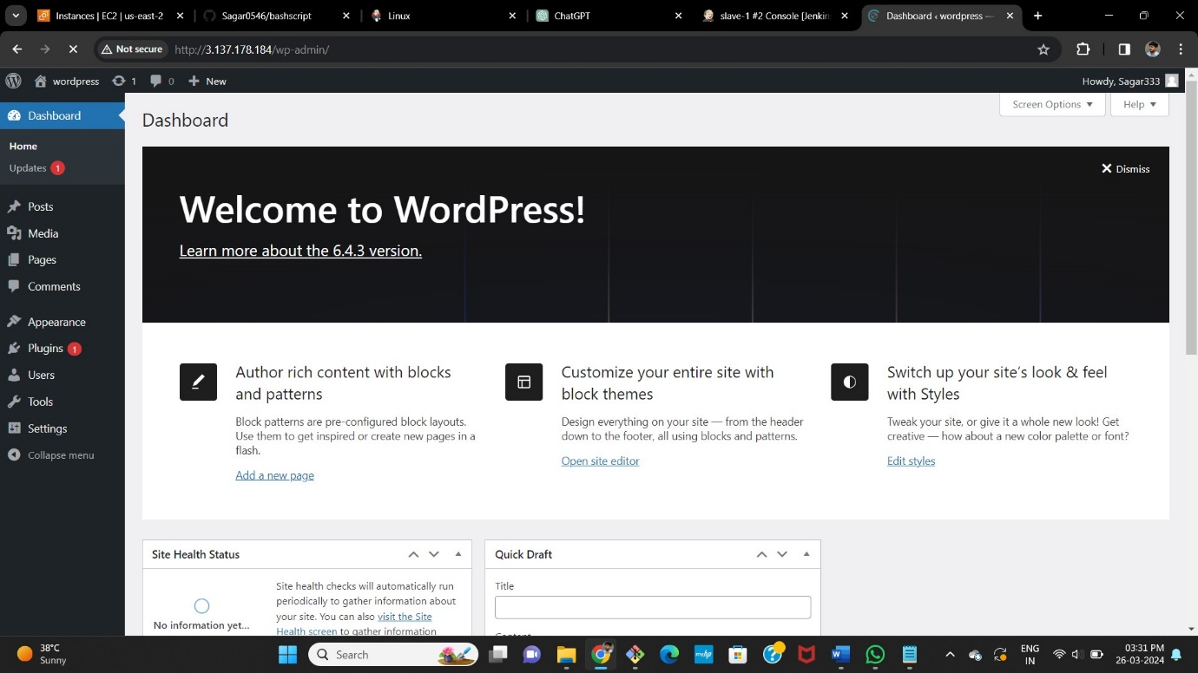

**SLAVE-2**

* Select new item > name the job > select freestyle project.
* Now select the option **Restrict where the project can be run** select the Slave-2 node which we created.

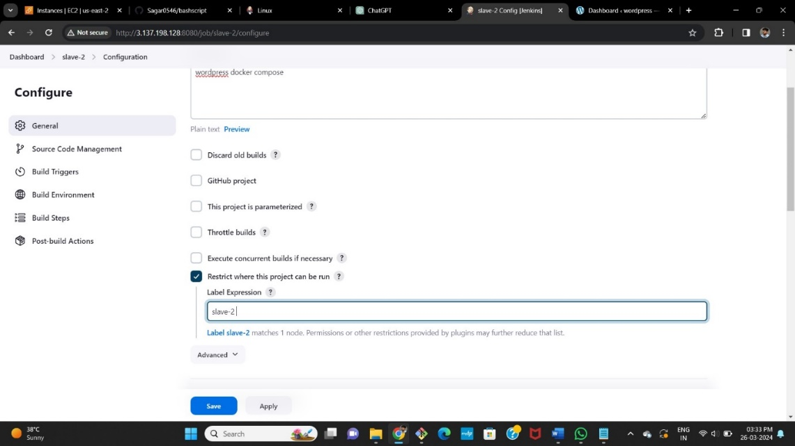

* Here we write the bash-script in the execute shell.

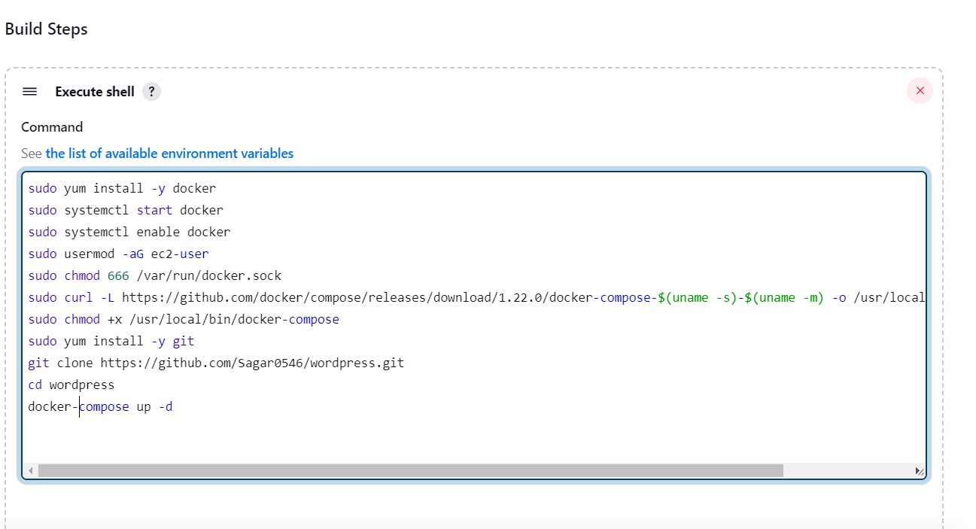

* After completion save the job and click on build no, it will be success.
* Here is the console output.

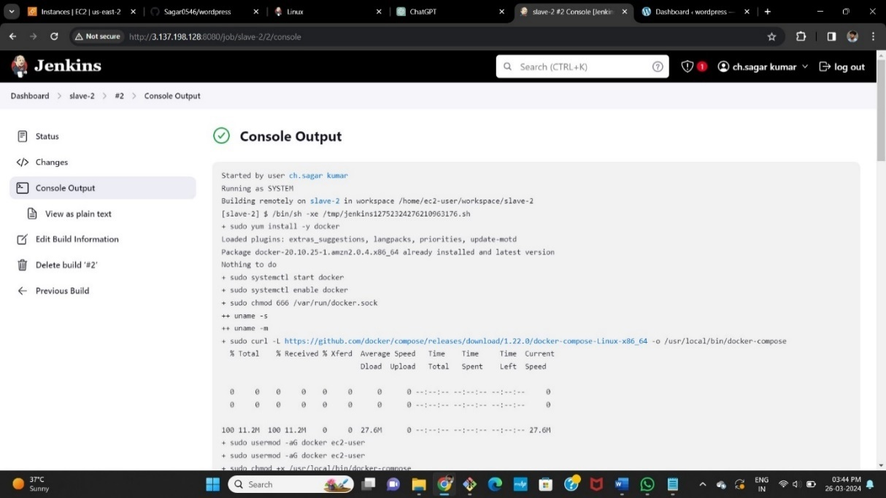

* After success go to AWS account copy the slave2 pubic IP address and browse.
* After browsing we will be directed to the official landing page of WORDPRESS.

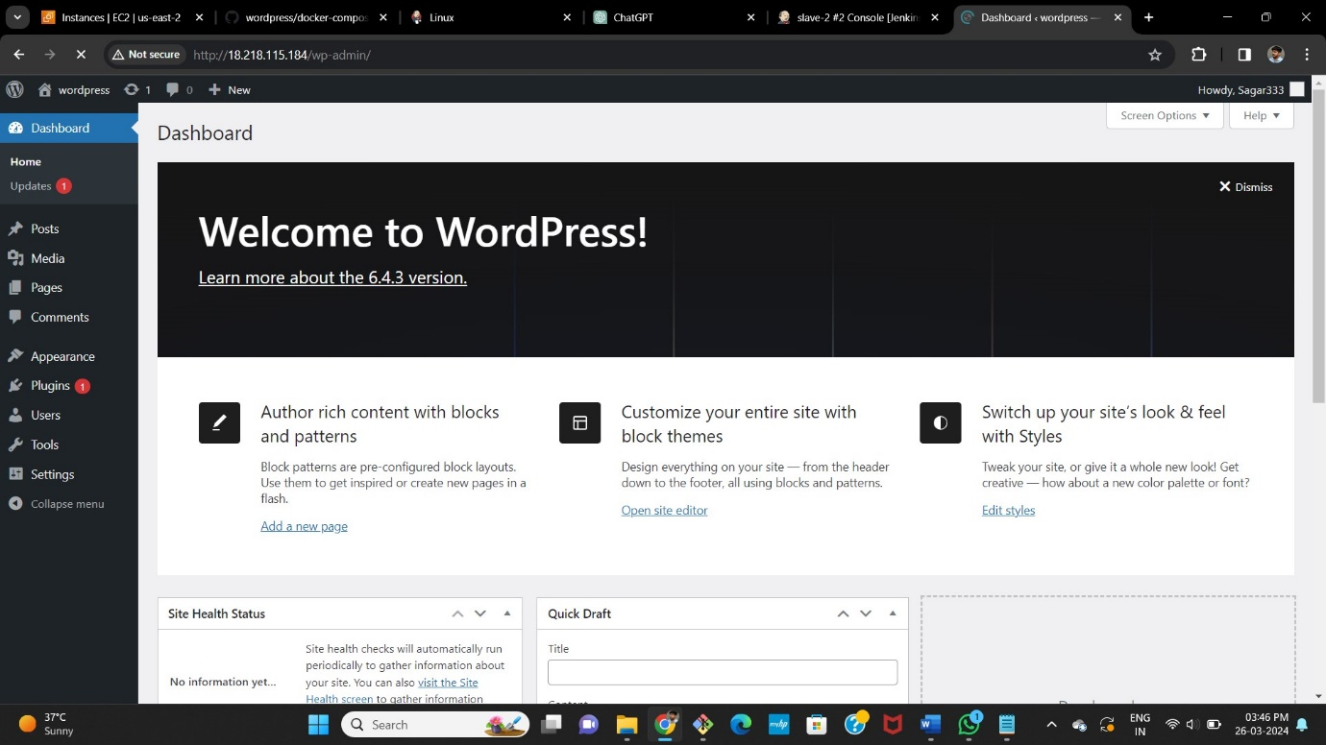

**SLAVE-3**

* Select new item > name the job > select freestyle project
* Now select the option **Restrict where the project can be run** select the Slave-3 node which we created.

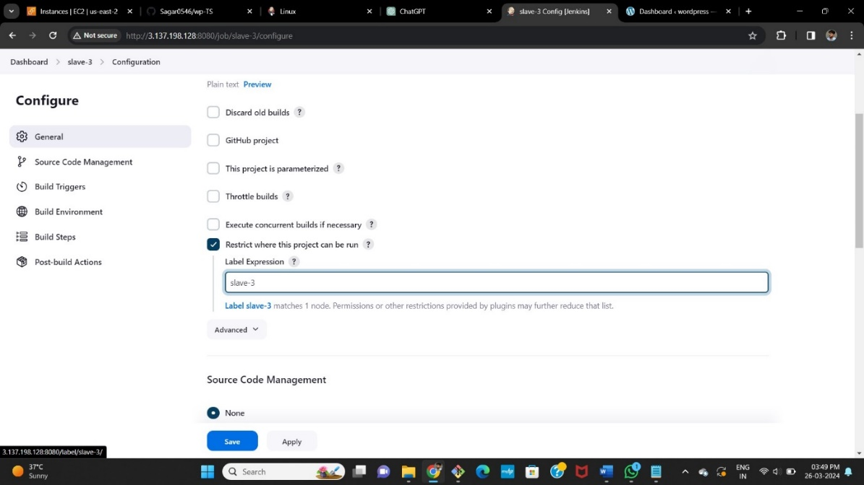

* Here we write the script and execute commands of terraform in the execute shell.

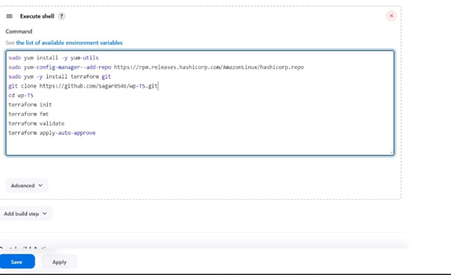

* After completion save the job and tap on build it will be success , here is the console output.

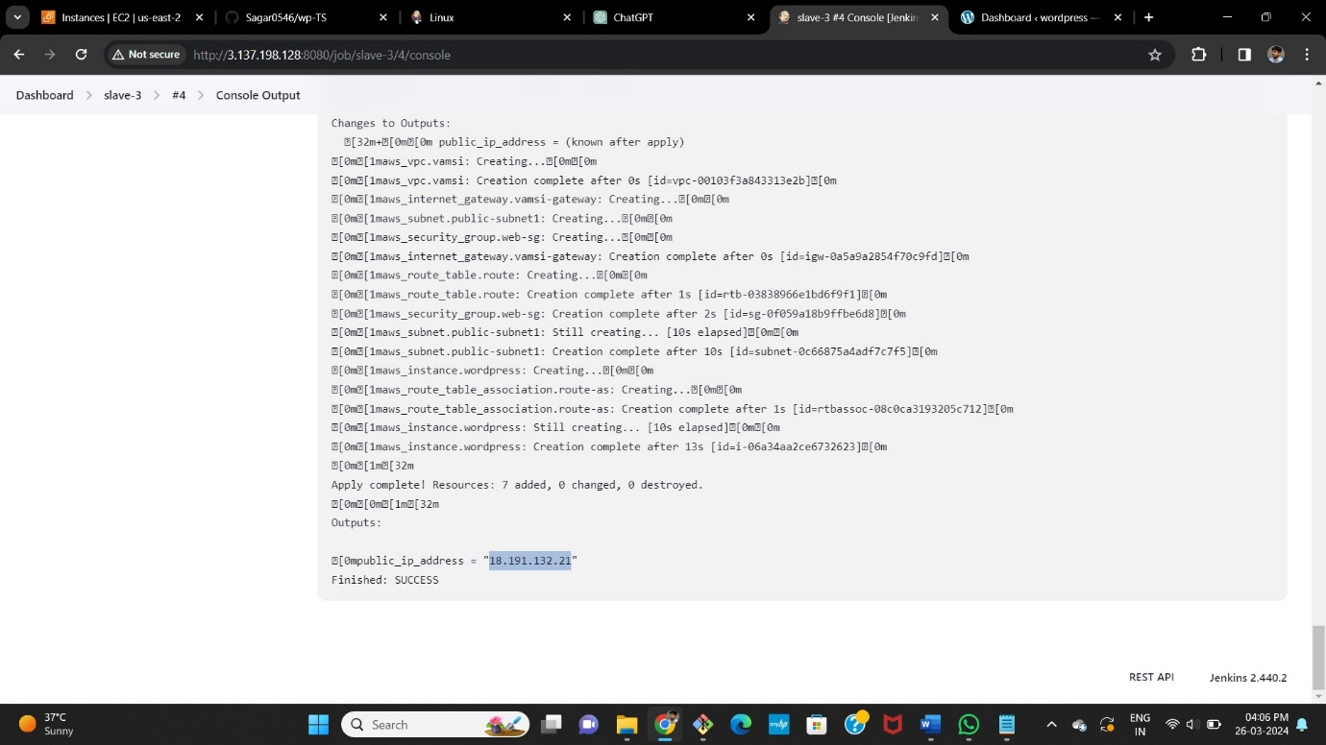

* From terraform scripts it gives newly created instance’s public IP-address.
* Now, copy and browse the IP address we will be directed to the official landing page of WORDPRESS.

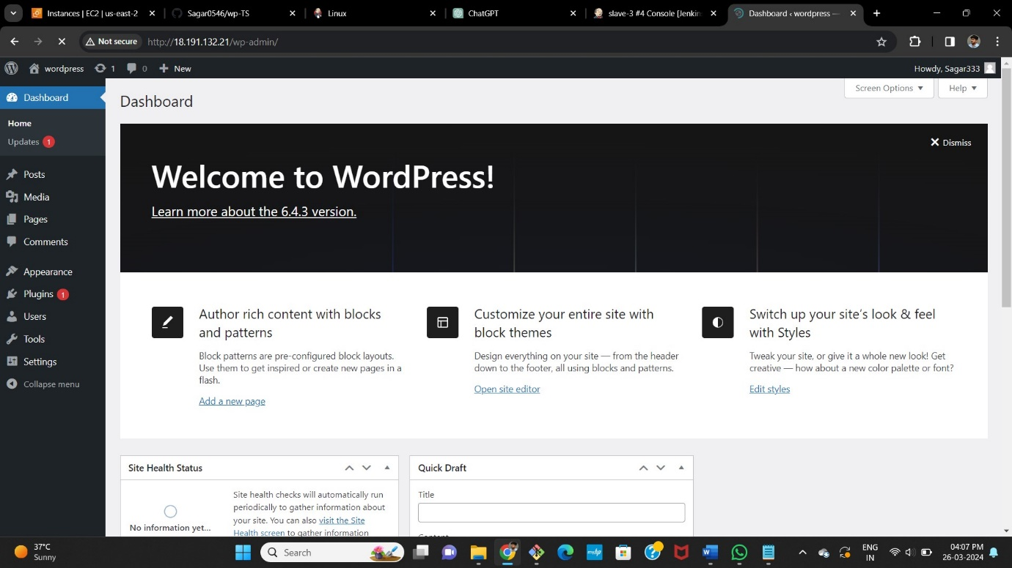

**SLAVE-4**

**BUILD PERIODICALLY**

* Select new item > name the job > select freestyle project
* Now select the option **Restrict where the project can be run** select the Slave-4 node which we created.

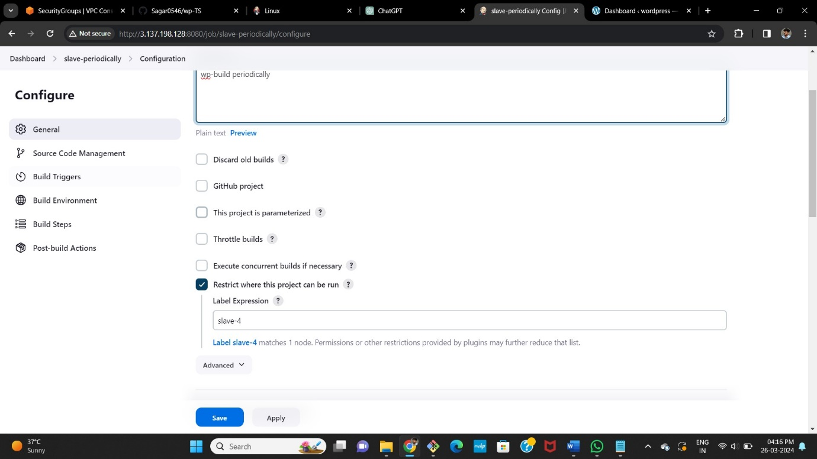

* Now in build triggers select **build periodically** option and give timing as

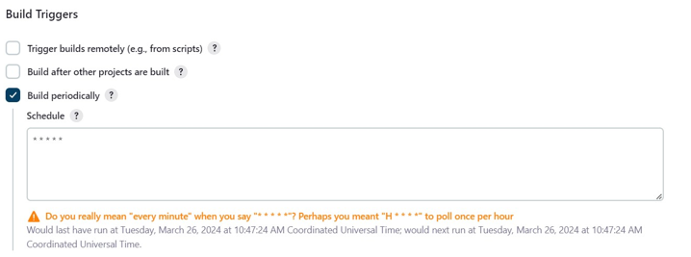 **\* * * * \*** means every minute every hour every day & month of the year.

* Here we write the bash-script in the execute shell.

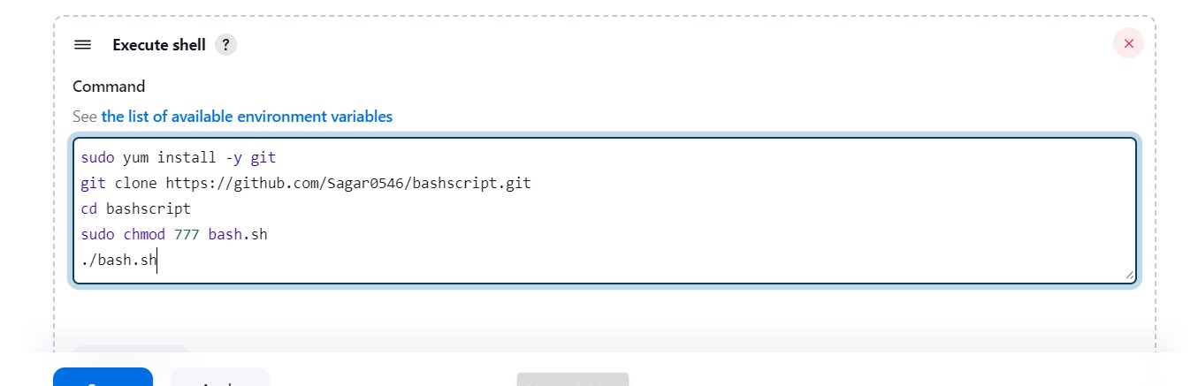

* After completion save the job and tap on build it will be success , here is the console output.

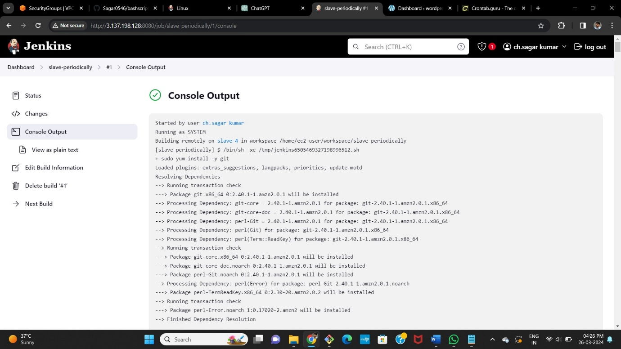

* After success go to AWS account copy the slave-4 pubic ip and browse.
* After browsing we will be directed to the official landing page of WORDPRESS.

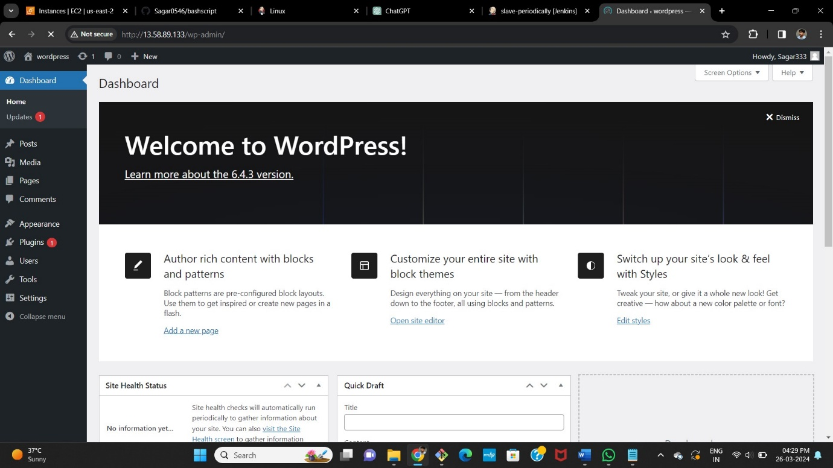

**POLL SCM**

* Now in build triggers select poll scm option and give timing as **\* * * * \*** means every minute every hour every day & month of the year.

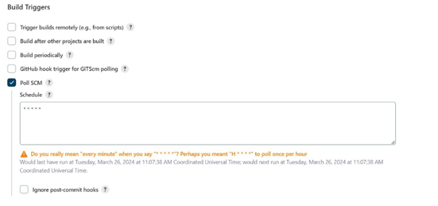

* 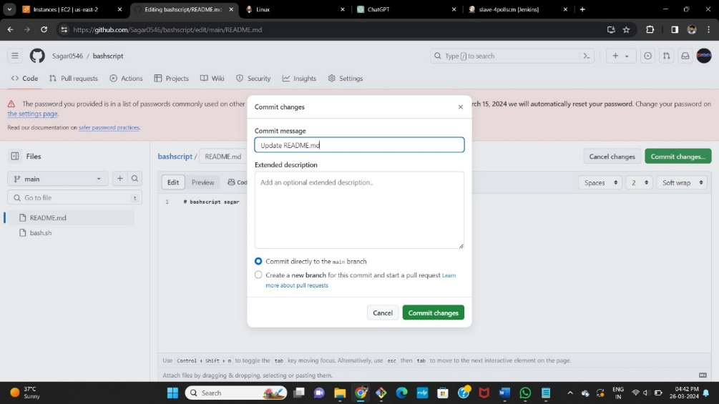Save it now in github make a change in any of the file or create a dummy file It will automatically trigger and build the job directly.

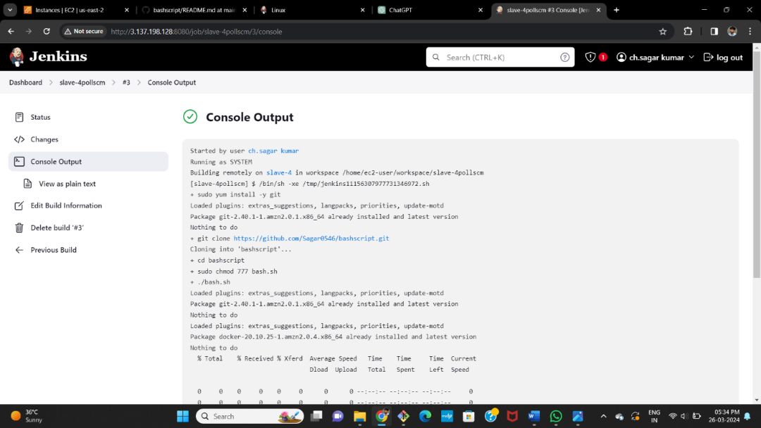

* It has same console output and same public ip to browse



**WEBHOOKS**

* Now in build triggers select github hook trigger for GITScm polling.



* Go to github and select the repository and go to settings there we will find webhooks option select it and add webhooks.

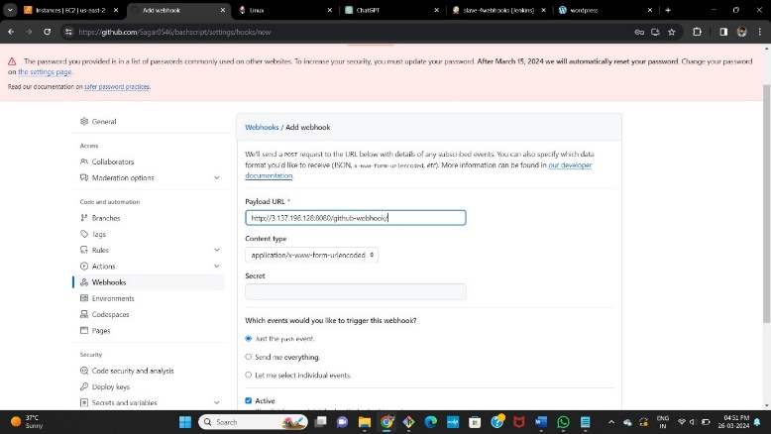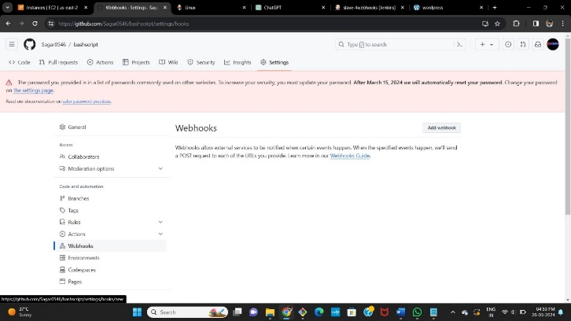

* Now add webhook give our **master public ip/github-webhook** and save it.

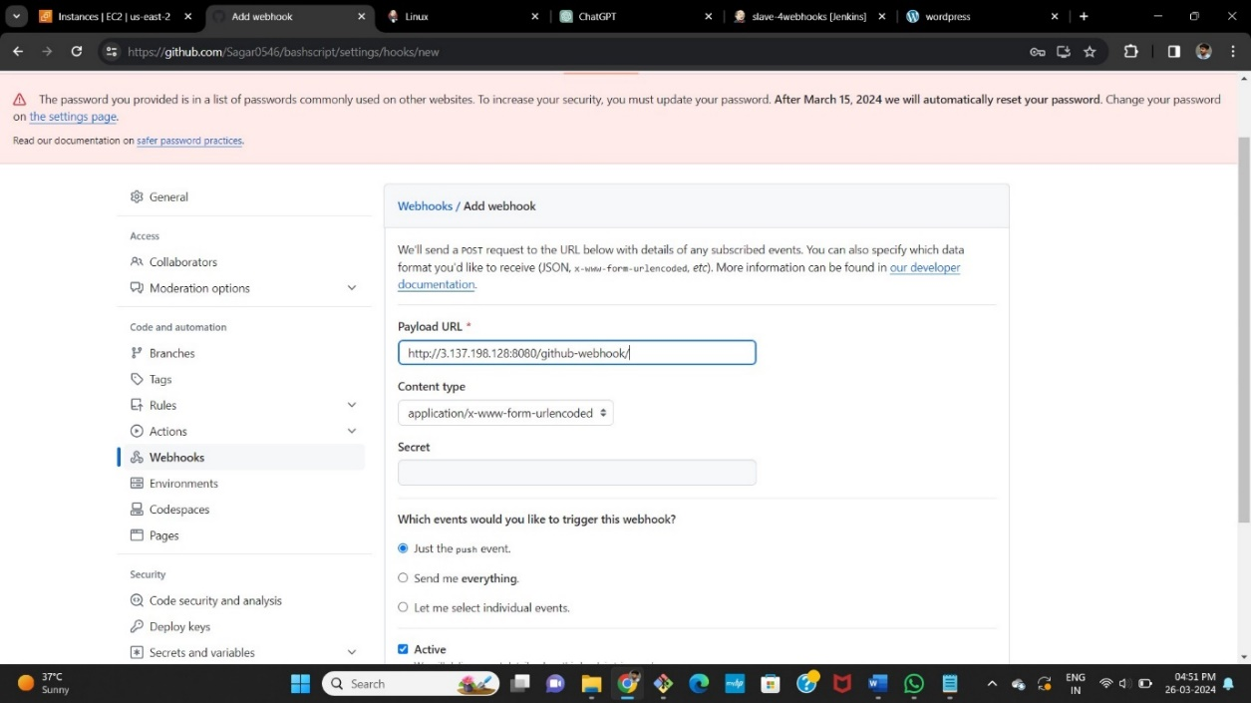

* Save it now in github make a change in any of the file or create a dummy file It will automatically trigger and build the job directly.



* It has same console output and same public ip to browse.

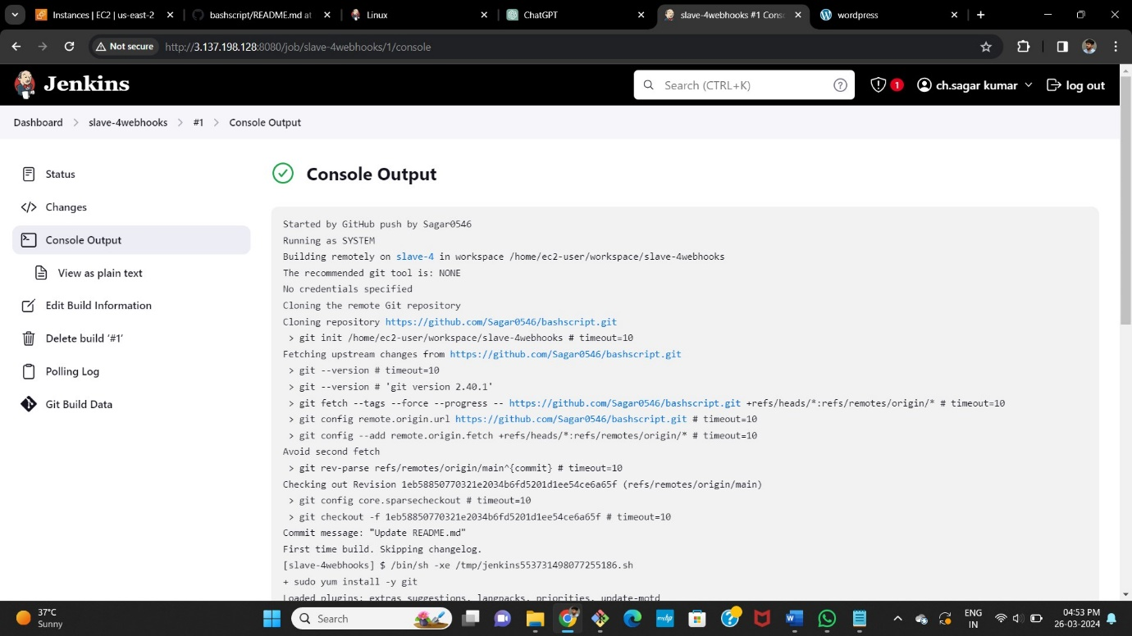

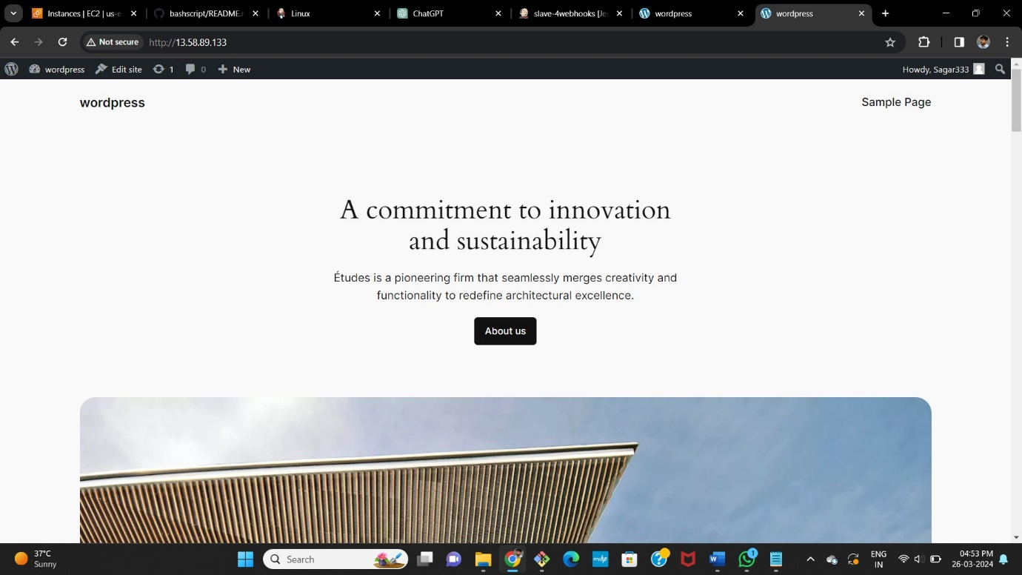

**Slave-5**

* Select new item > name the job > select freestyle project.

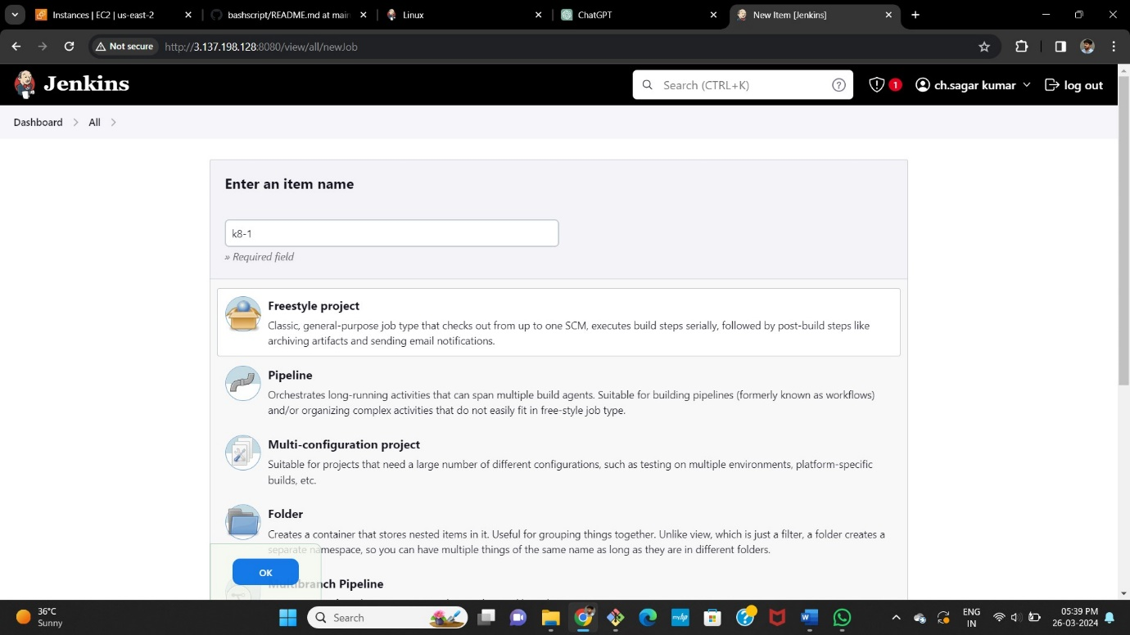

* Now select the option **Restrict where the project can be run** select the Slave-5 node which we created.

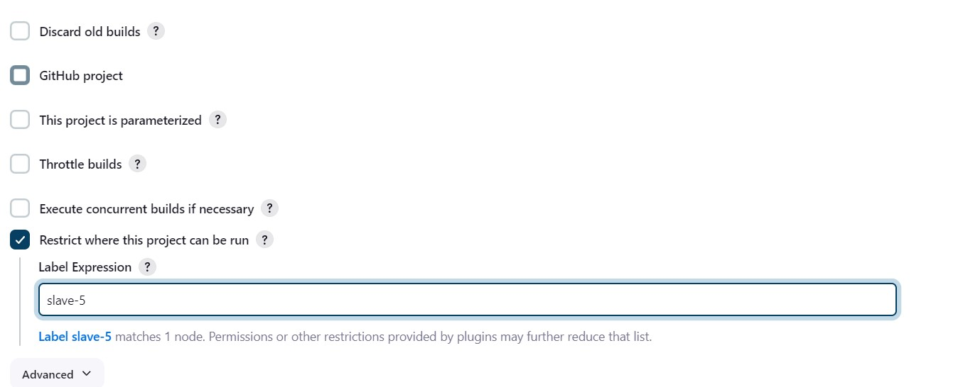

* Now in build steps give commands to install Kubernetes and kops,

And create s3 bucket, configure the cluster details we want to create in one job.

* For that go to amazon console attach the IAM role which have admin access for Slave-5 instance.



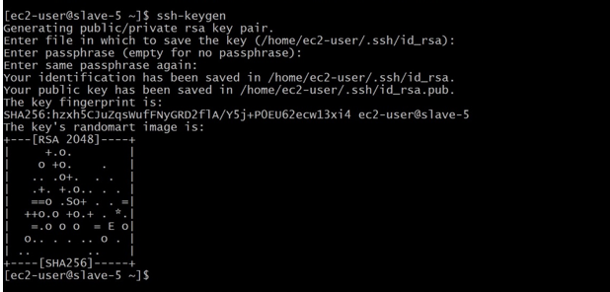

* After writing the commands build the job and see the console output, and wait for the cluster creation it will take minimum of 10minutes.

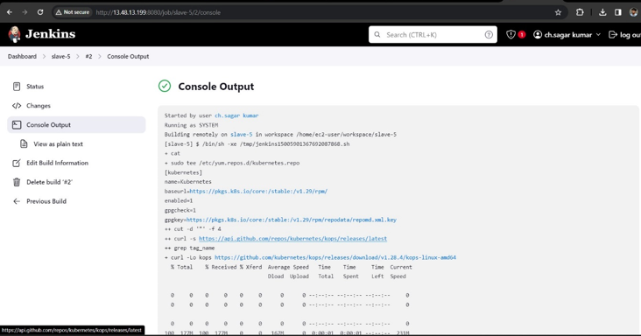

* Now create a new job for deployment unit and service layer and select the option **Restrict where the project can be run** select the Slave5 node which we created.

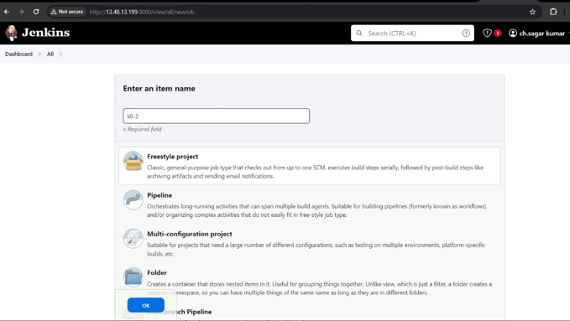



* In build steps select execute shell
* Install git and git clone the repository of the deployment and service files, which is already created in our git-hub account

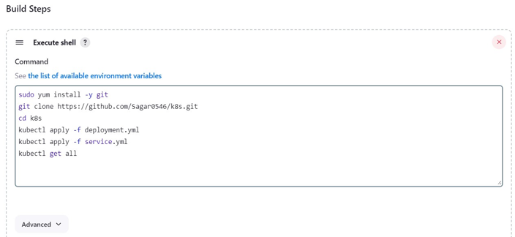

* After waiting of 10minutes build this job in which we clone **.yaml** files.
* Here is the successful installation and apply of deployment and service files.

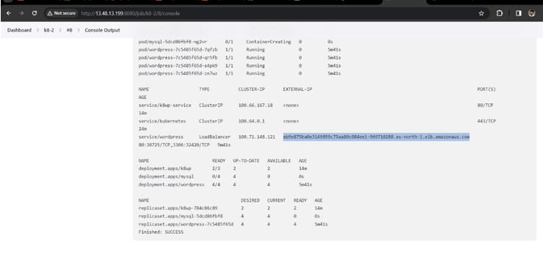

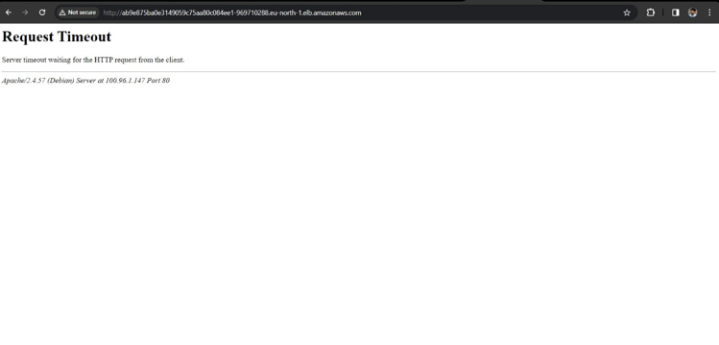

**Method -5**

**RAKESH Create one master and Slave-5 and SAGAR creates 1st and 2nd slave nodes in same AWS account and VAMSI creates 3rd and 4th slaveS IN same AWS account and SAGAR deploy word press with bash script(slave-1) and SAGAR deploy word press with Docker Compose file (slave-2), and VAMSI deploy word press with Terraform (slave-3) and VAMSI deploy the word press with poll-scm, build periodically, webhooks (slave-4) and RAKESH deploy the word press with k8’s (slave-5).**

* Go to AWS console login with credentials.
* Now create 6 instances (1 Master, 5 Slave).
* **Create Master instance and 5th slave instances by RAKESH in RAKESH Account.**
* **Create 1st and 2nd slave by SAGAR in RAKESH Account.**
* **Create 3rd and 4th slave by VAMSI in RAKESH Account**
* Now connect the master instance to the gitbash terminal.

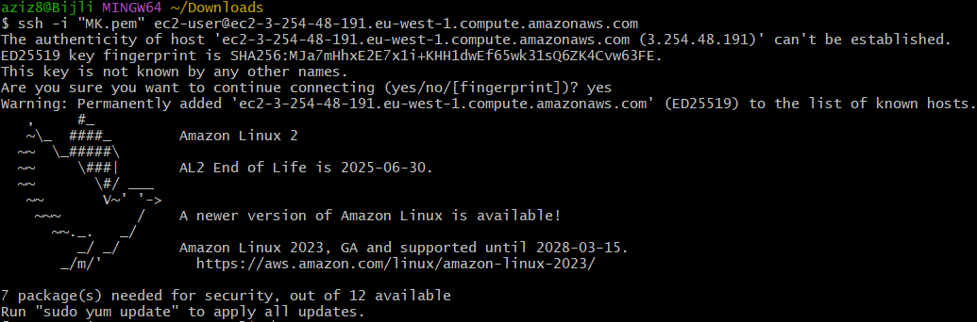

* Change the name of the instance using commands as **sudo hostname master.**
* use the ssh-keygen for the security layer
  + After creation of ssh-keygen, it generates private and public keys. With the help of newly generated public key, make Master-Slave configuration.
* Before that install run time into all the slave instances.
* Copy and paste the public key in slave instances at; cd .ssh/ 🡪 ls 🡪 sudo vi authorized­_keys

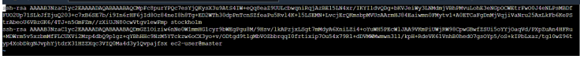

* Like this, paste the MASTER public key in all the slave instances.

* Now install Jenkins
* **sudo wget -O /etc/yum.repos.d/jenkins.repo \**

**https://pkg.jenkins.io/redhat-stable/jenkins.repo**

* **sudo rpm --import https://pkg.jenkins.io/redhat-stable/jenkins.io-2023.key**
* **sudo yum -y upgrade**
* **sudo yum install fontconfig java-17* -y**
* **sudo yum -y install jenkins**
* **sudo systemctl daemon-reload**
* **sudo systemctl start jenkins**
* **sudo systemctl enable jenkins**
* **sudo systemctl status Jenkins**
* Now copy the key and paste it in Jenkins unlock page.
* Now, copy paste the public IP address along with port 8080 and unlock Jenkins with admin password.
* Now, make master-slave configuration by creating worker nodes in Jenkins.
* Jenkins 🡪 manage Jenkins 🡪 Nodes

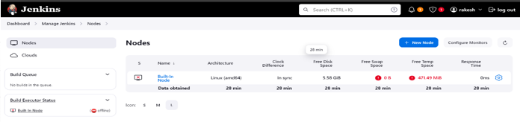

* Install run time java-17* in every slave-servers.

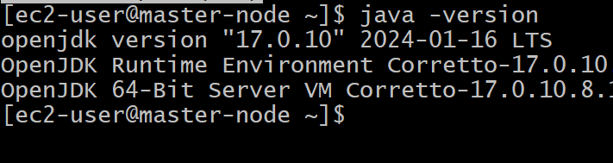

* Now create 5 slave nodes and name them as **Slave1, Slave2, Slave3, Slave4, Slave5.**
* Now name the node, select the no.of executors , Remote root directory as **/home/ec2-user¸**now label as name of the server , usage as much as possible, launch method as **via SSH**, host as **public IP of the instance,** in credentials add **id_rsa** name it , host key as **manually trusted key verification strategy,** availability **as online as much as possible** and save it.

**SLAVE1**

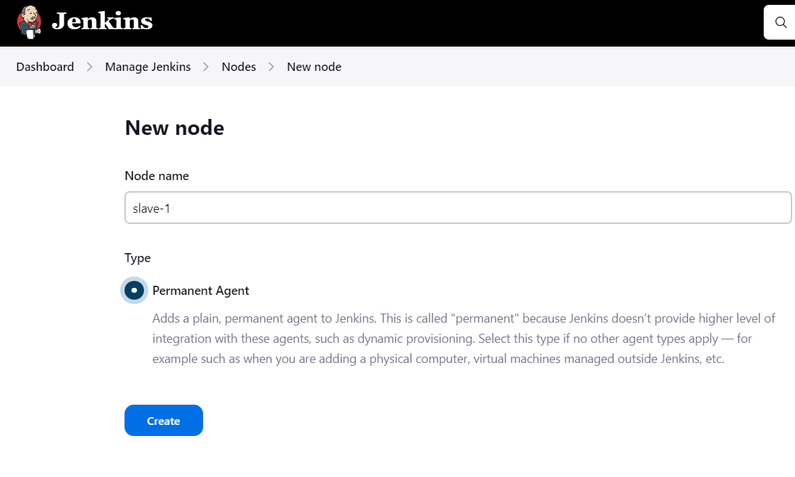

* launch method as **via SSH**, host as **public ip of the instance,** in credentials add **id_rsa** name it.
* Host key as **manually trusted key verification strategy,** availability **as online as much as possible** and save it.

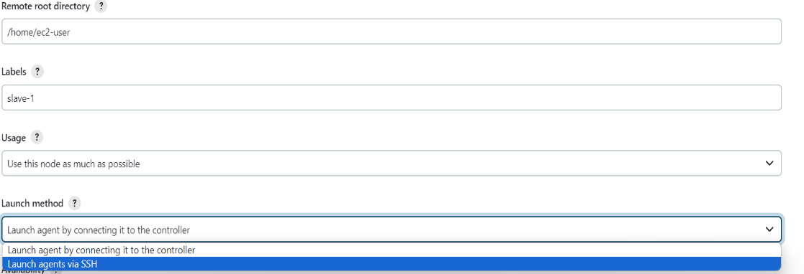

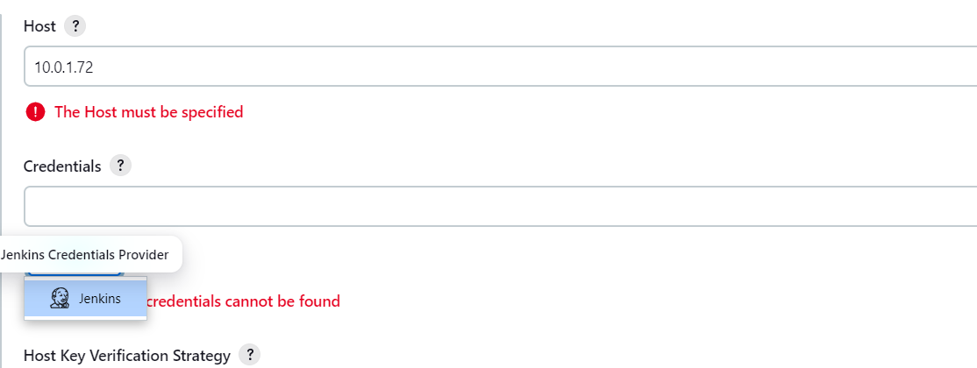

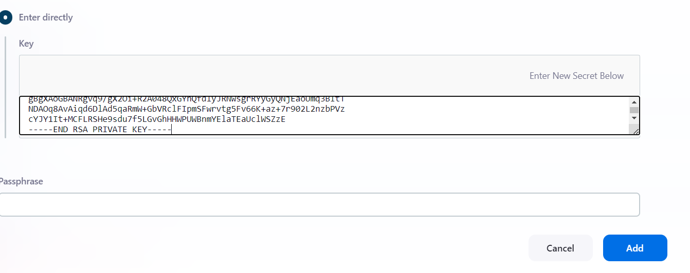

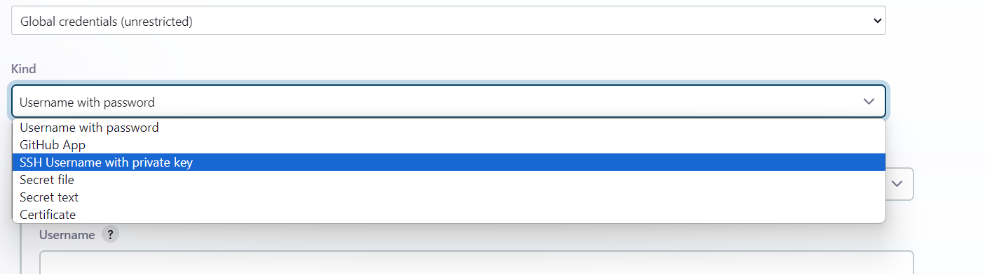

**FOR SLAVE-2,3,4,5**

* same repeat the same process for rest all the slave servers. Just change the labels as slave1, slave2 ,slave3, slave4, slave5. And replace the host by slaves public IP-address.
* Now check the created nodes in dashboard

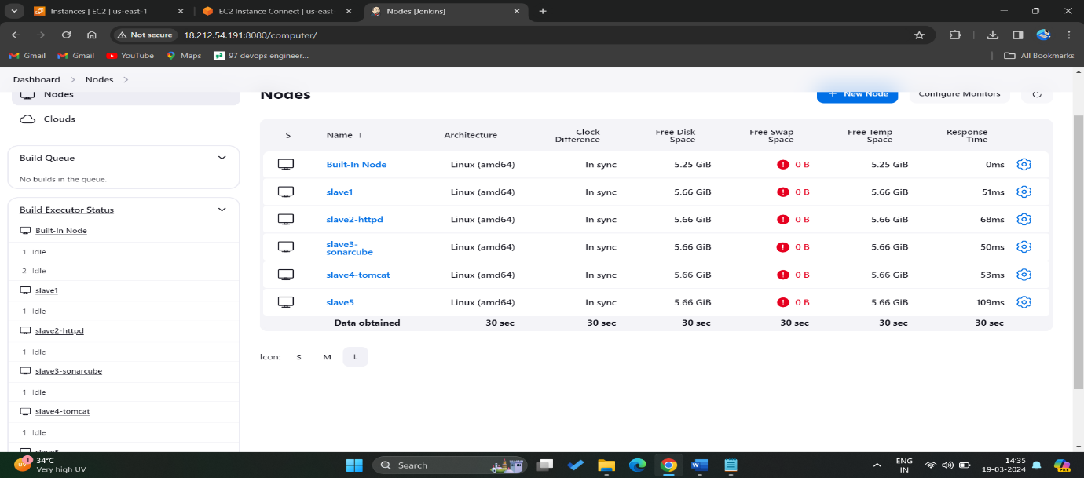

* Maser-Slave configuration is successful and all the servers are online.
* Now create job for the slave servers and name them as **Slave1, Slave2, Slave-3, Slave4, Slave5.**
* jobs we create in slaves are
* **Slave-1 =** deploy word press with bash script BY **SAGAR**
* Slave-2 = deploy word press with Docker Compose file BY **SAGAR**
* Slave-3 = deploy word press with Terraform BY **VAMSI**
* Slave-4 = deploy the word press with poll-scm, build periodically, webhooks BY **VAMSI**
* Slave-5 = deploy the word press with k8’s BY **RAKESH**

**SLAVE-1**

* Select new item > name the job > select freestyle project
* Now select the option **Restrict where the project can be run** select the Slave1 node which we created.

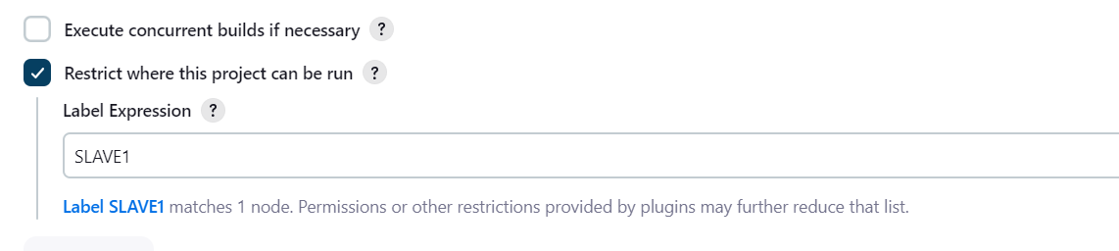

* Here we wrote the bash-script and pushed it into the git-hub account manually so pull the git repo and execute the script

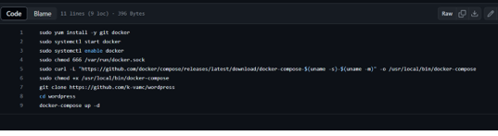

* Now in build steps give commands to install git and clone the git repo in source code manager, 777 permissions to .sh file and execution command for .sh file.

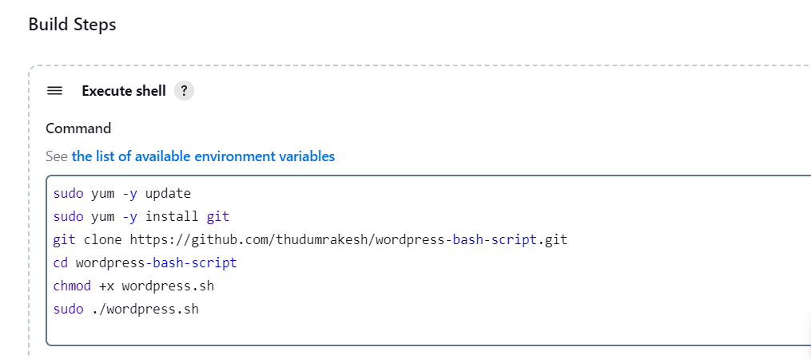

* After completion save the job and tap on build it will be success, here is the console output.

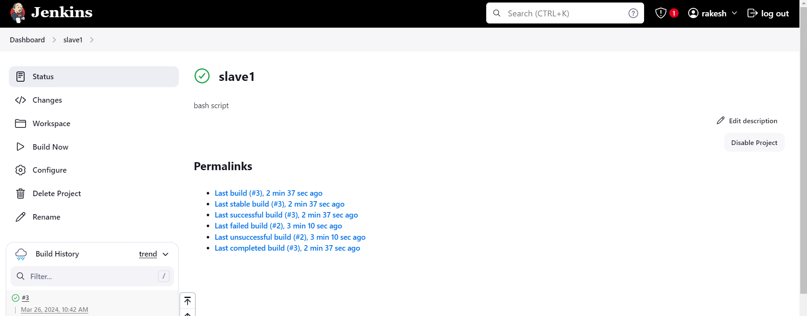

* After success go to AWS account copy the slave-1 pubic ip and browse.

After browsing we will be directed to the official landing page of WORDPRESS

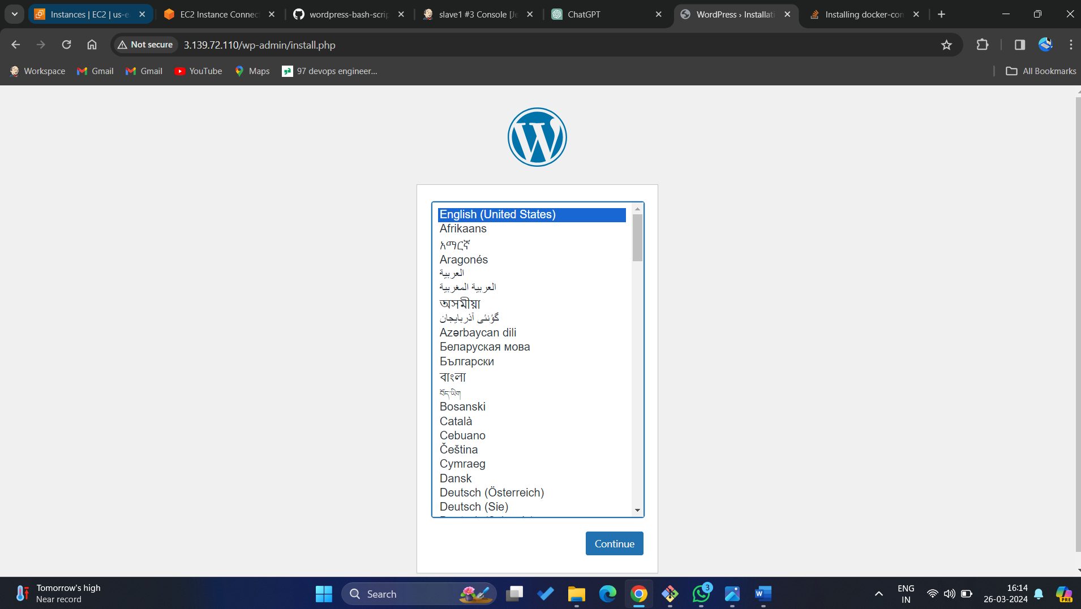

**SLAVE-2**

* Select new item > name the job > select freestyle project.
* Now select the option **Restrict where the project can be run** select the Slave2 node which we created.

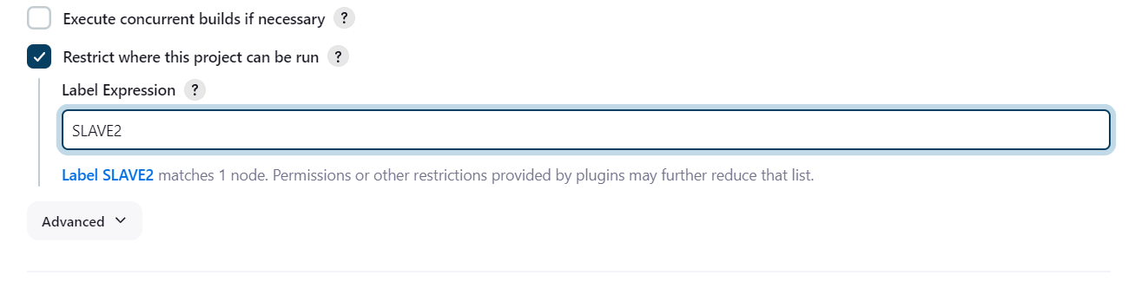

* Here we write the bash-script in the execute shell.

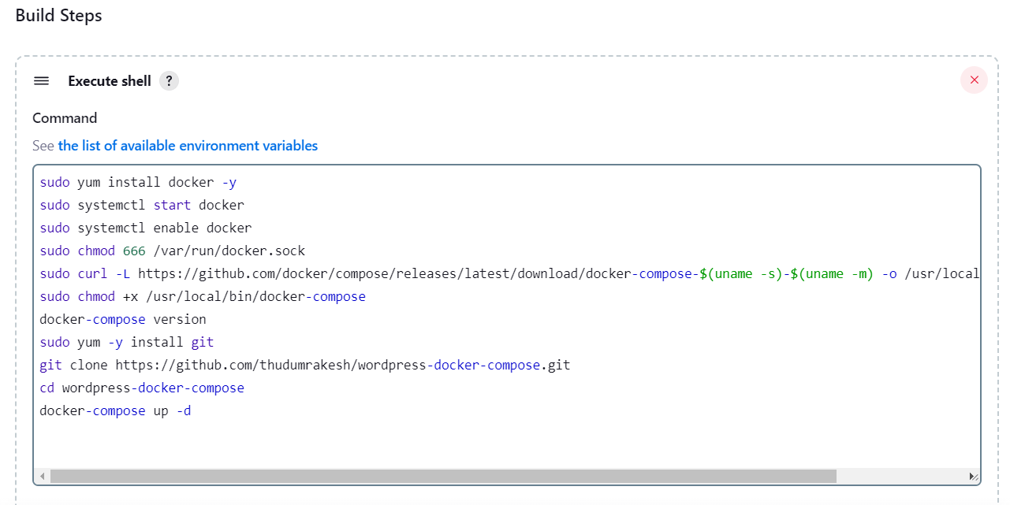

* After completion save the job and click on build no, it will be success.

here is the console output.

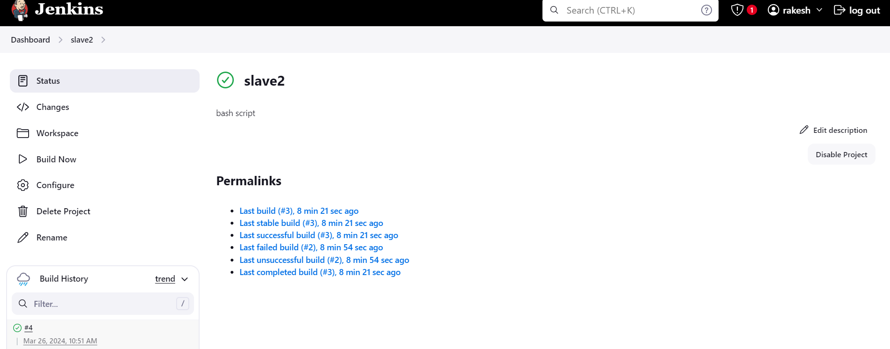

* After success go to AWS account copy the slave2 pubic IP address and browse.
* After browsing we will be directed to the official landing page of WORDPRESS.

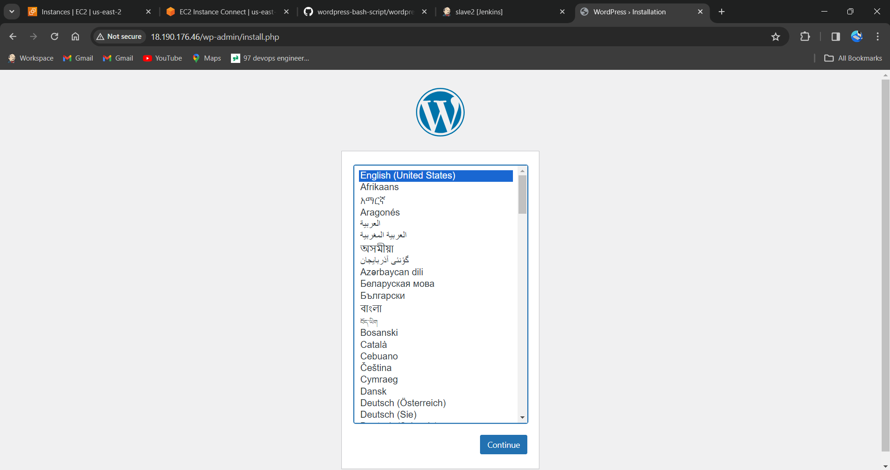

**SLAVE-3**

* Select new item > name the job > select freestyle project.
* Now select the option **Restrict where the project can be run** select the Slave-3 node which we created.

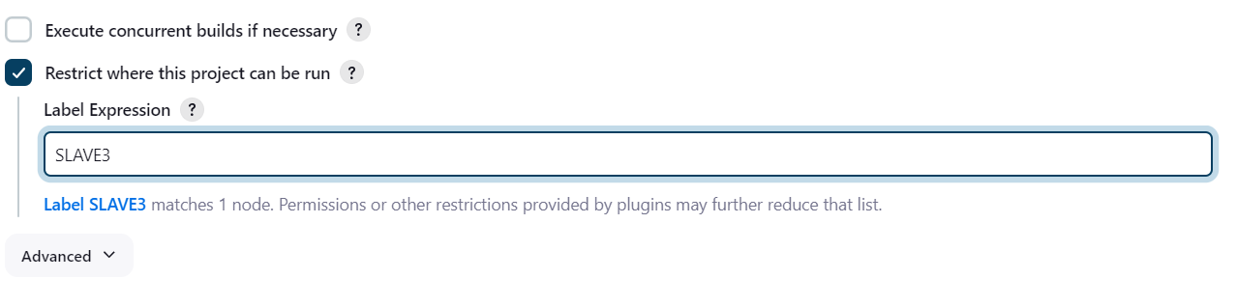

* Here we write the script and execute commands of terraform in the execute shell.

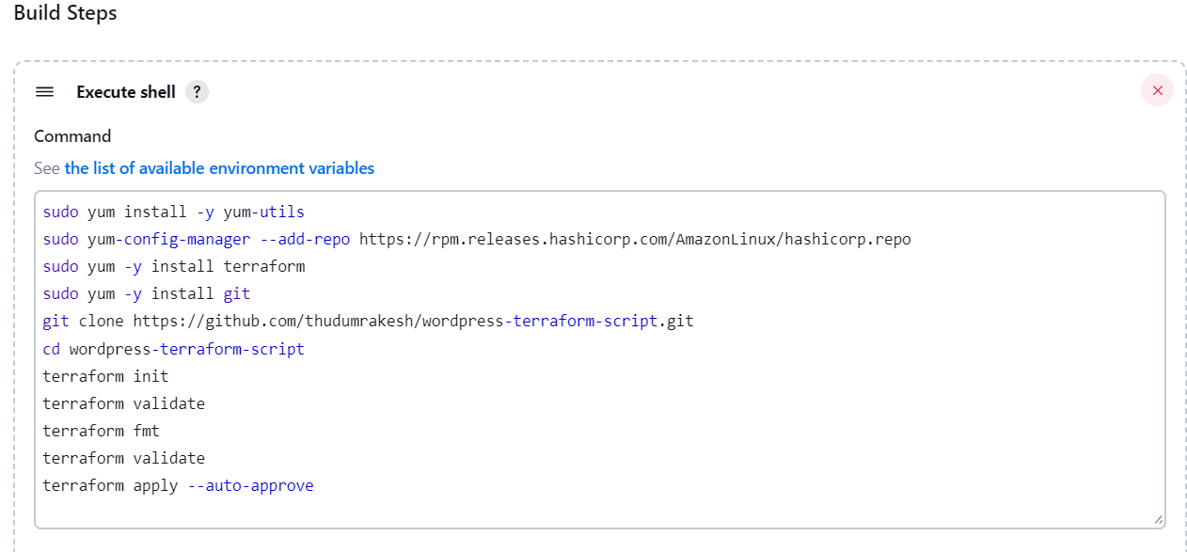

* After SAVE and BUILD the JOB,it will be success.
* here is the console output.

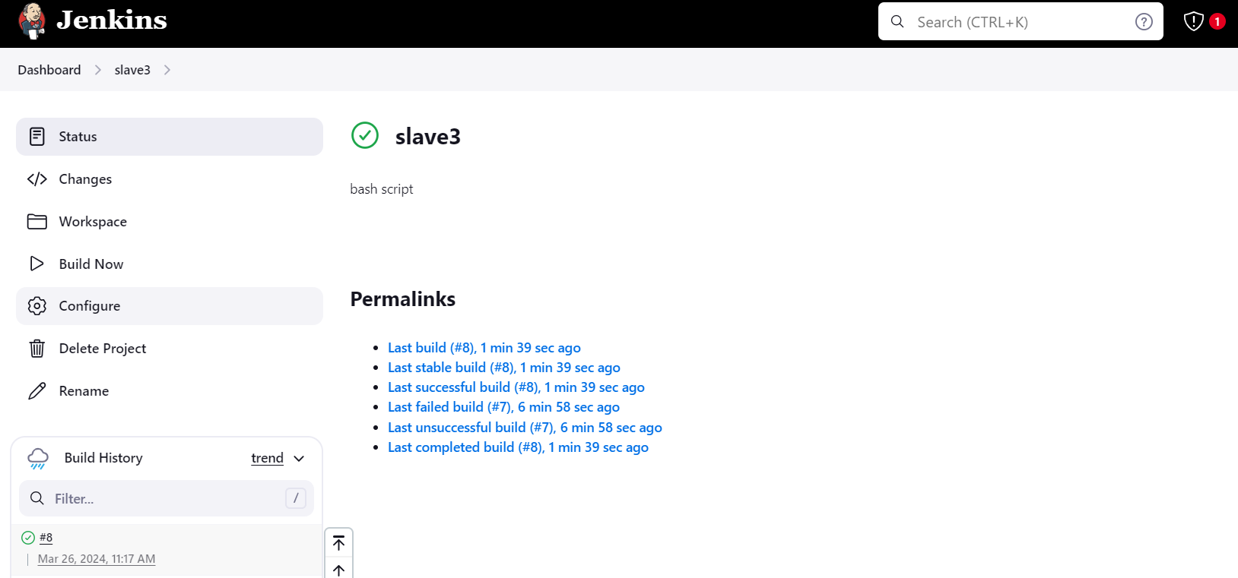

* From terraform scripts it gives newly created instance’s public IP-address.
* 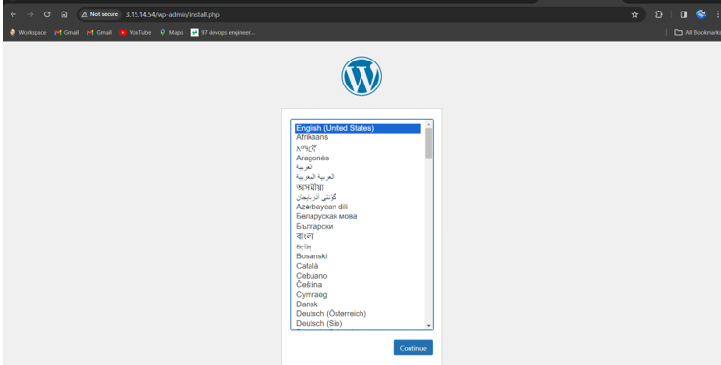Now, copy and browse the IP address we will be directed to the official landing page of WORDPRESS.

**SLAVE-4**

**BUILD PERIODICALLY**

* Now in build triggers select poll scm option and give timing as **\* * * * \*** means every minute every hour every day & month of the year.



* Save it now in github make a change in any of the file or create a dummy file It will automatically trigger and build the job directly.
* Select new item > name the job > select freestyle project.

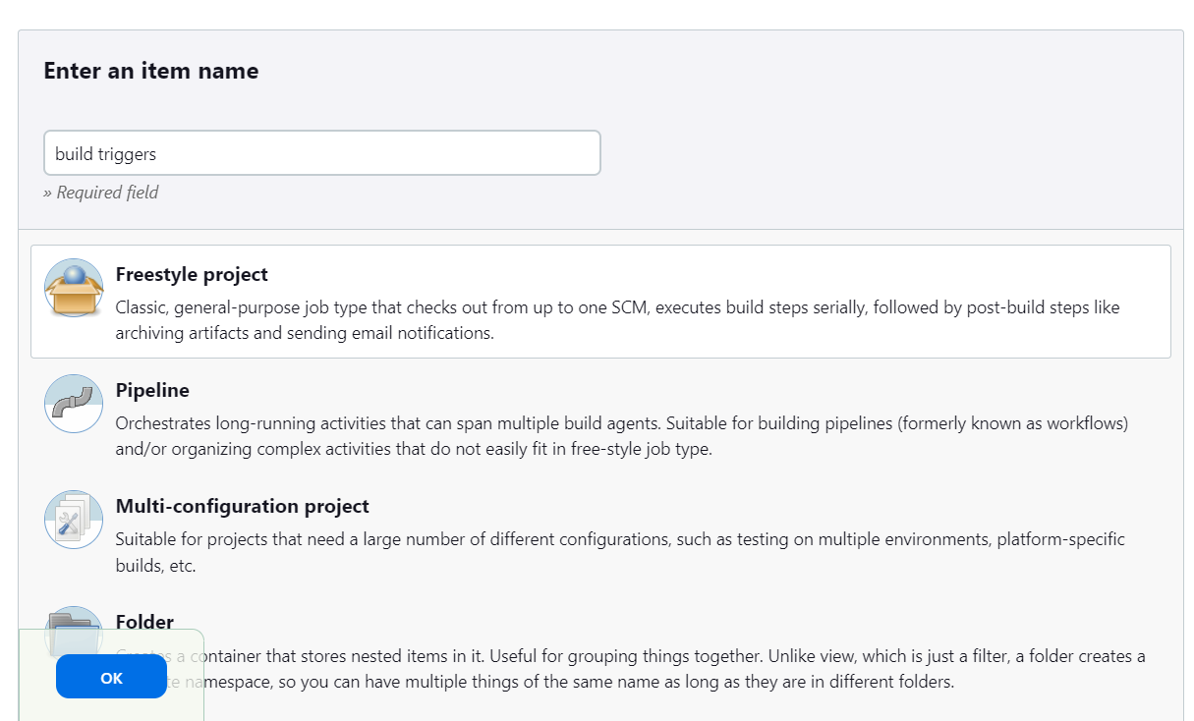

* Now select the option **Restrict where the project can be run** select the Slave-4 node which we created.

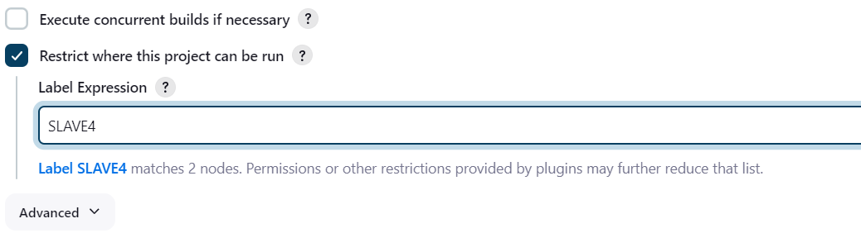

* Now in build triggers select **build periodically** option and give timing as

**\* * * * \*** means every minute every hour every day & month of the year.



* Here we write the bash-script in the execute shell.



* After completion save the job and tap on build it will be success, here is the console output.

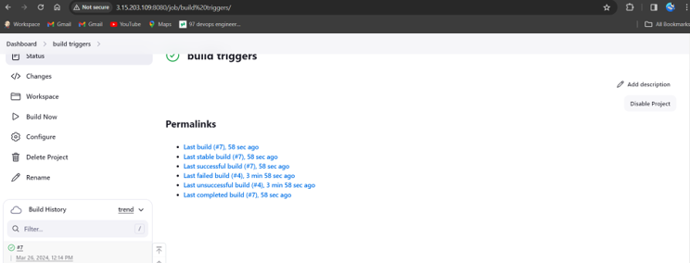

* After success go to AWS account copy the slave-4 pubic ip and browse.
* After browsing we will be directed to the official landing page of WORDPRESS.

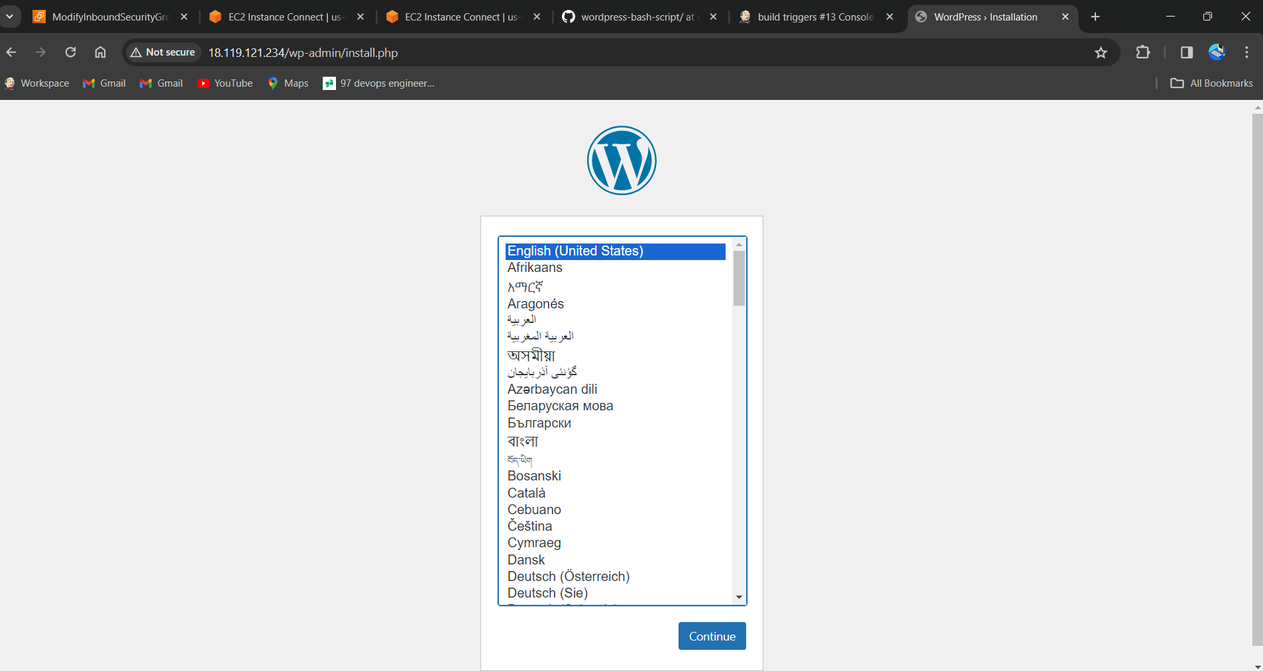

**POLL SCM**

* Now in build triggers select poll scm option and give timing as **\* * * * \*** means every minute every hour every day & month of the year.



* Save it now in github make a change in any of the file or create a dummy file It will automatically trigger and build the job directly.

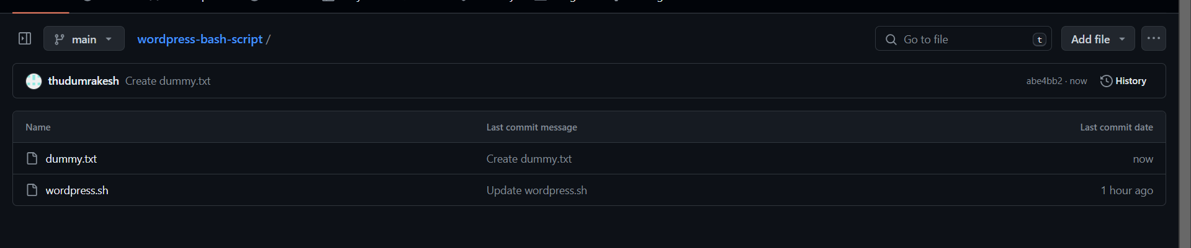

* It has same console output and same public IP to browse.

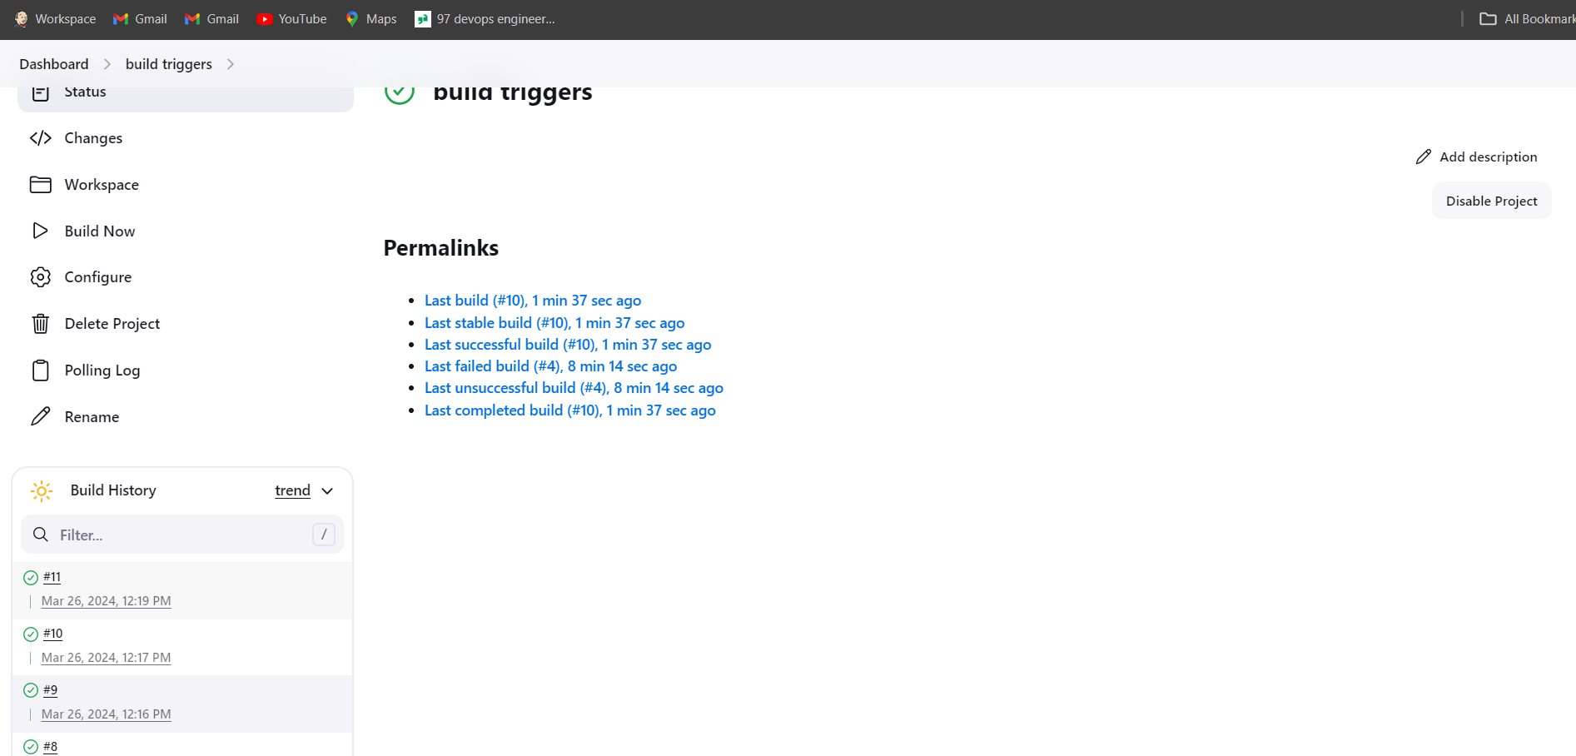



**WEBHOOK**

* Now in build triggers select GitHub hook trigger for Git scm polling
* .



* Go to GitHub and select the repository and go to settings there we will find webhooks option and give payload as Jenkins URL select it and add webhooks.

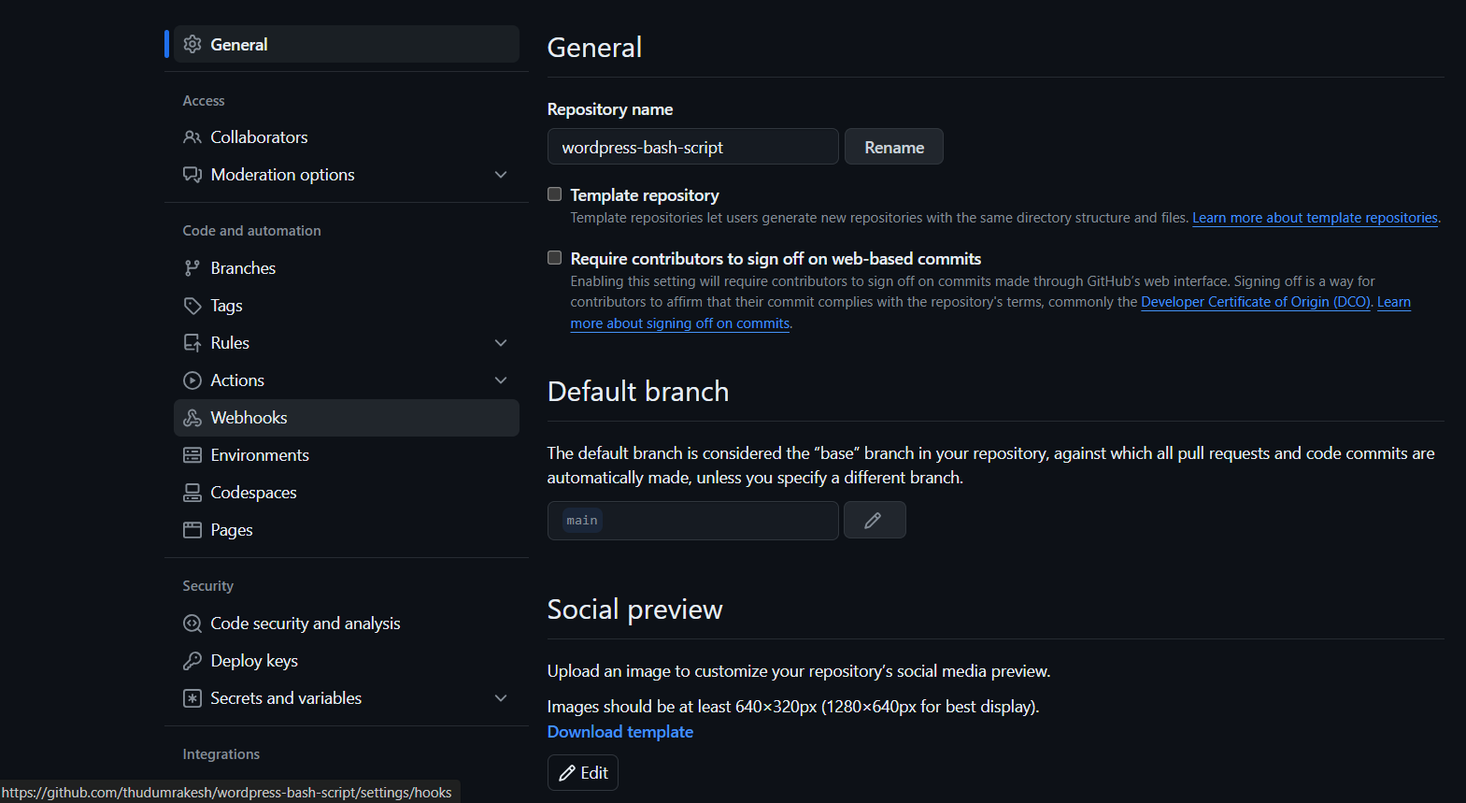

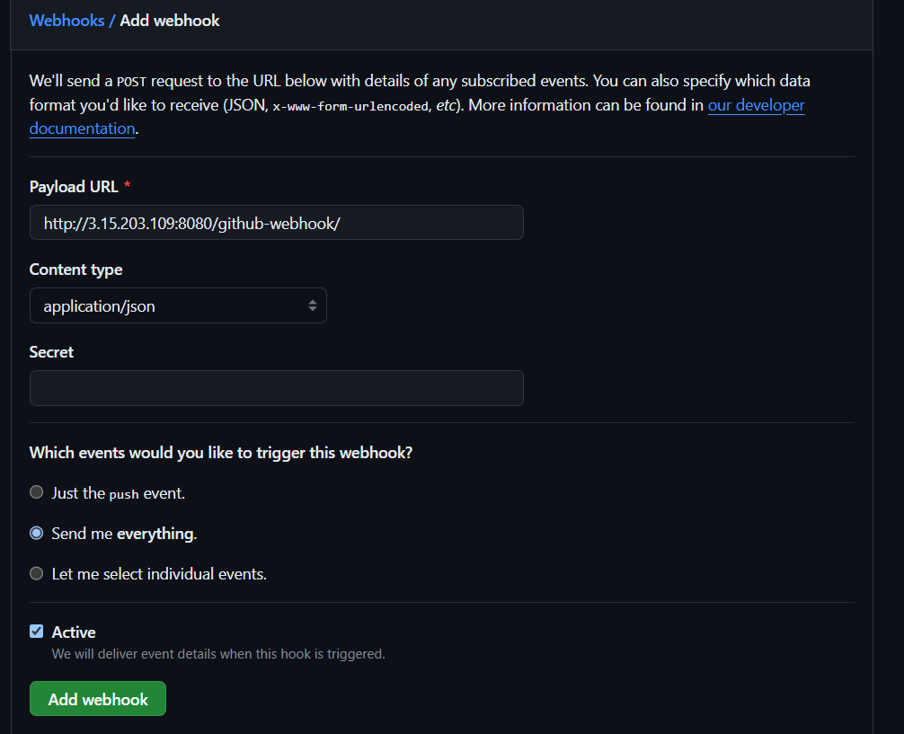

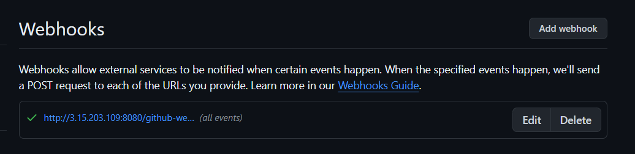

* Save it now in GitHub make a change in any of the file or remove a dummy file It will automatically trigger and build the job directly.
* It has same console output and same public IP to browse.

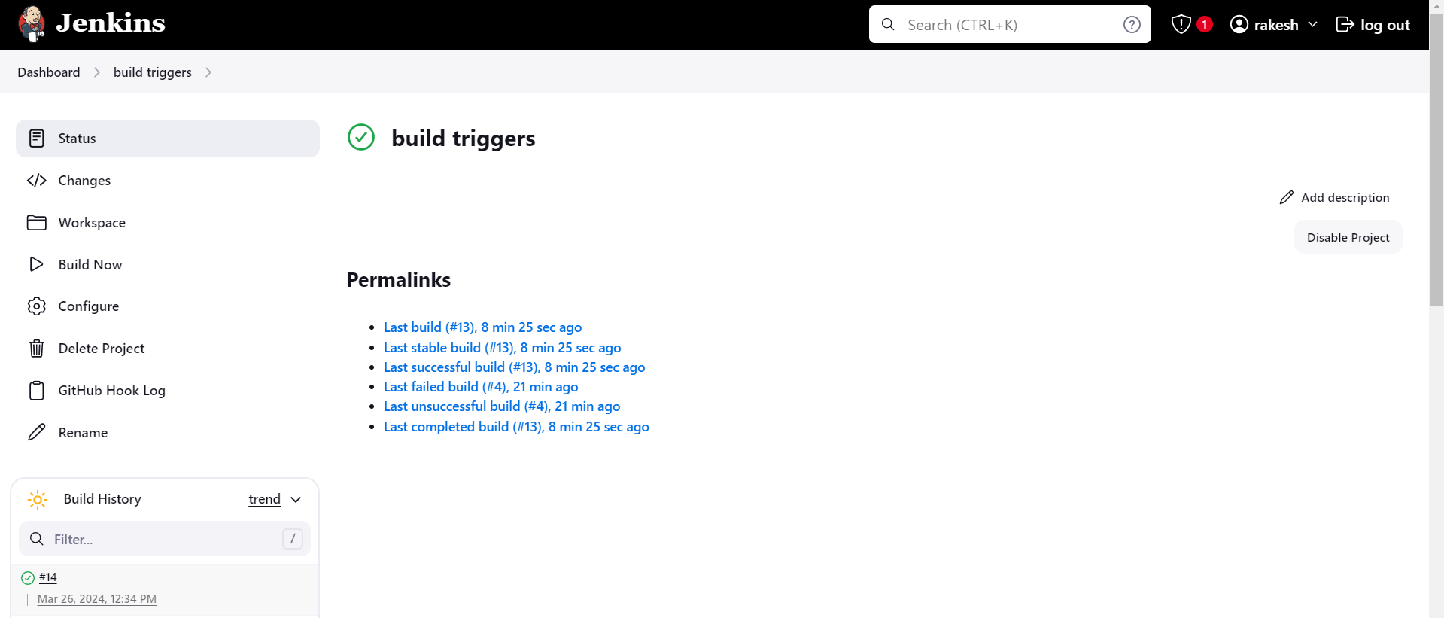

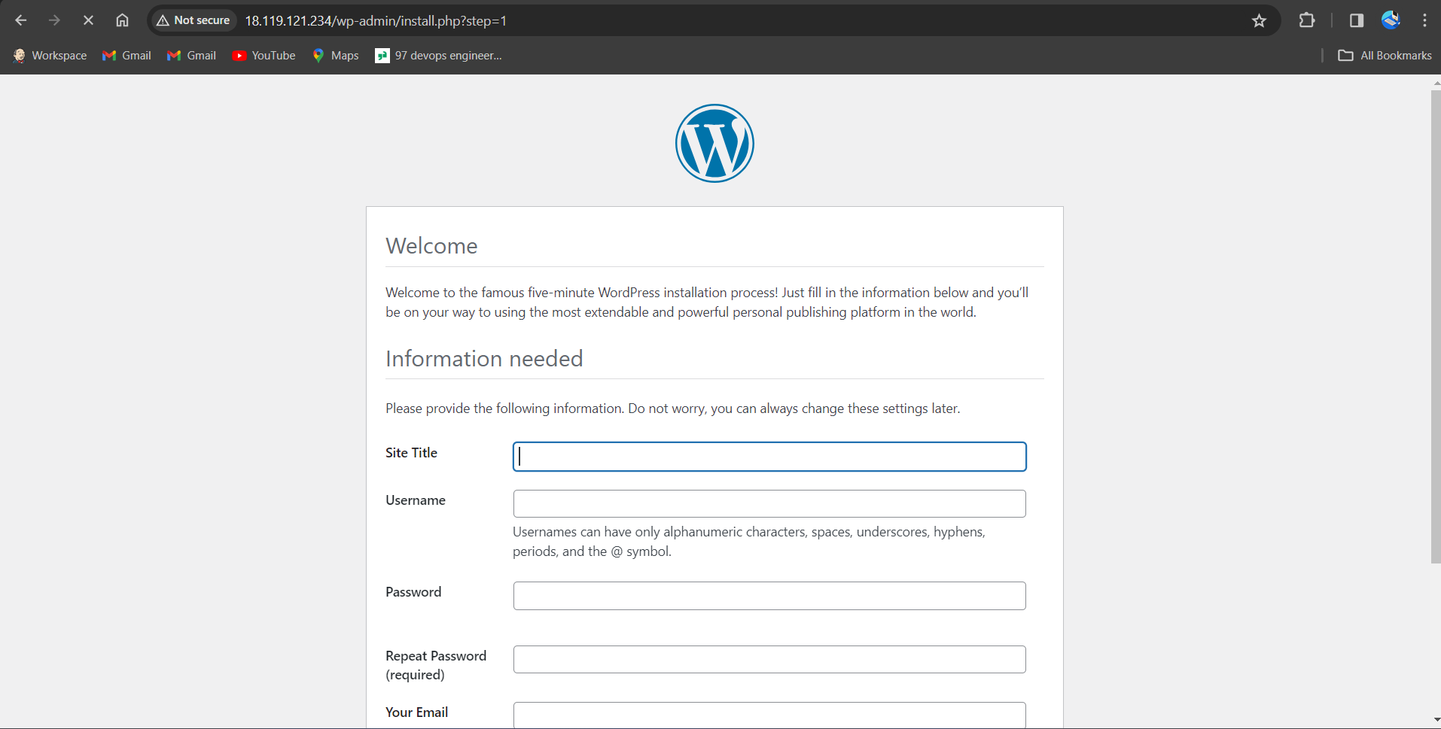

**Slave-5**

* Select new item > name the job > select freestyle projec
* Now select the option **Restrict where the project can be run** select the Slave-3 node which we created.

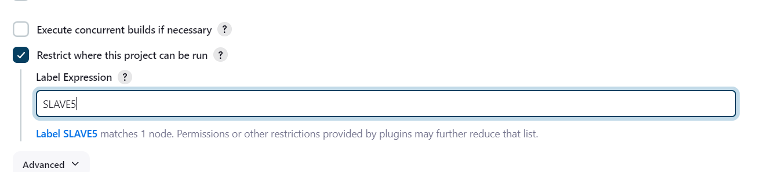

* Now in build steps give commands to install Kubernetes and kops,
* And create s3 bucket, configure the cluster details we want to create in one job.
* For that go to amazon console attach the IAM role which have admin access for Slave-5 instance.

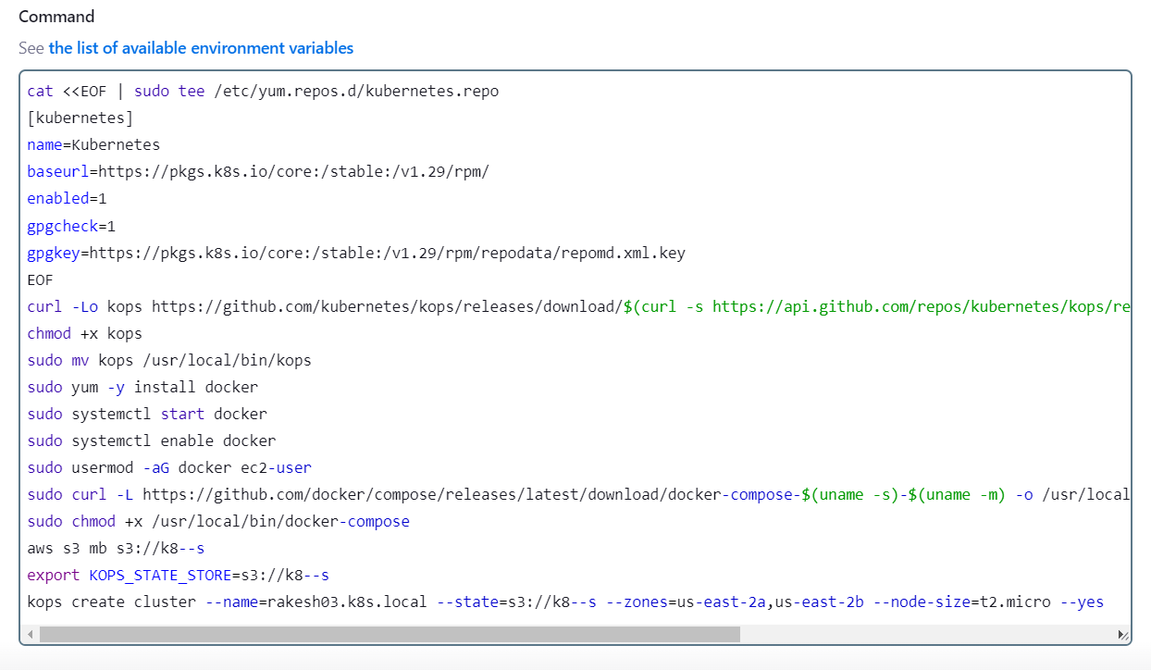

**save and build the job.**



* After EXECUTING the commands build the job and see the console output, and wait for the cluster creation it will take minimum of 10minutes.

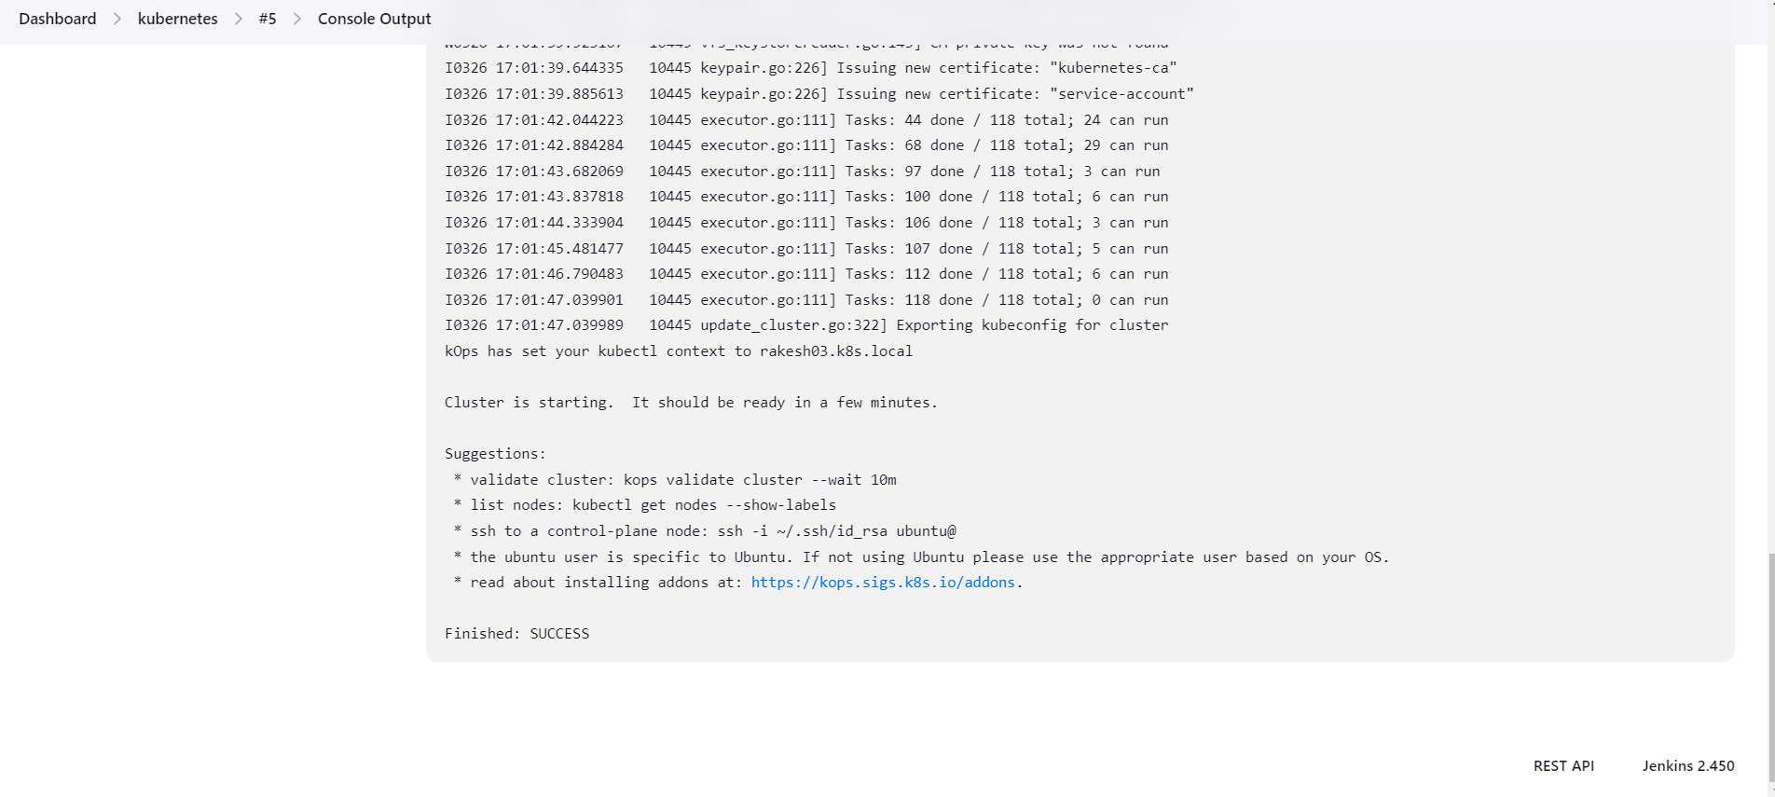

* Now create a new job for deployment unit and service layer and select the option **Restrict where the project can be run** select the Slave5 node which we created.

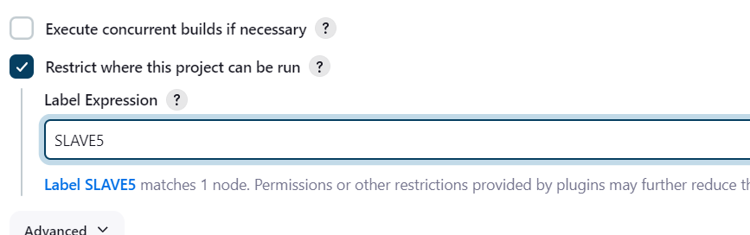

* In build steps select execute shell
* install git and git clone the repository of the deployment and service files, which is already created in our git-hub account

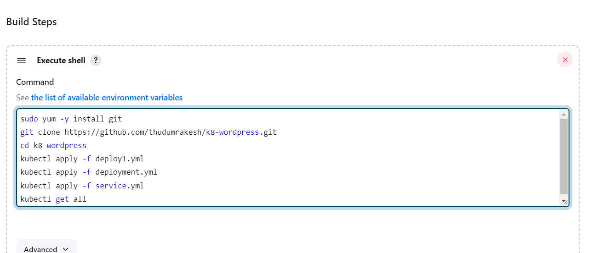

* After waiting of 10minutes build this job in which we gave **.yaml** files.
* Here is the successful installation and apply of deployment and service files.

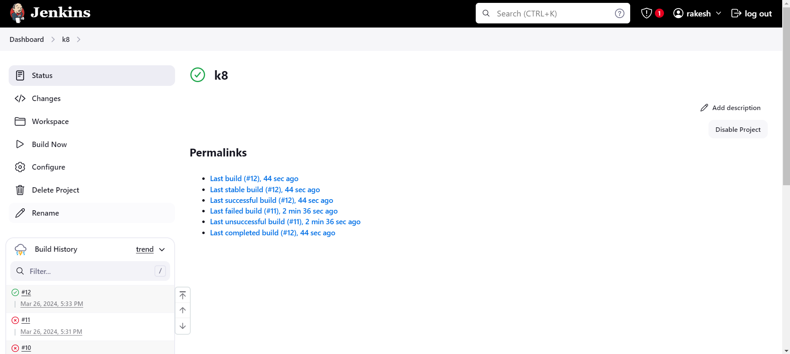

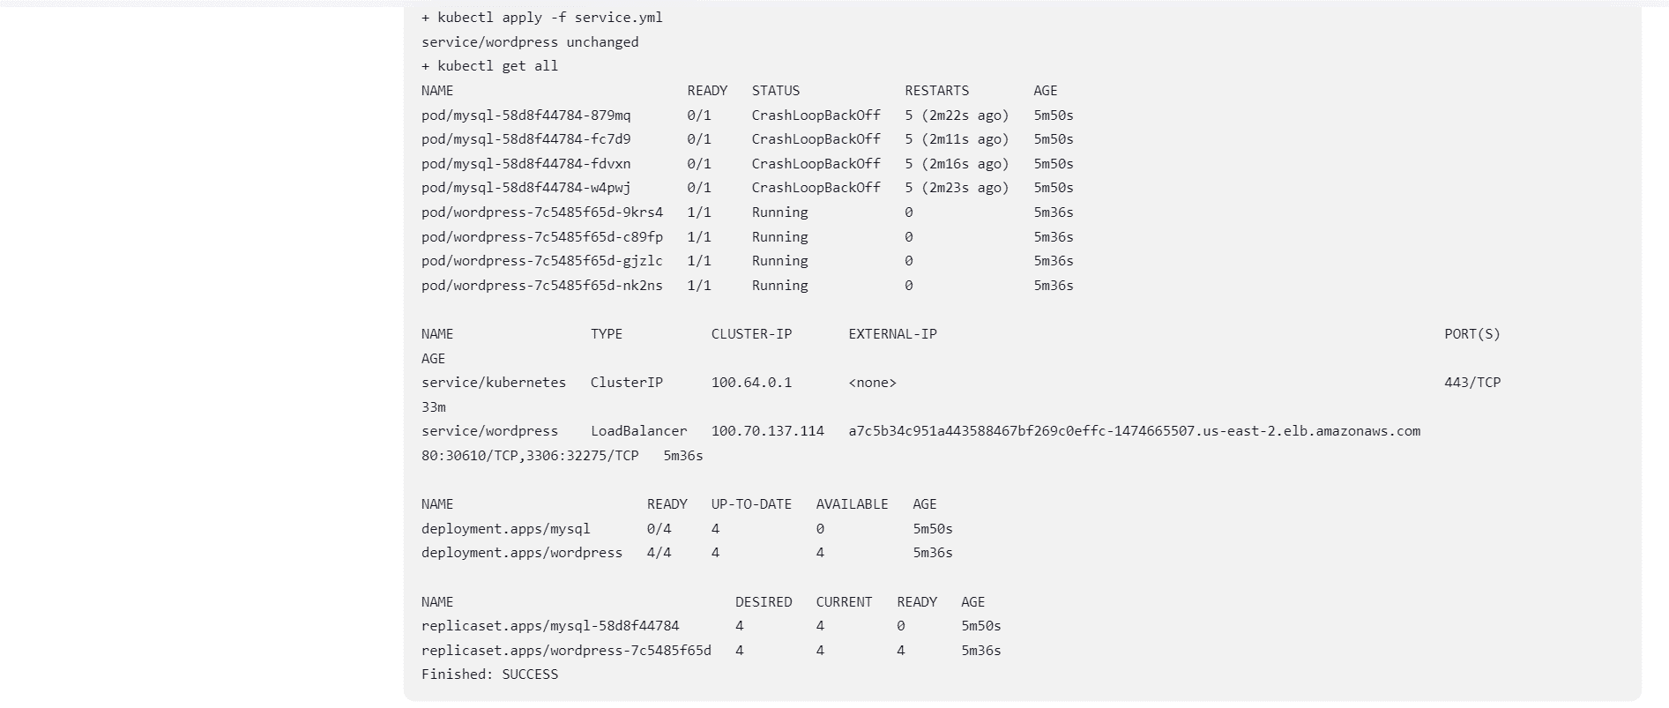

Method -6

VAMSI Create one master and Slave-5 and rakesh creates 1st and 2nd slave nodes in DIFFERENT AWS account and SAGAR creates 3rd and 4th slaves DIFFERENT AWS account and rakesh deploy word press with bash script(slave-1) and rakesh deploy word press with Docker Compose file (slave-2), and sagar deploy word press with Terraform (slave-3) and sagar deploy the word press with poll-scm, build periodically, webhooks (slave-4) and vamsi deploy the word press with k8’s (slave-5*).*

* Go to AWS console login with credentials, here we use 3 different accounts.
* Now create 6 instances (1Master, 5 Slaves ) in different accounts.
* **Vamsi** Create Master and 5th slave instances in **VAMSI** Account.
* **RAKESH** create 1st and 2nd slave instances in **RAKESH** Account.
* 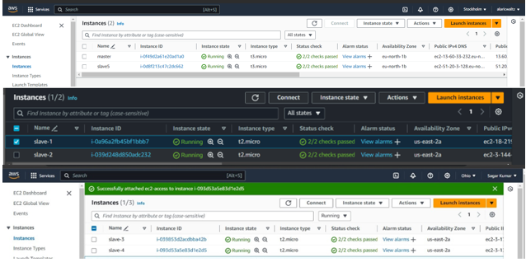 **SAGAR** create 3rd and 4th slave instances in **SAGAR** Account.
* Now connect the master instance to the CLI terminal.



* Change the name of the instance using commands as **sudo hostname master.**
* use the ssh-keygen for the security layer
  + After creation of ssh-keygen, it generates private and public keys. With the help of newly generated public key, make Master-Slave configuration.
* Before that install run time java into all the slave instances.
* Copy and paste the public key in slave instances at; cd .ssh/ 🡪 ls 🡪 sudo vi authorized­_keys



*****FOR SLAVE-5 in vamsi account*

*FOR SLAVE-1,2 in rakesh account*

*FOR SLAVE-3,4 in sagar account*

* Now install Jenkins in master server instance
* **sudo wget -O /etc/yum.repos.d/jenkins.repo \**

**https://pkg.jenkins.io/redhat-stable/jenkins.repo**

* **sudo rpm --import https://pkg.jenkins.io/redhat-stable/jenkins.io-2023.key**
* **sudo yum -y upgrade**
* **sudo yum install fontconfig java-17* -y**
* **sudo yum -y install jenkins**
* **sudo systemctl daemon-reload**
* **sudo systemctl start jenkins**
* **sudo systemctl enable jenkins**
* **sudo systemctl status Jenkins**
* Now copy the key and paste it in Jenkins to unlock page.
* **I (VAMSI) gave my master public-IP address and jenkins credentials to RAKESH and SAGAR**
* **They login into vamsi’s Jenkins account.**
* Now, copy paste the public IP address along with port 8080 and unlock Jenkins with admin password.
* Now, make master-slave configuration by creating worker nodes in Jenkins.
* Jenkins 🡪 manage Jenkins 🡪 Nodes
* Here, **RAKESH** creates slave1, slave2 nodes in **VAMSI’S** Jenkins account
* **SAGAR** creates slave3,4 nodes in **VAMSI’S** Jenkins account
* Slave5 node was created by **VAMSI(master)**
* Now search for option add new node for the slave servers.

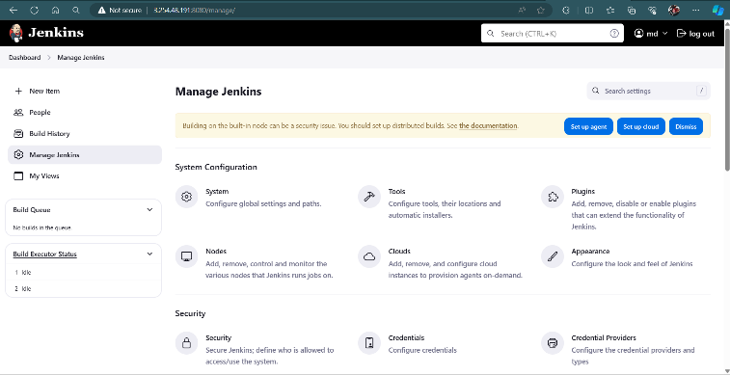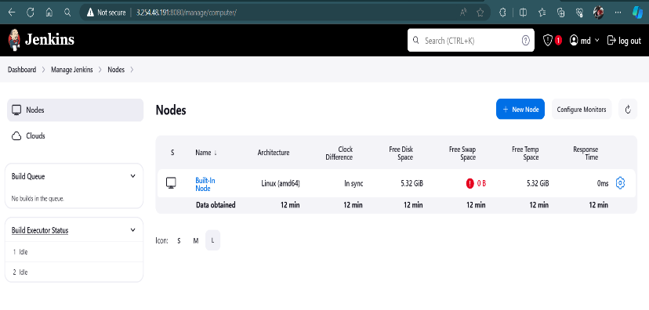

* Now create 5 slave nodes and name them as **Slave1, Slave2, Slave3, Slave4, Slave5.**
* Select the type as Permanent Agent.
* Now name the node, select the no of executors , Remote root directory as **/home/ec2-user¸**now label as name of the server , usage as much as possible, launch method as **via SSH**, host as **private ip of the instance,** in credentials add **id_rsa** name it , host key as **manually trusted key verification strategy,** availability **as online as much as possible** and save it .
* As we are dealing with 3 different accounts give host as required.
* **1st and 2nd slave public ip’s from rakesh account.**
* **3rd and 4th slave public ip’s from sagar account.**
* **5th slave private ip’s from Karthik account.**

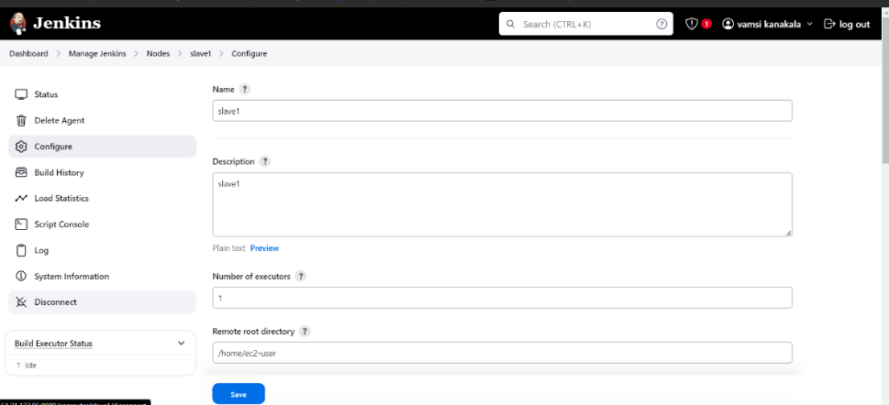**Slave-1,2 node(Rakesh Account)**

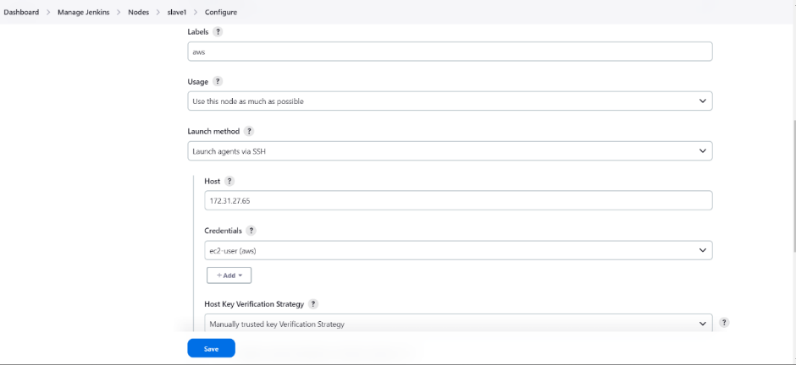

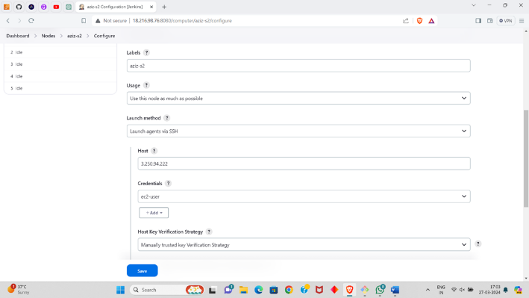

**Slave-3,4 node (Sagar Account)**

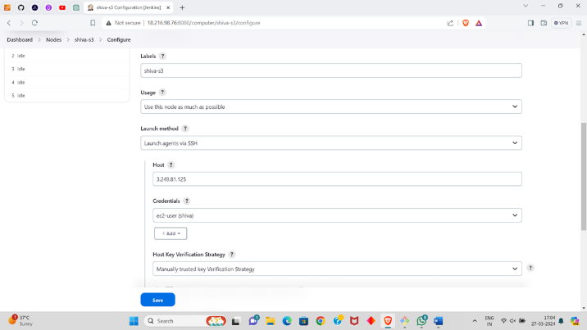

**Slave-5 node (vamsi account)**



* Now check the created nodes in dashboard.
* Here we can connect only one account private ip using master private key , to connect another account ip we must add the other account private key in our credentials.



* Now create job for the slave servers and name them as **Slave-1, Slave-2, Slave-3, Slave-4, Slave-5.**
* jobs we create in slaves are
* **Slave-1** = deploy word press with bash script by **rakesh**
* **Slave-2** = deploy word press with Docker Compose file BY **RAKESH**
* **Slave-3** = deploy word press with Terraform BY **SAGAR**
* **Slave-4** = deploy the word press with poll-scm, build periodically, webhooks BY **SAGAR**
* **Slave-5** = deploy the word press with k8’s BY **VAMSI**

**SLAVE-1 (RAKESH in VAMSI Account)**

* Select new item > name the job > select freestyle project

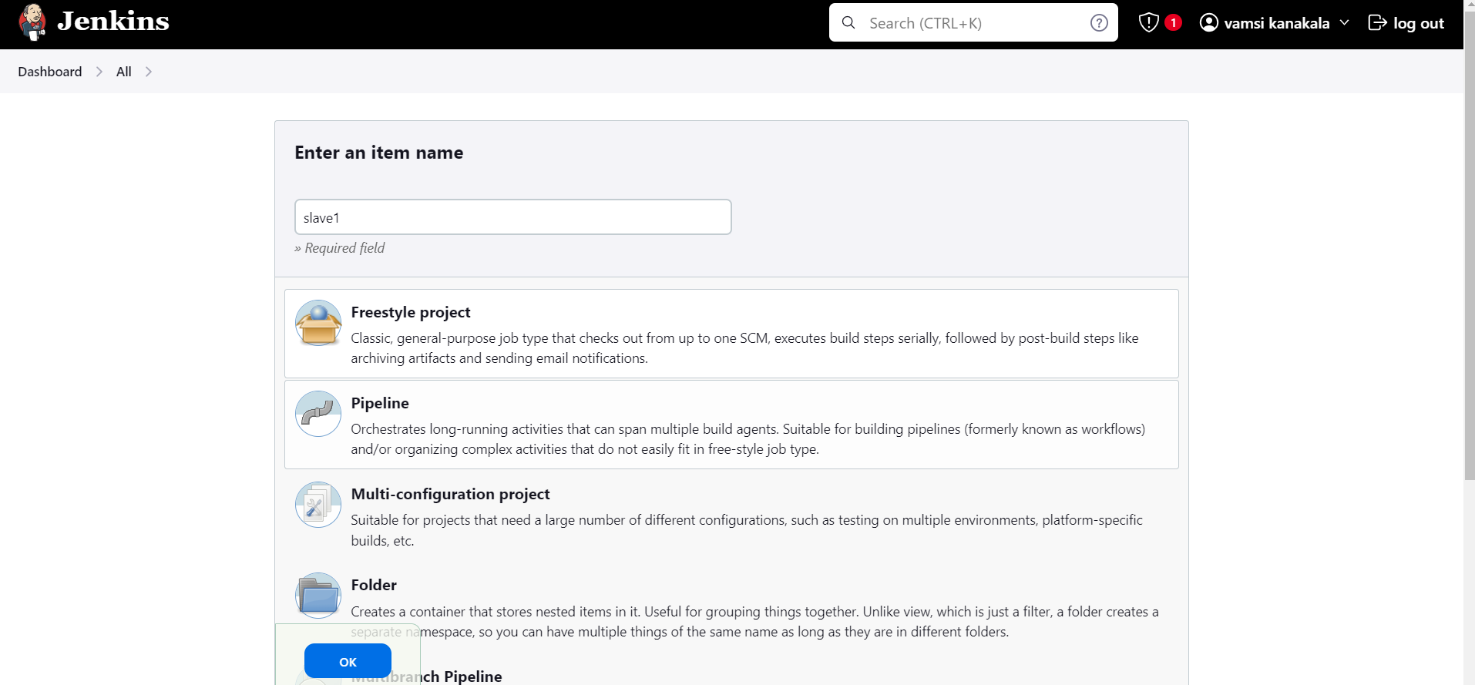

* Now select the option **Restrict where the project can be run** select the Slave-1 node which we created.

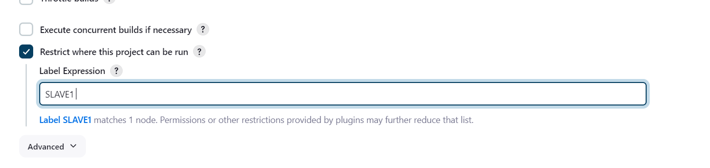

* Here we wrote the bash-script and pushed it into the git-hub account manually so pull the git repo and execute the script.

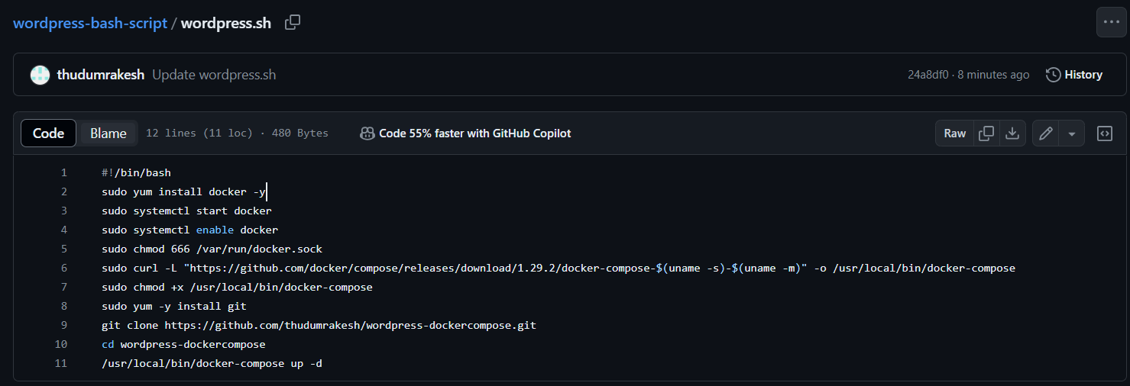

* Now in build steps give commands to install git and clone git , 777 permissions to .sh file and execution command for .sh file.

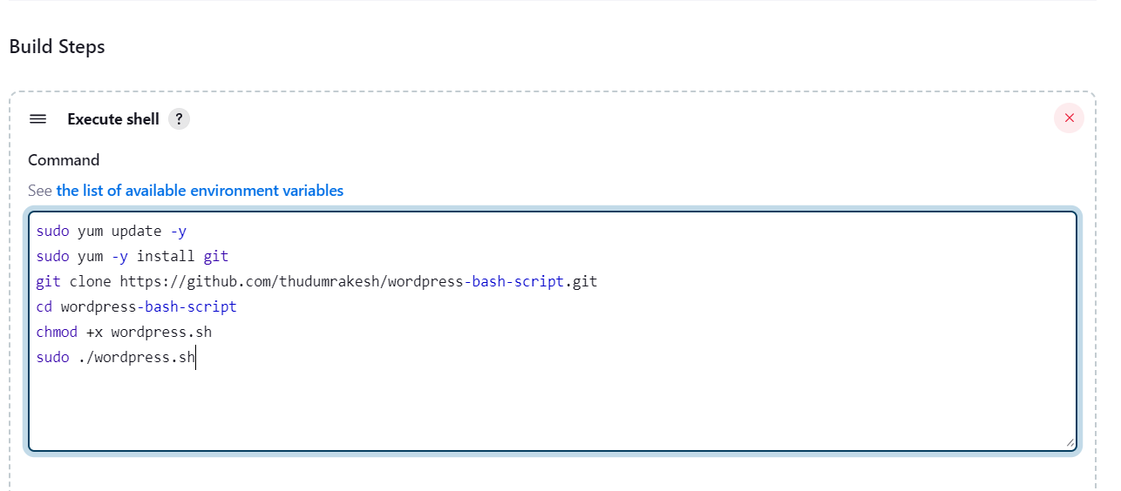

* After completion save the job and tap on build it will be success , here is the console output.

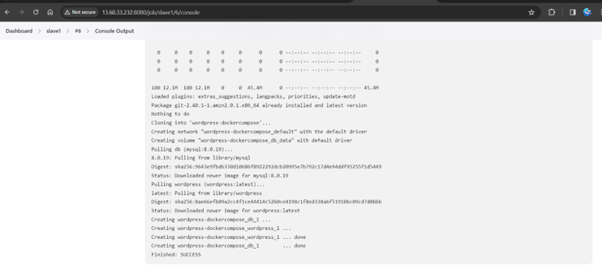

* After success go to AWS account copy the slave pubic ip from RAKESH account and browse.
* After browsing we will be directed to the official landing page of WORDPRESS.

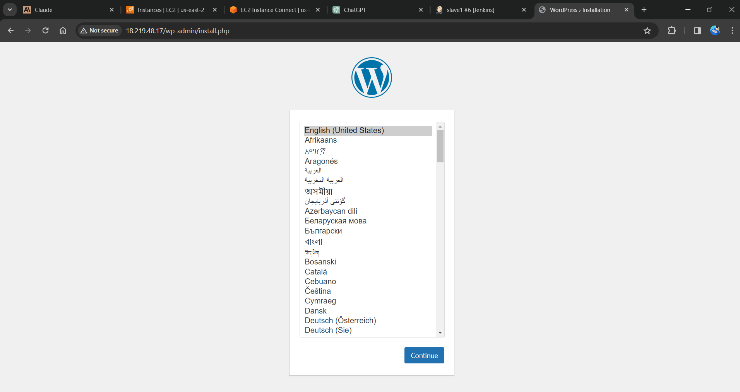

**SLAVE-2 (RAKESH in VAMSI Account)**

* Select new item > name the job > select freestyle project
* Now select the option **Restrict where the project can be run** select the Slave-2 node which we created.

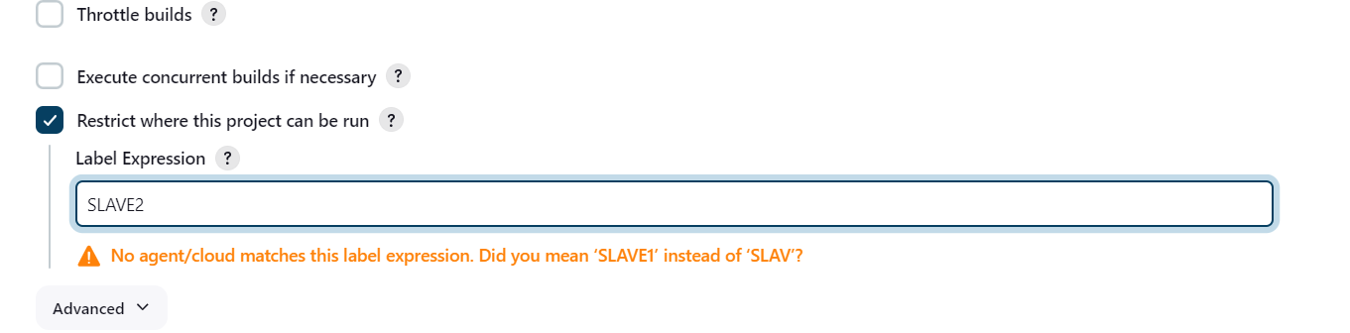

* Here we write the bash-script in the execute shell.

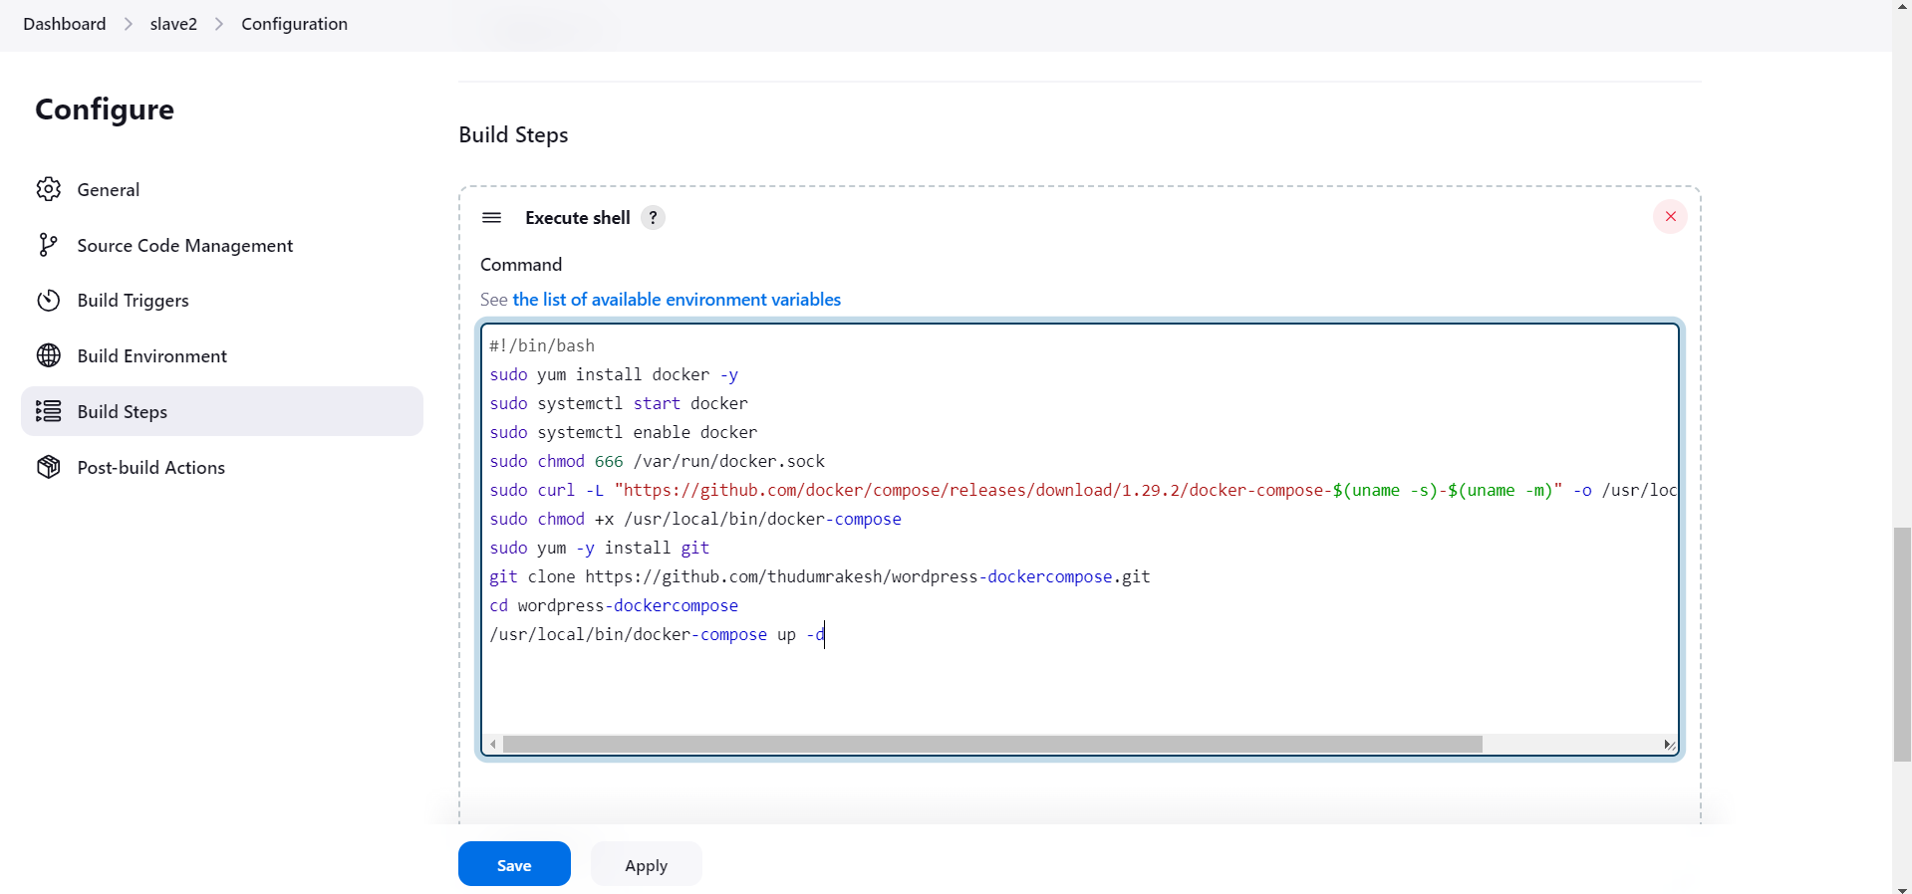

* After completion save the job and tap on build it will be success , here is the console output.

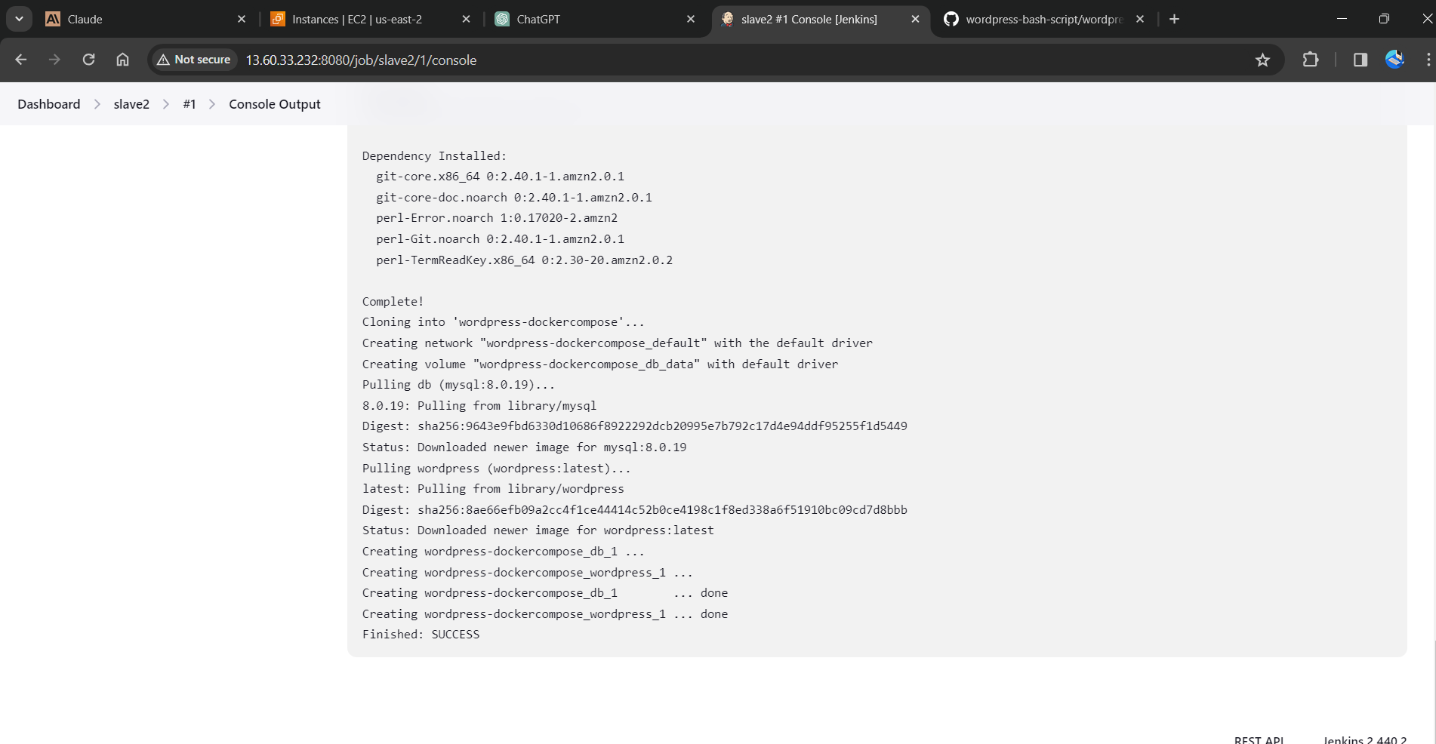

* After success go to AWS account copy the slave pubic ip from RAKESH account and browse.
* After browsing we will be directed to the official landing page of WORDPRESS

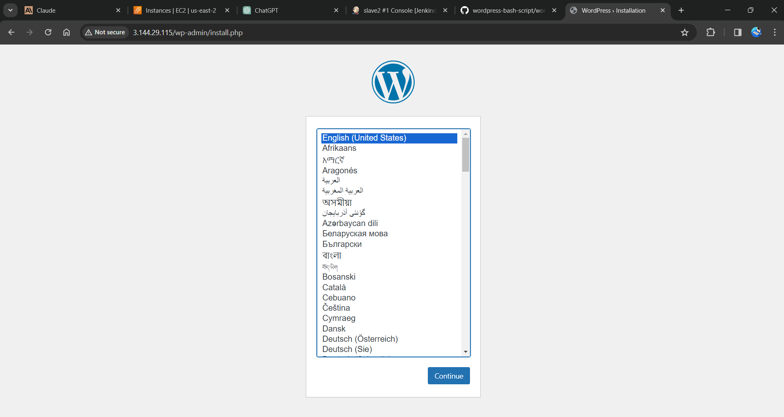

**SLAVE-3 (SAGAR in VAMSI Account)**

* Select new item > name the job > select freestyle project
* Now select the option **Restrict where the project can be run** select the Slave-3 node which we created.

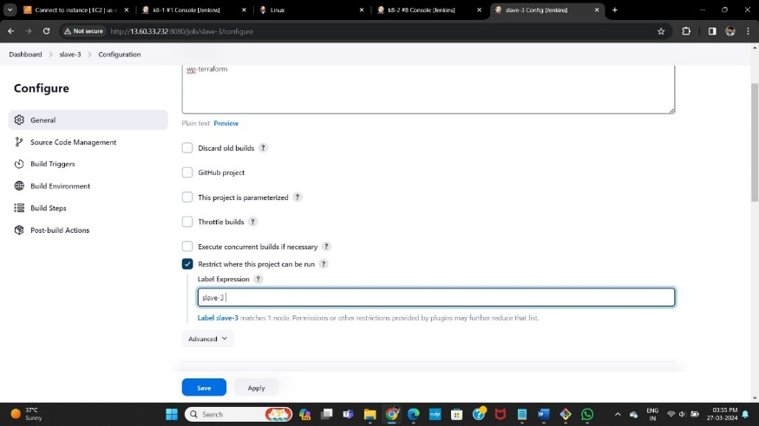

* Here we write the script and execute commands of terraform in the execute shell.

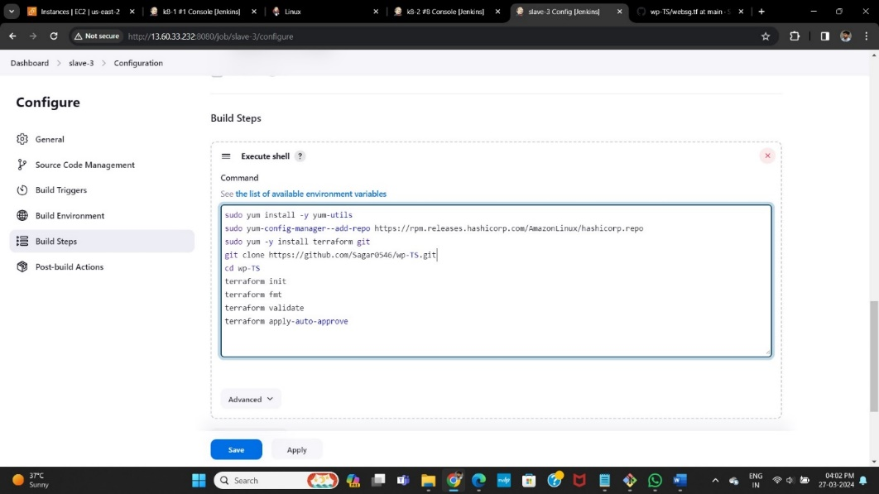

* After completion save the job and tap on build it will be success, here is the console output.

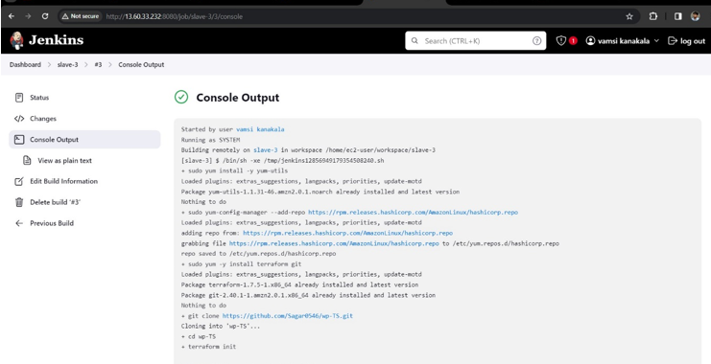

* After success go to AWS account copy the new created pubic ip from SAGAR account or copy it from the console output page and browse.
* After browsing we will be directed to the official landing page of WORDPRESS.

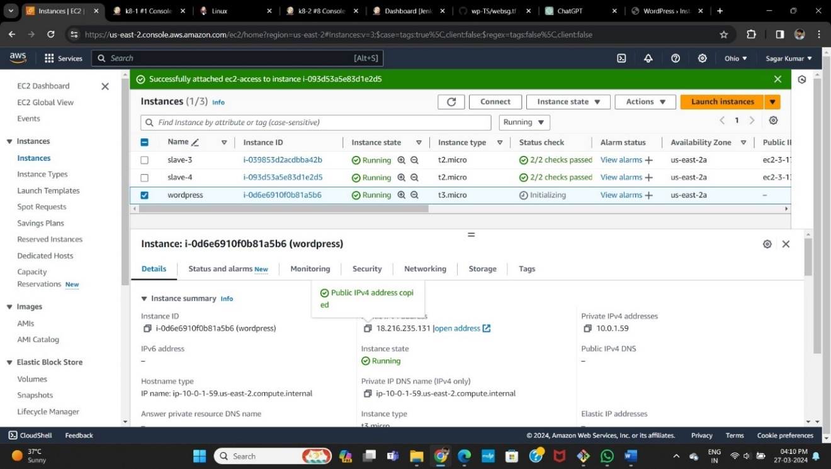

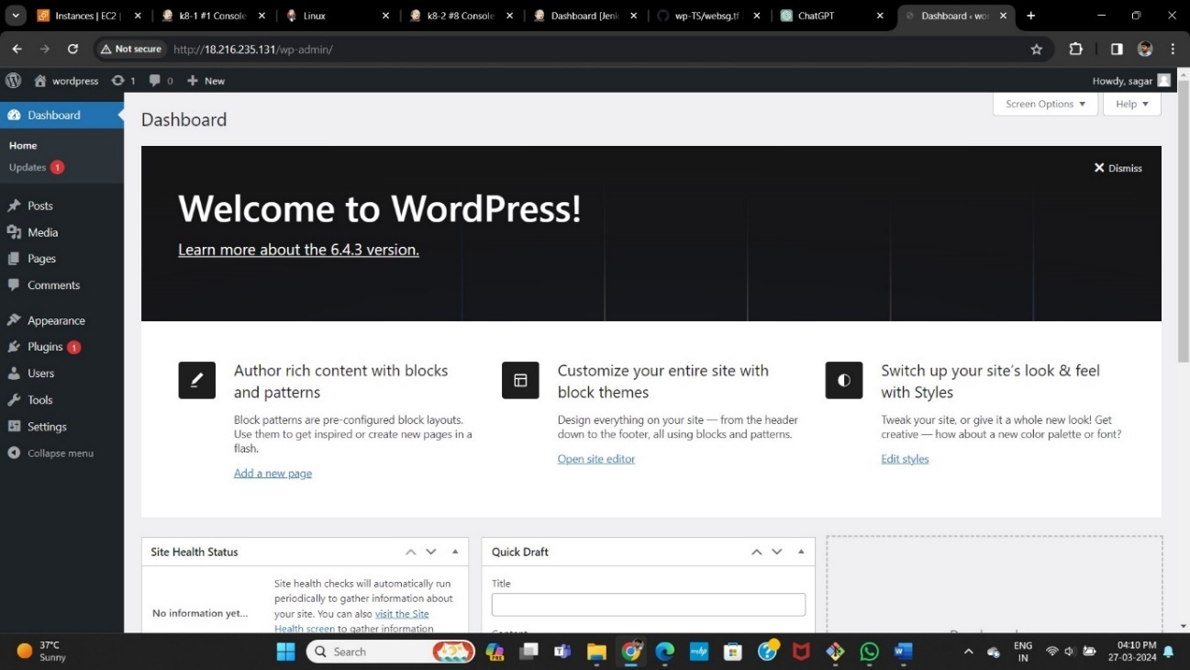

**SLAVE-4 (SAGAR in VAMSI Account)**

* Select new item > name the job > select freestyle project
* Now select the option **Restrict where the project can be run** select the Slave-3 node which we created.

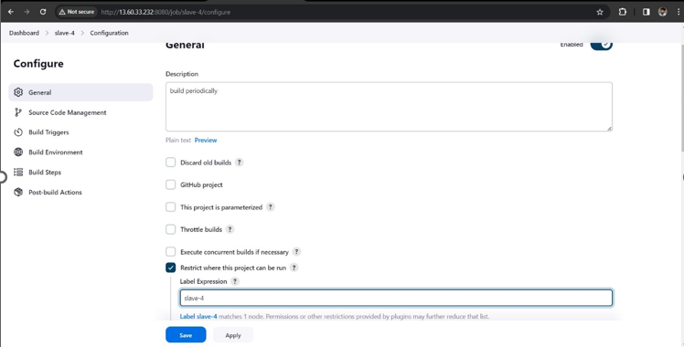

* Now in build triggers select **build periodically** option and give timing as

**\* * * * \*** means every minute every hour every day & month of the year.



* Here we write the bash-script in the execute shell.

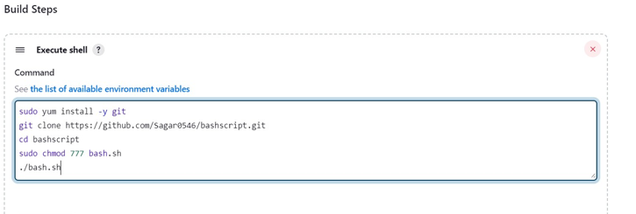

* After completion save the job and tap on build it will be success, here is the console output.

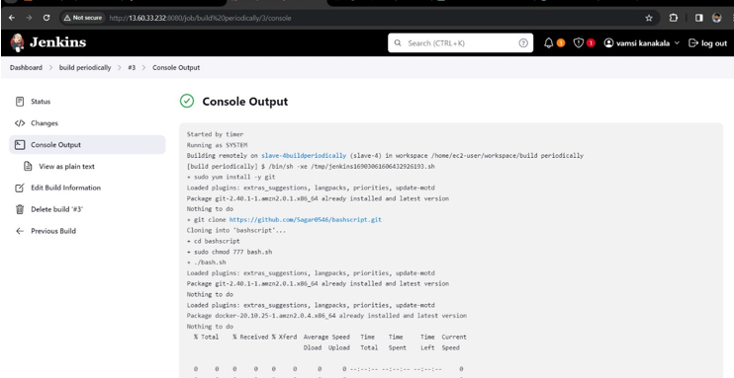

* After success go to AWS account copy the slave pubic ip from SAGAR account and browse.
* After browsing we will be directed to the official landing page of WORDPRESS.

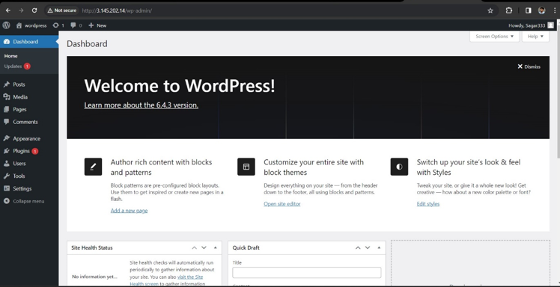

**POLL SCM**

* Now in build triggers select poll scm option and give timing as **\* * * * \*** means every minute every hour every day & month of the year.
* Save it now in github make a change in any of the file or create a dummy file It will automatically trigger and build the job directly.



* It has same console output and same public ip from SAGAR account and browse.



Webhooks

* Now in build triggers select github hook trigger for GITScm polling.



* Now add webhook give our **master public ip/github-webhook** and save it.

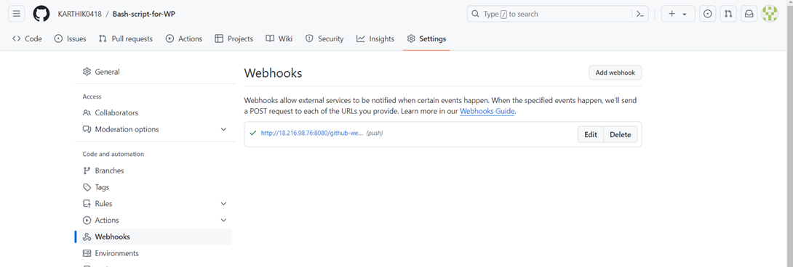

* Save it now in github make a change in any of the file or remove a dummy file It will automatically trigger and build the job directly.

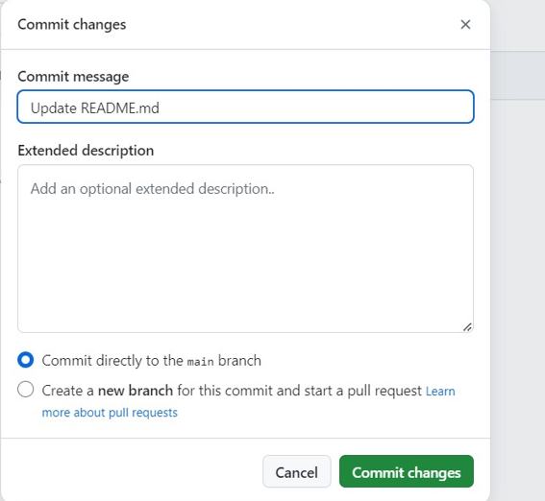

* It has same console output and same public ip from SAGAR Account browse





**Slave-5 (VAMSI IN VAMSI Account)**

* Select new item > name the job > select freestyle project
* Now select the option **Restrict where the project can be run** select the Slave-3 node which we created.

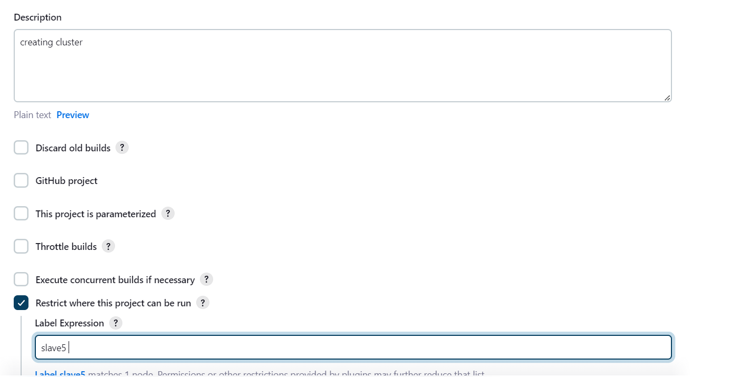

* Now in build steps give commands to install Kubernetes and kops,

And create s3 bucket, configure the cluster details we want to create in one job.

* For that go to amazon console attach the IAM role which have admin access for Slave-5 instance.



**save and build the job.**

After EXECUTING the commands build the job and see the console output, and wait for the cluster creation it will take minimum of 10minutes



* Now create a new job for deployment unit and service layer and select the option **Restrict where the project can be run** select the Slave5 node which we created.

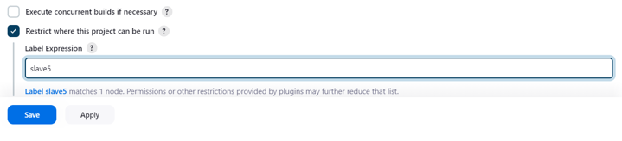

* In build steps select execute shell
* install git and git clone the repository of the deployment and service files, which is already created in our git-hub account.



* After waiting of 10minutes build this job in which we gave **.yaml** files.
* Here is the successful installation and apply of deployment and service files.





Method -7

SAGAR Create one master and Slave-5 and creates 1st and 2nd slave nodes in DIFFERENT AWS account and creates 3rd and 4th slaves DIFFERENT AWS account and VAMSIdeploy word press with bash script(slave-1) and VAMSIdeploy word press with Docker Compose file (slave-2), and rakesh deploy word press with Terraform (slave-3) and rakesh deploy the word press with poll-scm, build periodically, webhooks (slave-4) and SAGAR deploy the word press with k8’s (slave-5*).*

* Go to AWS console login with credentials, here we use 3 different accounts.
* Now create 6 instances (1Master, 5 Slaves ) in different accounts.
* **SAGAR** Create Master and 5th slave instances in **SAGAR** Account.
* **Vamsi** create 1st and 2nd slave instances in **Vamsi** Account.
* 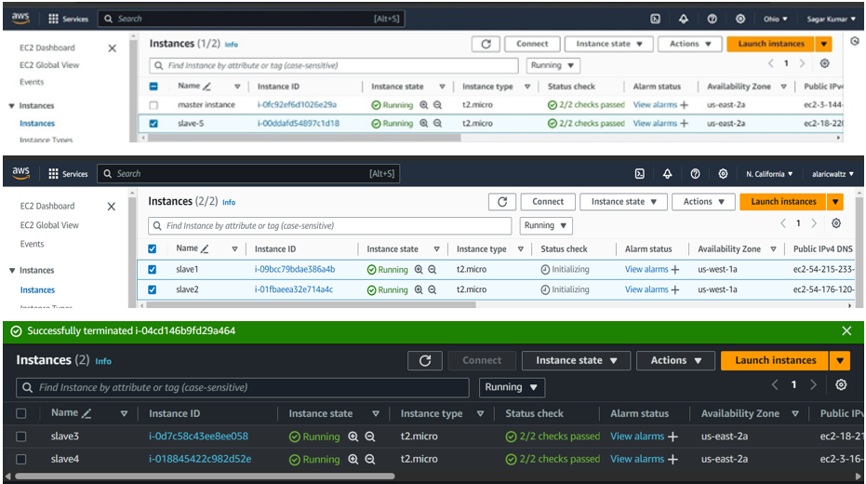**RAKESH** create 3rd and 4th slave instances in **RAKESH** Account.
* Now connect the master instance to the CLI terminal.
* Change the name of the instance using commands as **sudo hostname master.**
* use the ssh-keygen for the security layer
  + After creation of ssh-keygen, it generates private and public keys. With the help of newly generated public key, make Master-Slave configuration.
* Before that install run time java into all the slave instances.
* Copy and paste the public key in slave instances at; cd .ssh/ 🡪 ls 🡪 sudo vi authorized­_keys



FOR SLAVE-5 in sagar account

****FOR SLAVE-1,2 in vamsi account

FOR SLAVE-3,4 in rakesh account

* Now install Jenkins in master server instance
* **sudo wget -O /etc/yum.repos.d/jenkins.repo \**

**https://pkg.jenkins.io/redhat-stable/jenkins.repo**

* **sudo rpm --import https://pkg.jenkins.io/redhat-stable/jenkins.io-2023.key**
* **sudo yum -y upgrade**
* **sudo yum install fontconfig java-17* -y**
* **sudo yum -y install jenkins**
* **sudo systemctl daemon-reload**
* **sudo systemctl start jenkins**
* **sudo systemctl enable jenkins**
* **sudo systemctl status Jenkins**
* Now copy the key and paste it in Jenkins to unlock page.
* **I SAGAR) gave my master public-IP address and jenkins credentials to VAMSI and RAKESH**
* **They login into SAGAR’S Jenkins account.**
* Now, copy paste the public IP address along with port 8080 and unlock Jenkins with admin password.
* Now, make master-slave configuration by creating worker nodes in Jenkins.
* Jenkins 🡪 manage Jenkins 🡪 Nodes
* Here, **VAMSI** creates slave1, slave2 nodes in **SAGAR’S** Jenkins account
* **RAKESH** creates slave3,4 nodes in **I’S** Jenkins account
* Slave5 node was created by **SAGAR(master)**
* Now search for option add new node for the slave servers.



* Now create 5 slave nodes and name them as **Slave1, Slave2, Slave3, Slave4, Slave5.**
* Select the type as Permanent Agent.
* Now name the node, select the no of executors , Remote root directory as **/home/ec2-user¸**now label as name of the server , usage as much as possible, launch method as **via SSH**, host as **private ip of the instance,** in credentials add **id_rsa** name it , host key as **manually trusted key verification strategy,** availability **as online as much as possible** and save it .
* As we are dealing with 3 different accounts give host as required.
* **1st and 2nd slave public ip’s from VAMSIaccount.**
* **3rd and 4th slave public ip’s from RAKESH account.**
* **5th slave private ip’s from SAGAR’S account.**
* **Slave-1,2 node(VAMSI Account)**
* Jenkins 🡪 manage Jenkins 🡪 Nodes

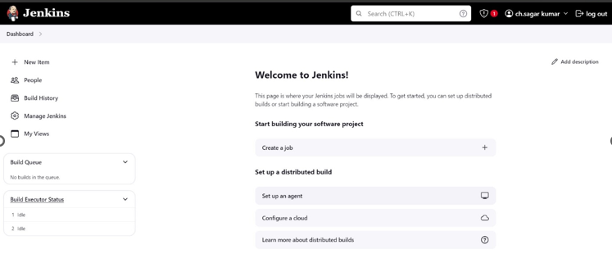

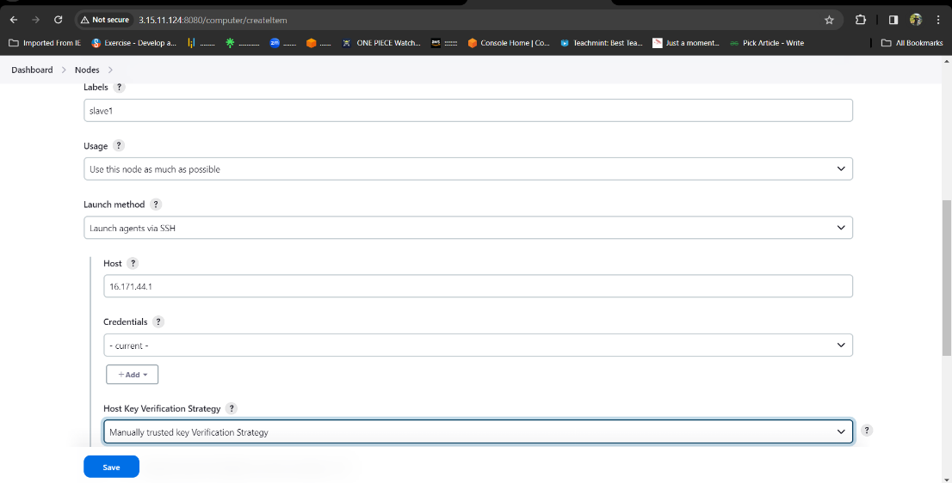

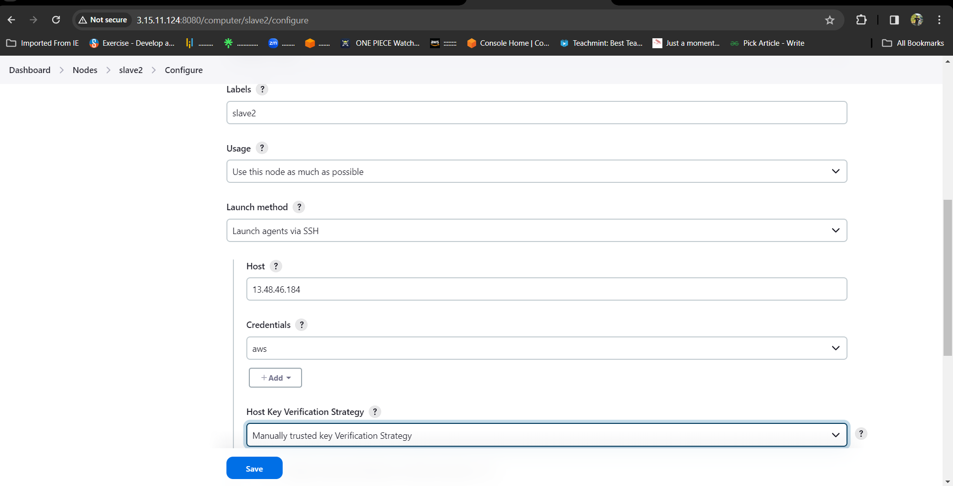

**Slave-3,4 node (Rakesh Account)**



 **Slave-5 node (Sagar Account)**

* Now check the created nodes in dashboard.
* Here we can connect only one account private ip using master private key , to connect another account ip we must add the other account private key in our credentials.

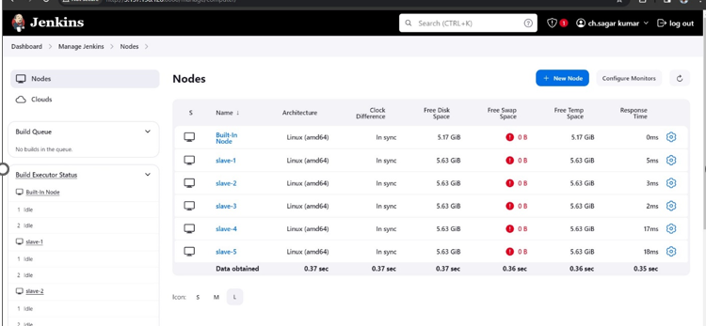

* Maser-Slave configuration is successful and all the servers are online.
* Now create job for the slave servers and name them as **Slave1, Slave2, Slave3, Slave4, Slave5.**
* jobs we create in slaves are
* **Slave-1** = deploy word press with bash script by **VAMSI**
* **Slave-2** = deploy word press with Docker Compose file BY **VAMSI**
* **Slave-3** = deploy word press with Terraform BY **RAKESH**
* **Slave-4** = deploy the word press with poll-scm, build periodically, webhooks BY **RAKESH**
* **Slave-5** = deploy the word press with k8’s BY **SAGAR**

**SLAVE-1 (VAMSI in SAGAR Account)**

* Select new item > name the job > select freestyle project
* Now select the option **Restrict where the project can be run** select the Slave-1 node which we created.

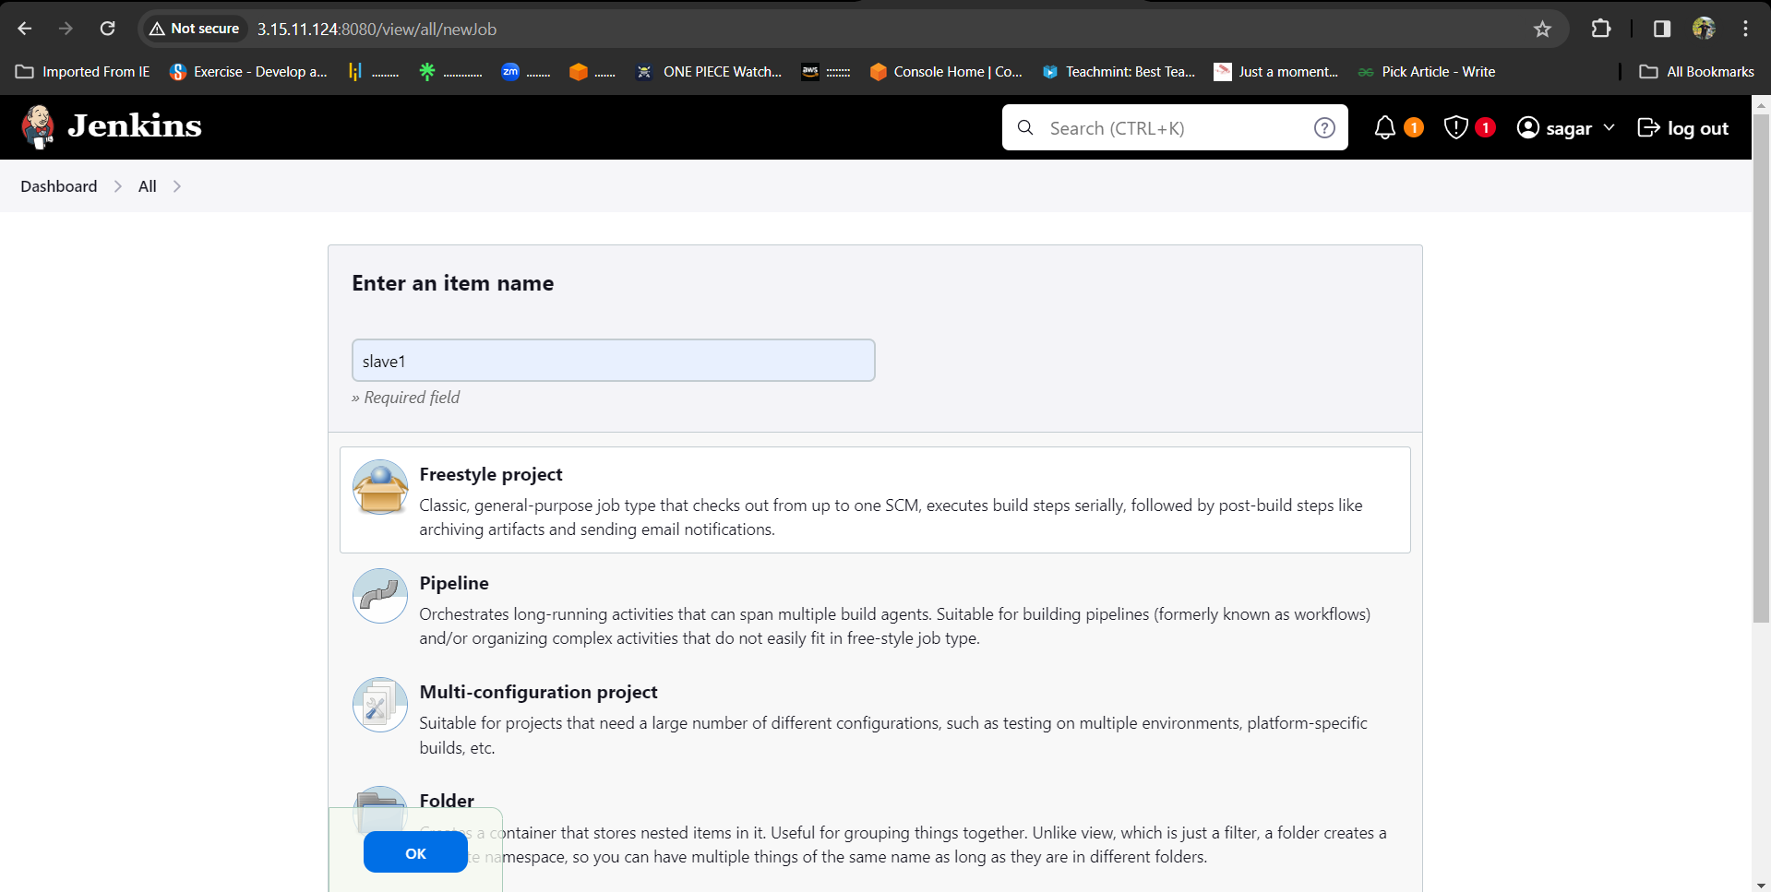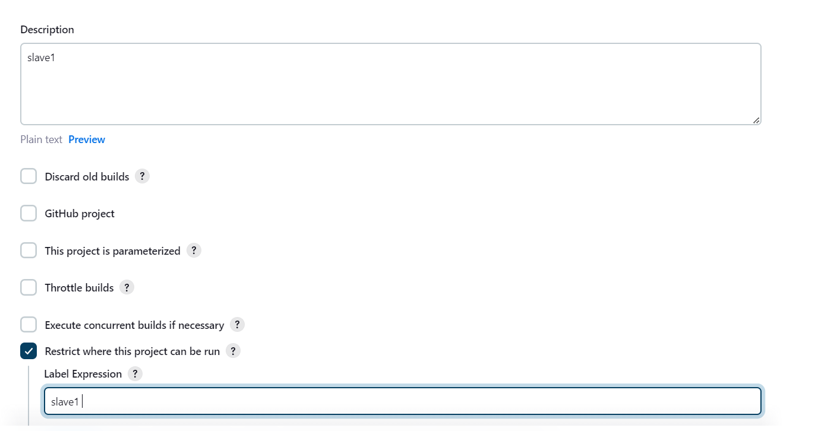

* Here we wrote the bash-script and pushed it into the git-hub account manually so pull the git repo and execute the script.



* 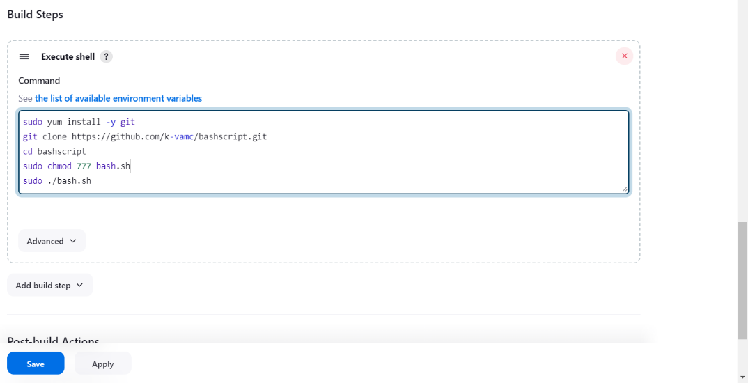Now in build steps give commands to install git and clone the git repo in source code manager, 777 permissions to .sh file and execution command for .sh file.
* After completion save the job and tap on build it will be success, here is the console output.

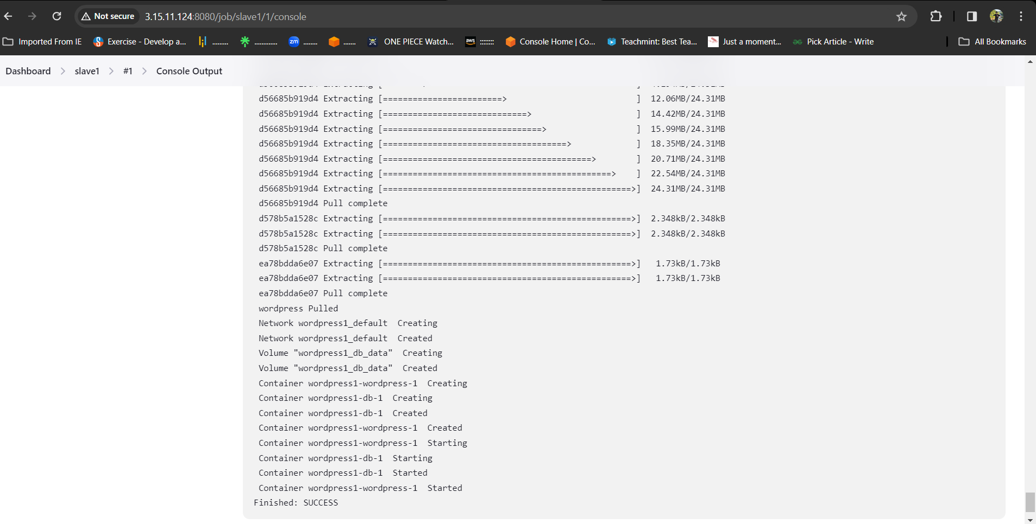

* After success go to AWS account copy the slave-1 pubic ip and browse.

After browsing we will be directed to the official landing page of WORDPRESS

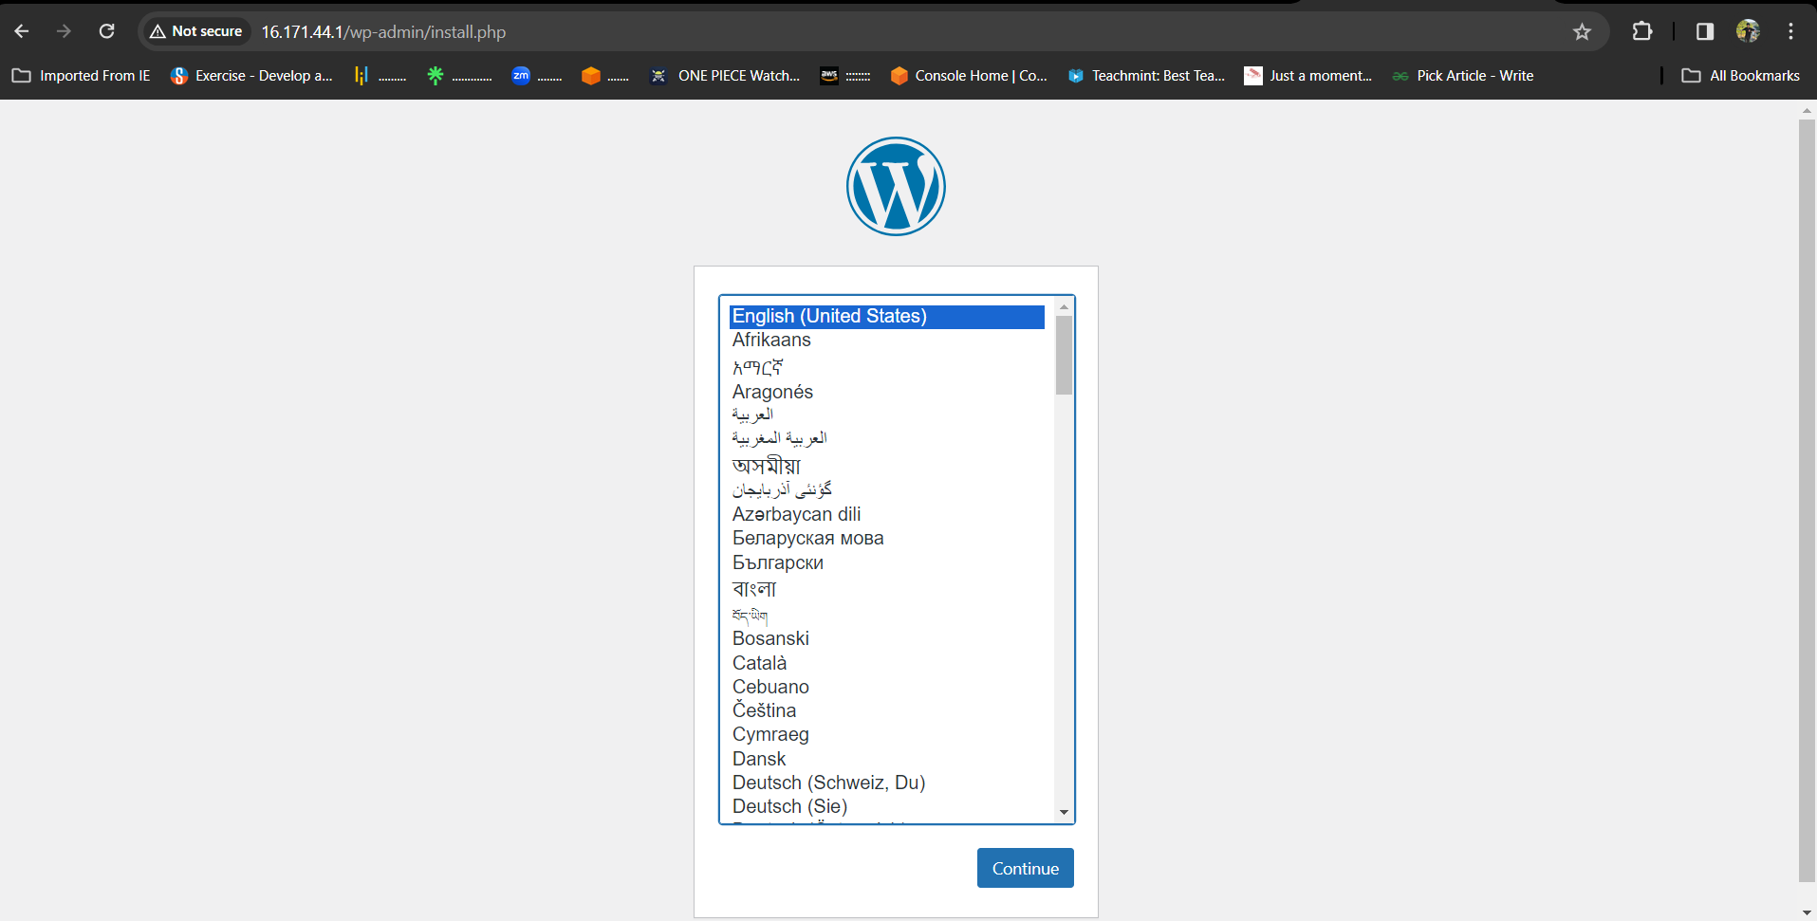

**SLAVE-2 (VAMSI in SAGAR Account)**

* Select new item > name the job > select freestyle project.

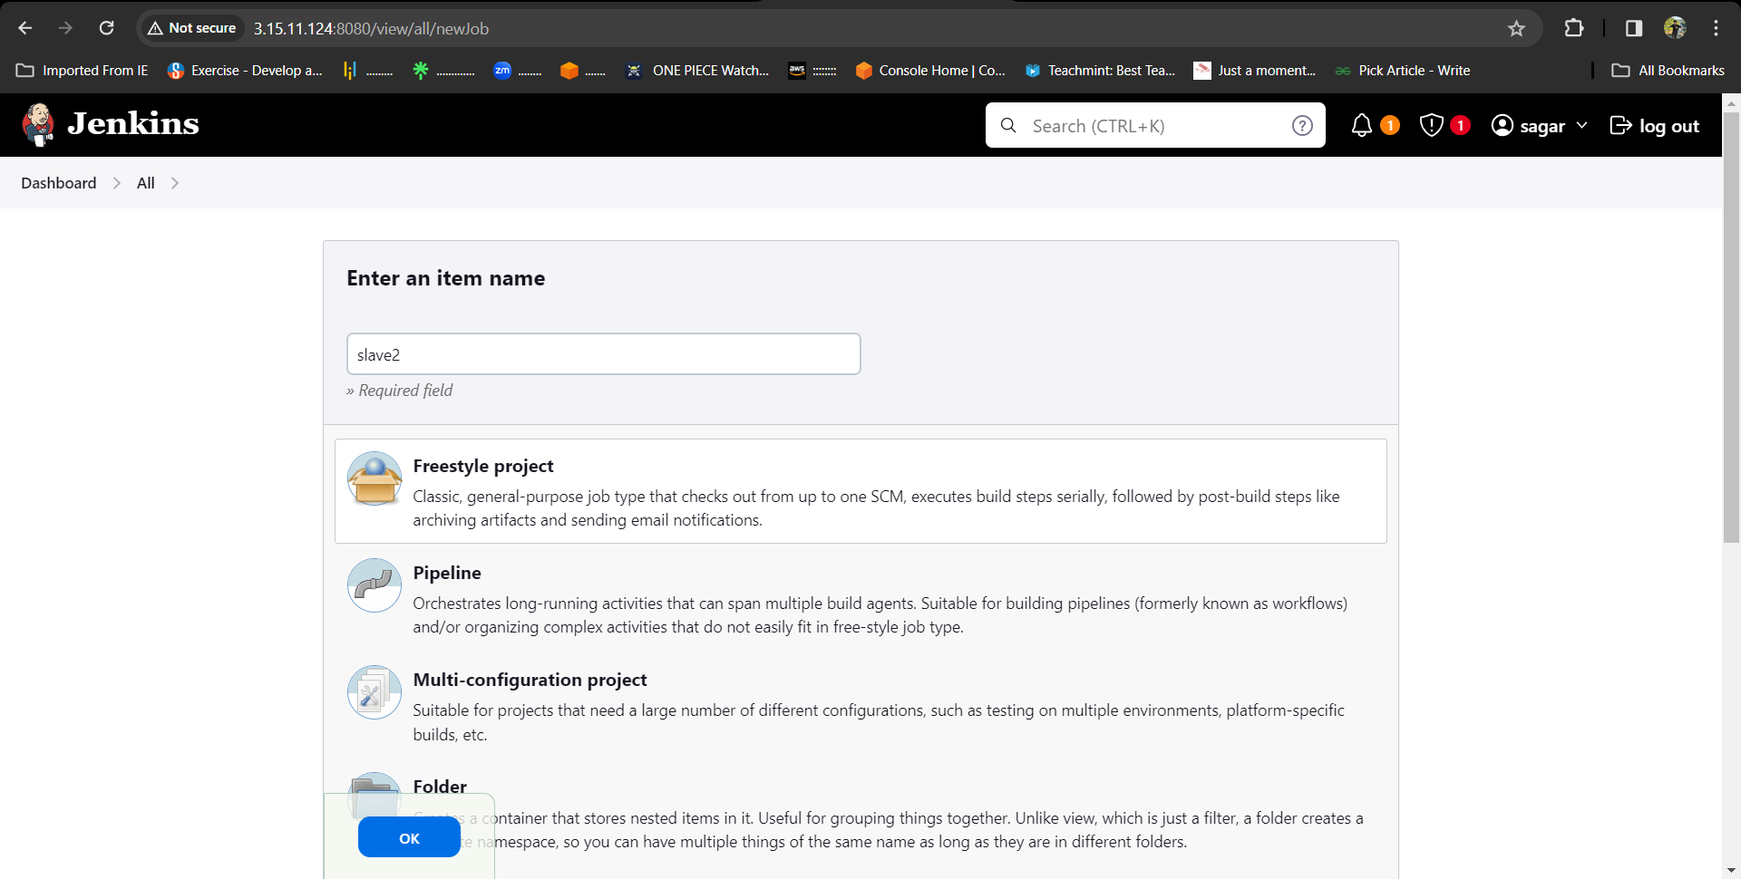

* Now select the option **Restrict where the project can be run** select the Slave2 node which we created.

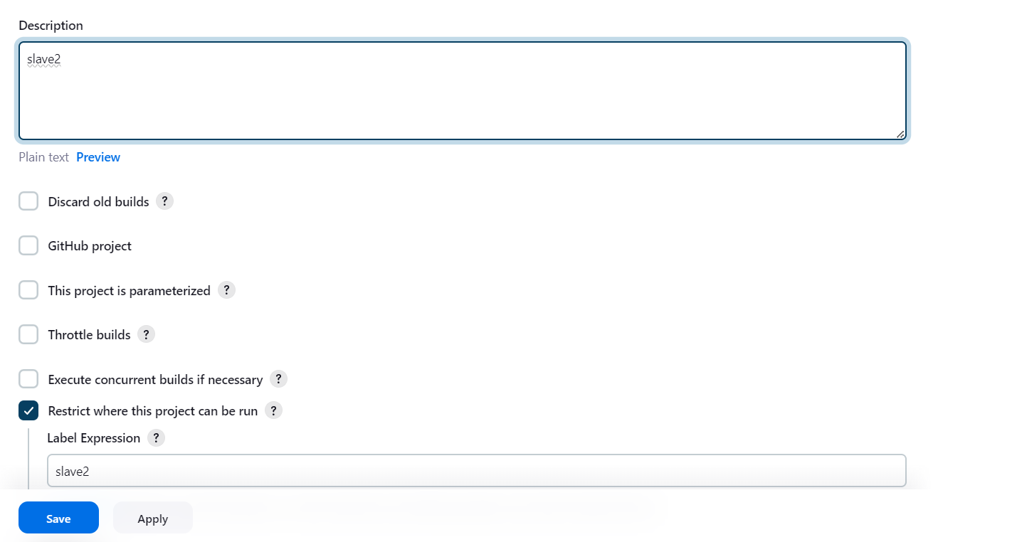

* Here we write the bash-script in the execute shell.

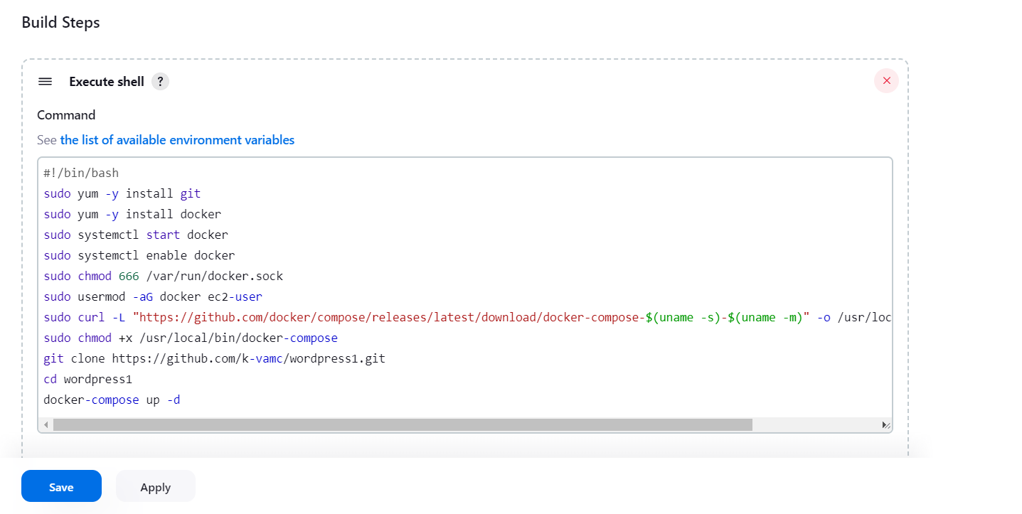

* After completion save the job and click on build no, it will be success.
* here is the console output.

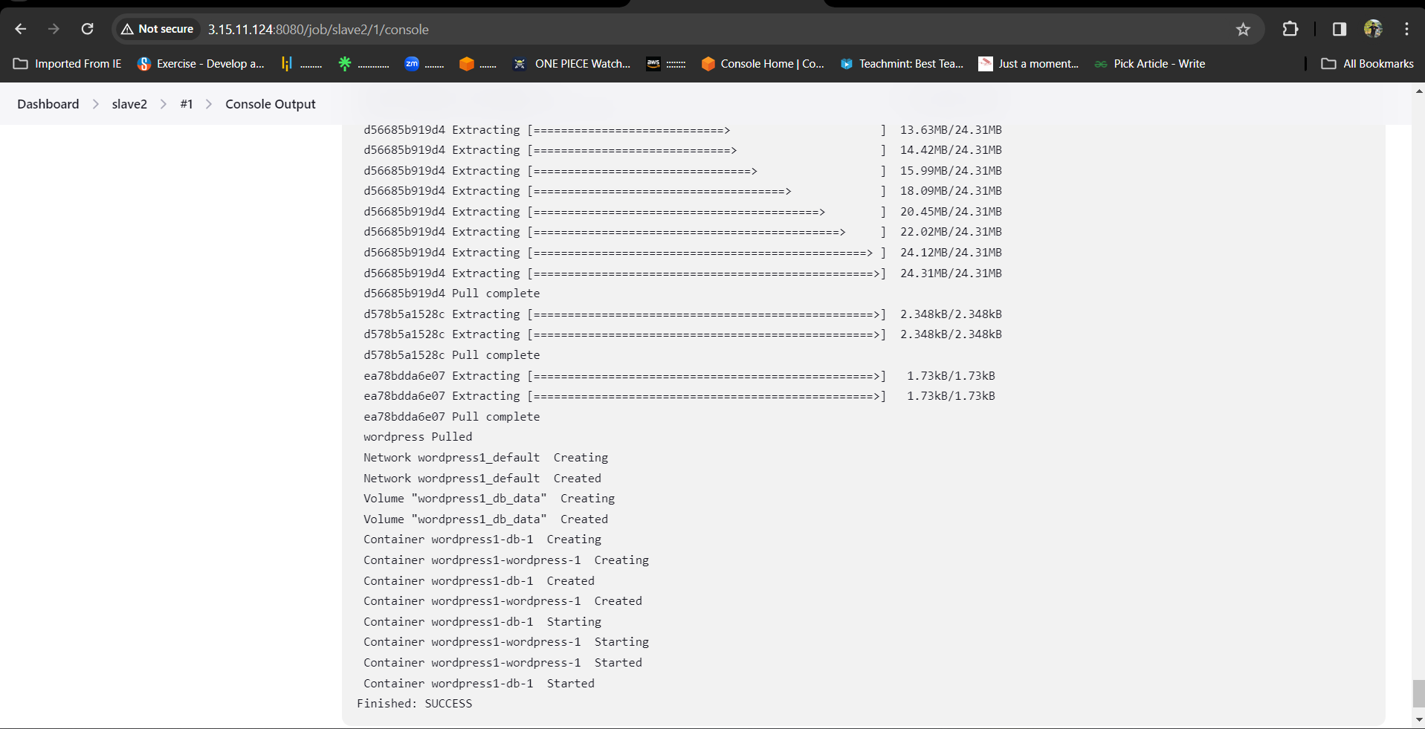

* After success go to AWS account copy the slave2 pubic IP address and browse.
* After browsing we will be directed to the official landing page of WORDPRESS.

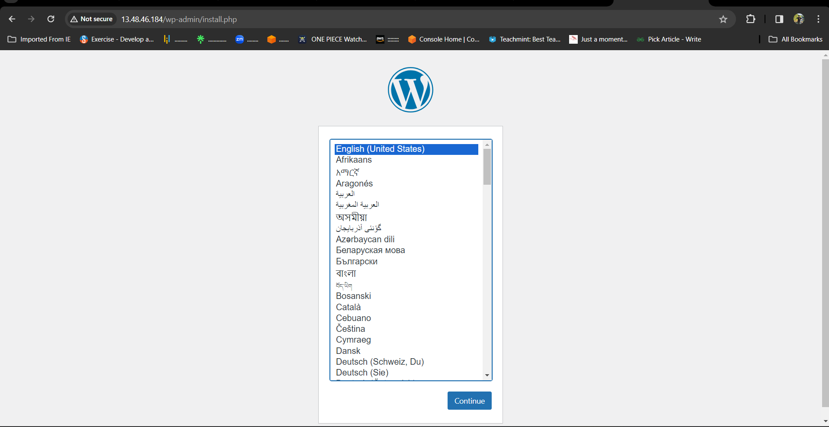

**SLAVE-3 (RAKESH in SAGAR Account)**

* Select new item > name the job > select freestyle project.
* Now select the option **Restrict where the project can be run** select the Slave-3 node which we created.

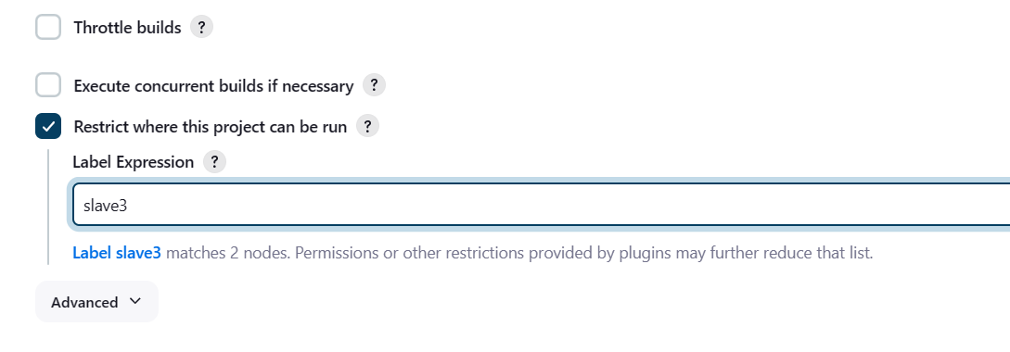

* Here we write the script and execute commands of terraform in the execute shell.

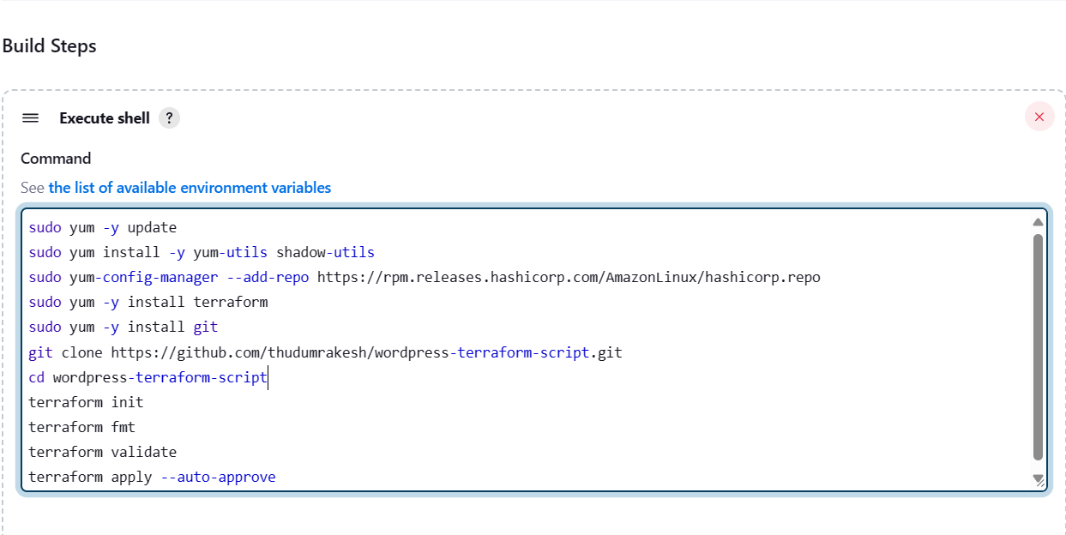

* After SAVE and BUILD the JOB,it will be success.
* here is the console output.

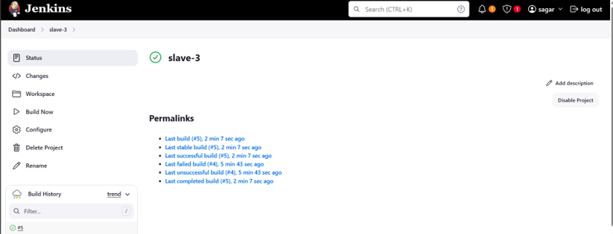

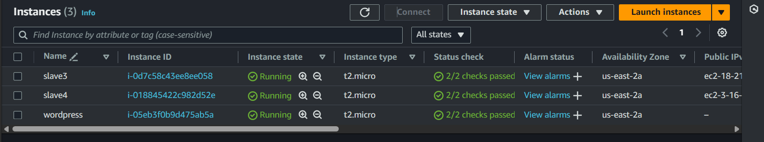

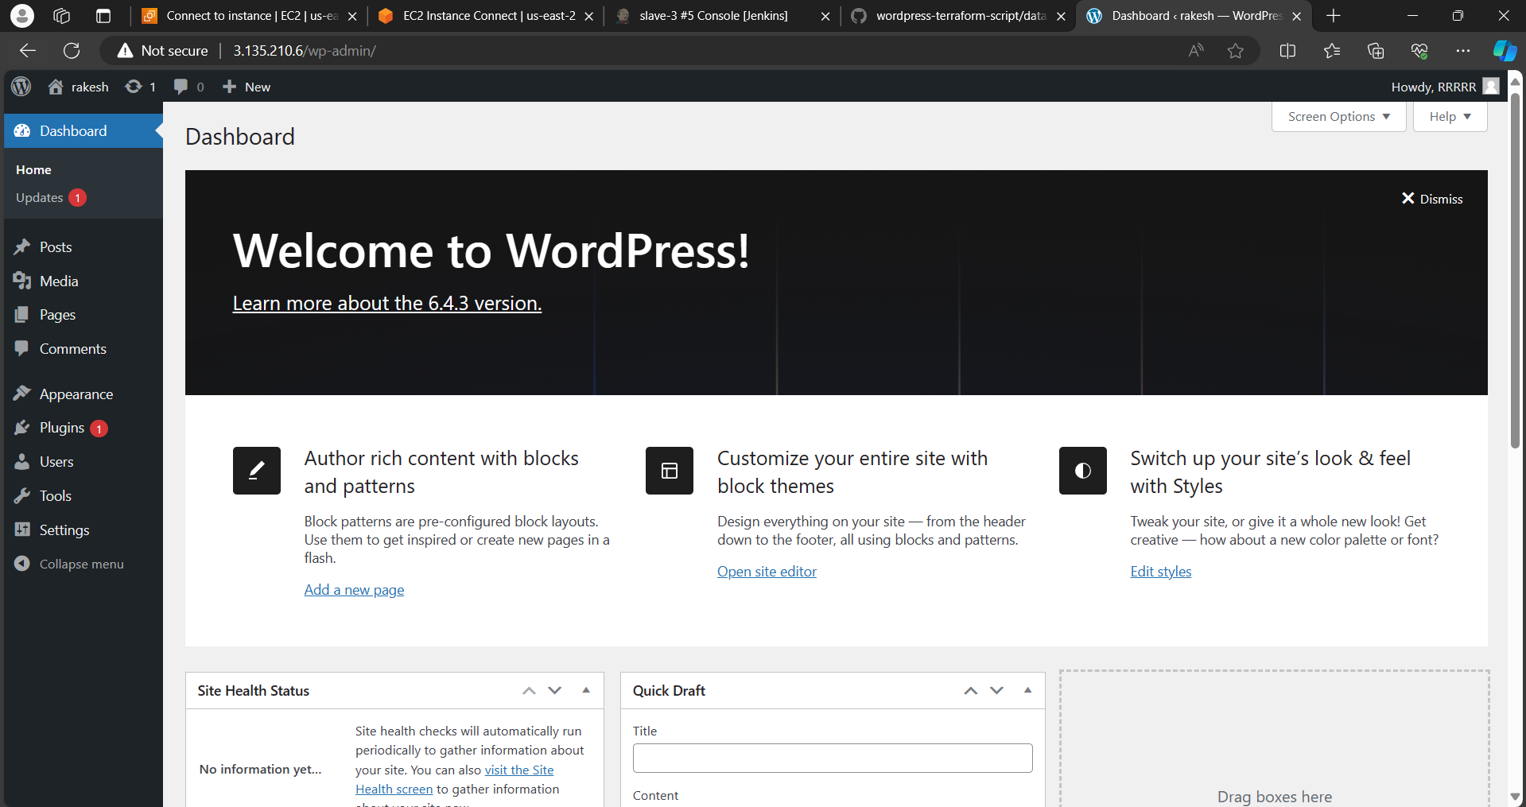

**SLAVE-4 (RAKESH in SAGAR Account)**

* Select new item > name the job > select freestyle project

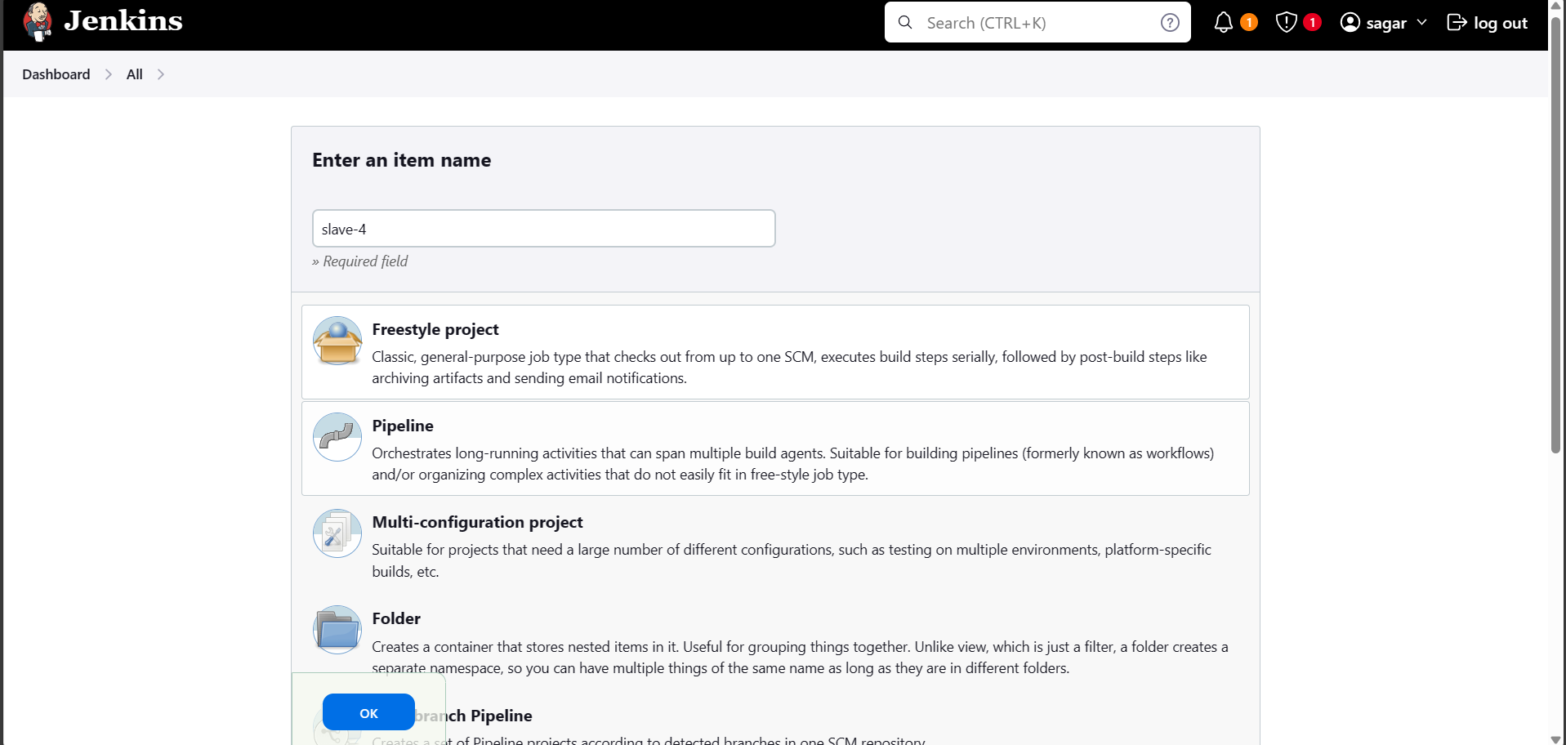

* Now select the option **Restrict where the project can be run** select the Slave-4 node which we created.

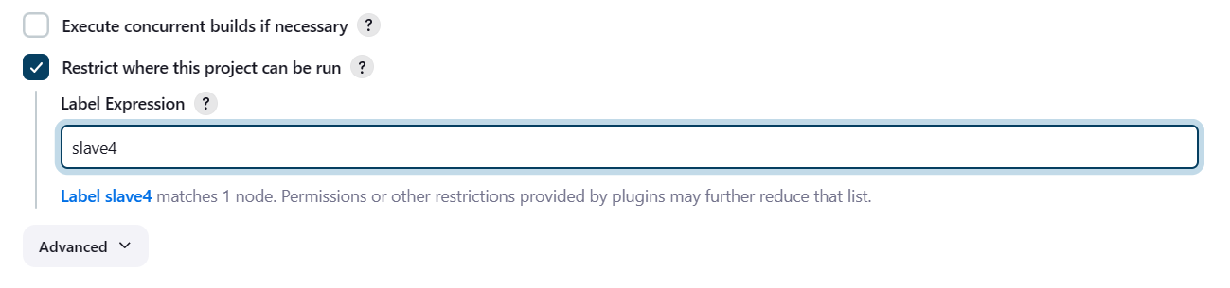

* Now in build triggers select **build periodically** option and give timing as

**\* * * * \*** means every minute every hour every day & month of the year.



* Here we write the bash-script in the execute shell.

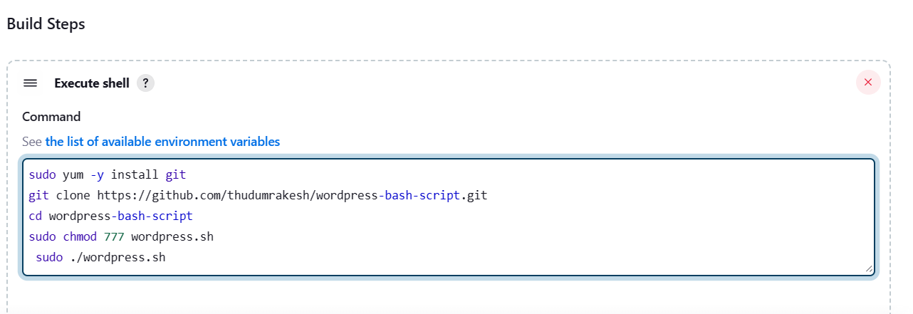

* After completion save the job and tap on build it will be success , here is the console output.

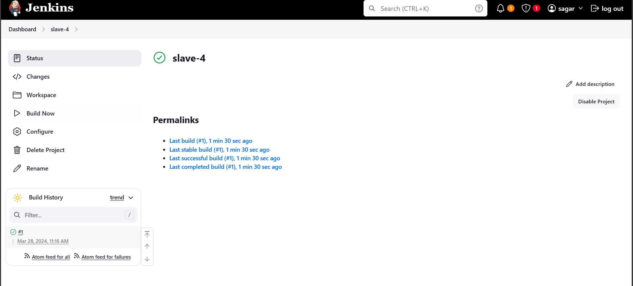

* After success go to AWS account copy the slave-4 pubic ip and browse.
* After browsing we will be directed to the official landing page of WORDPRESS.

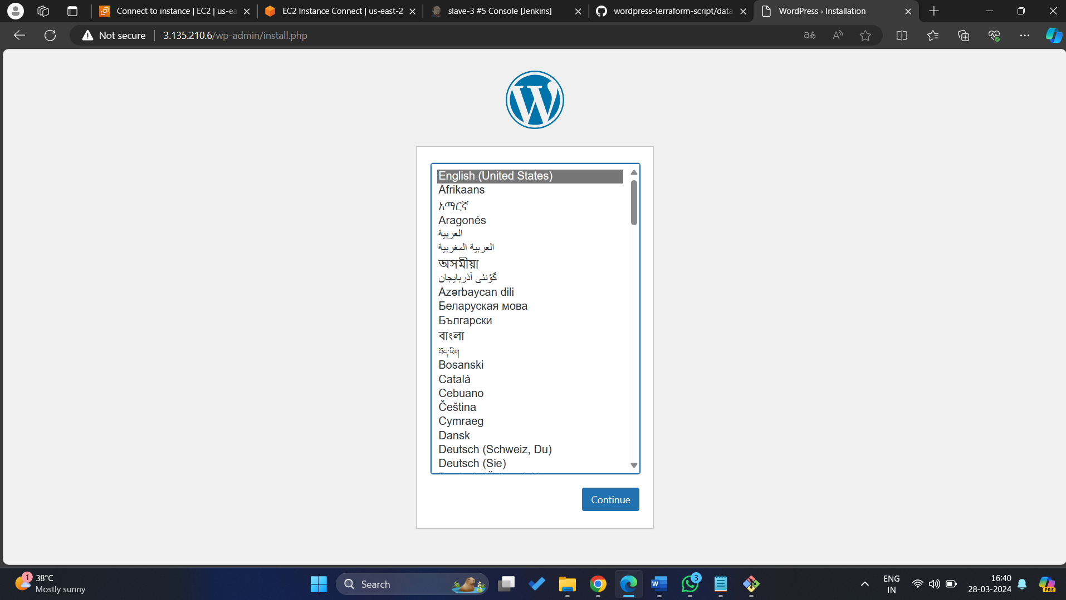

**POLL SCM**

* Now in build triggers select poll scm option and give timing as **\* * * * \*** means every minute every hour every day & month of the year.



* Save it now in github make a change in any of the file or create a dummy file It will automatically trigger and build the job directly.



* It has same console output and same public IP to browse.



**WEBHOOK**

* Now in build triggers select GitHub hook trigger for Git scm polling.

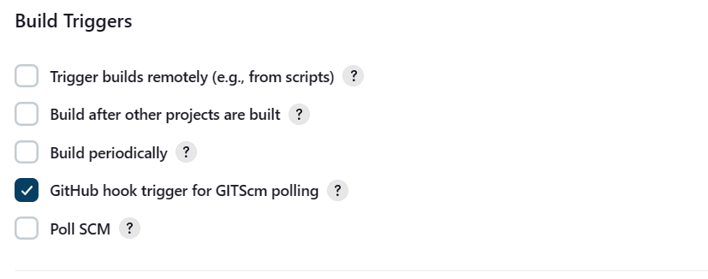

* Go to GitHub and select the repository and go to settings there we will find webhooks option and give payload as Jenkins URL select it and add webhooks.

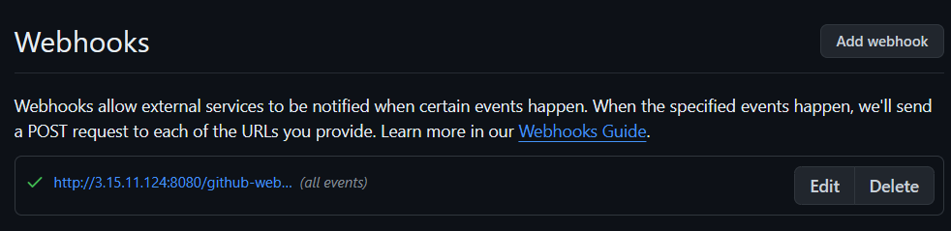

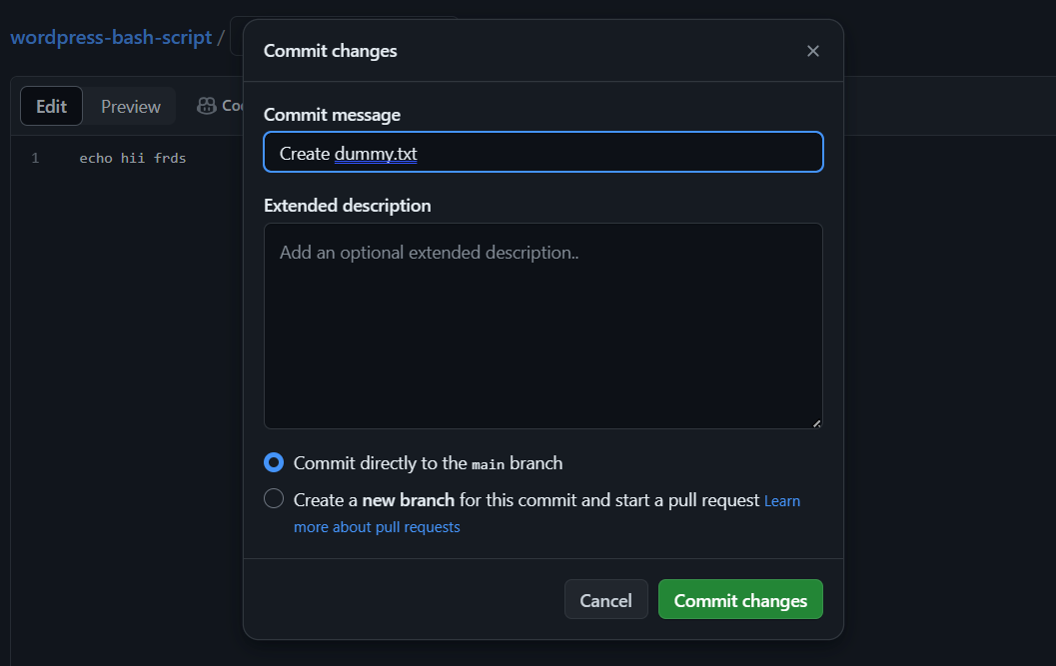

* Save it now in GitHub make a change in any of the file or remove a dummy file It will automatically trigger and build the job directly.
* It has same console output and same public IP to browse.

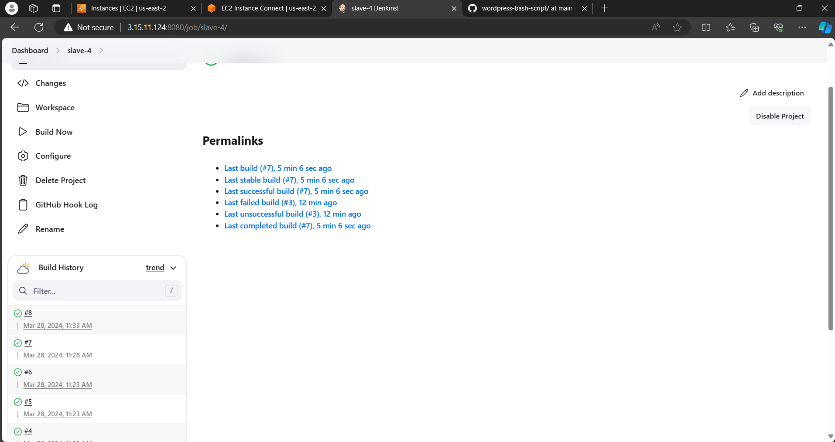



**SLAVE-5 (SAGAR in SAGAR Account)**

* Select new item > name the job > select freestyle project
* Now select the option **Restrict where the project can be run** select the Slave-5 node which we created.



* Now in build steps give commands to install Kubernetes and kops,

And create s3 bucket, configure the cluster details we want to create in one job.

* For that go to amazon console attach the IAM role which have admin access for Slave-5 instance.

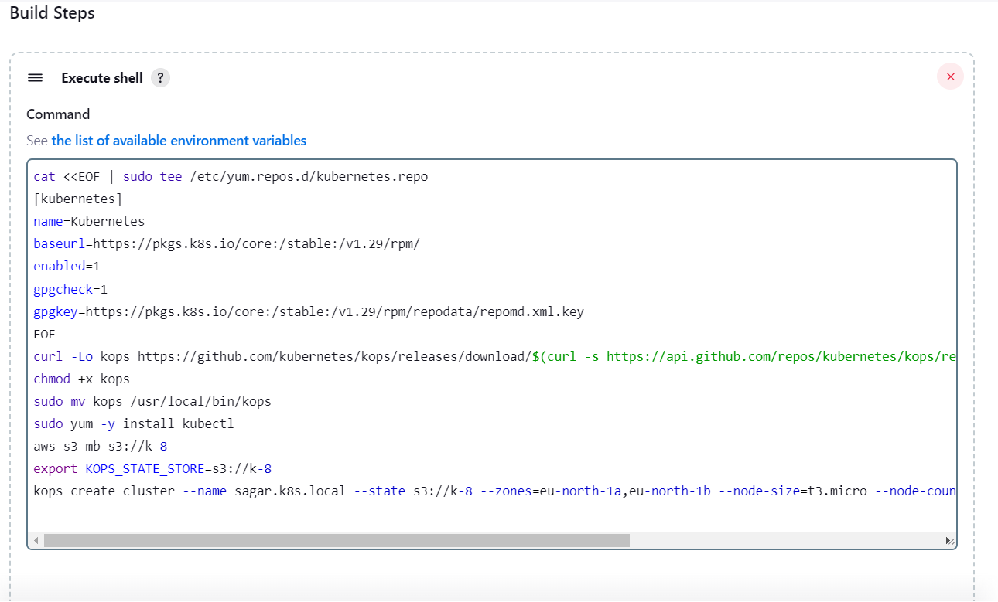

**save and build the job.**

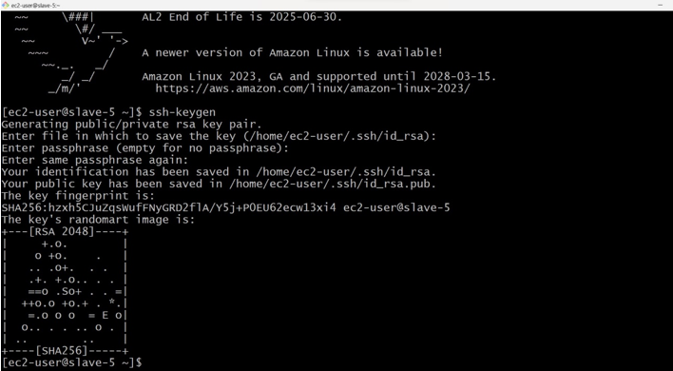

* After writing the commands build the job and see the console output, and wait for the cluster creation it will take minimum of 10minutes.

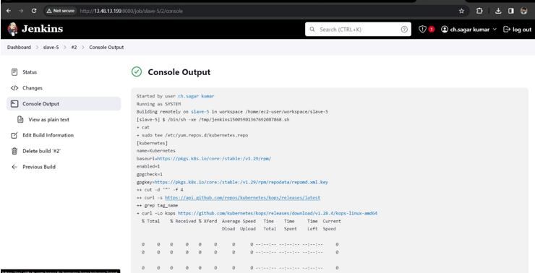

* Now create a new job for deployment unit and service layer and select the option **Restrict where the project can be run** select the Slave5 node which we created.

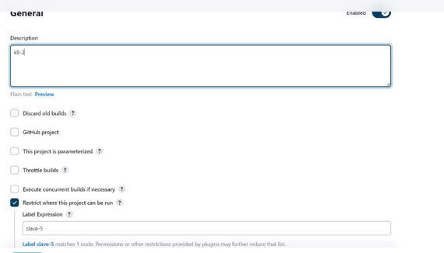

* In build steps select execute shell
* install git and git clone the repository of the deployment and service files, which is already created in our git-hub account.

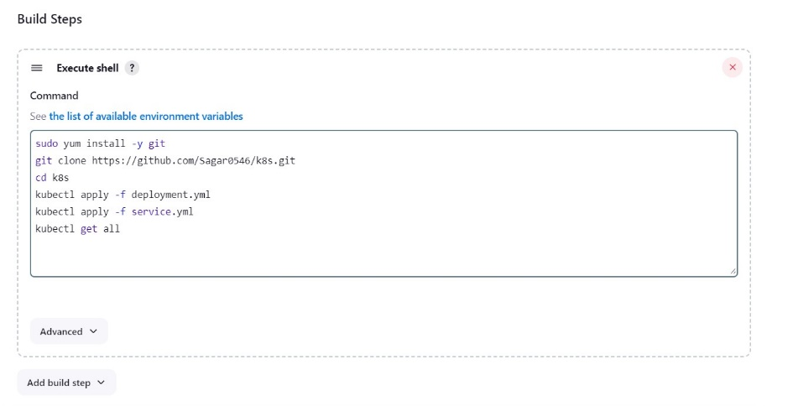

* After waiting of 10minutes build this job in which we gave **.yaml** files.
* Here is the successful installation and apply of deployment and service files.

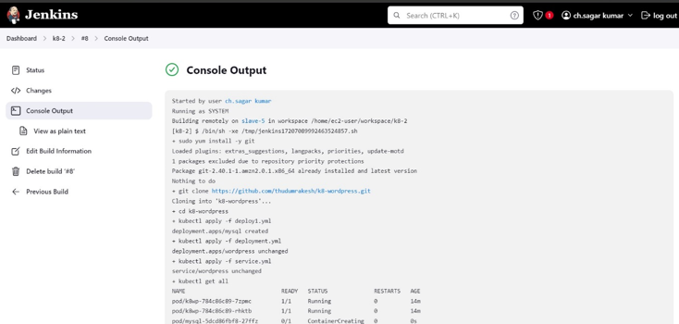

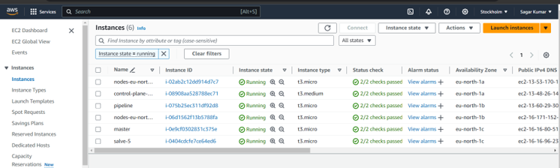

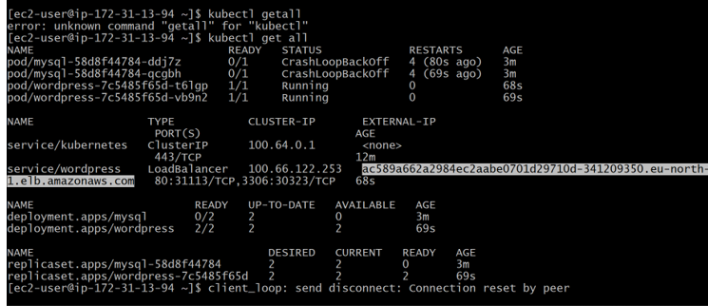

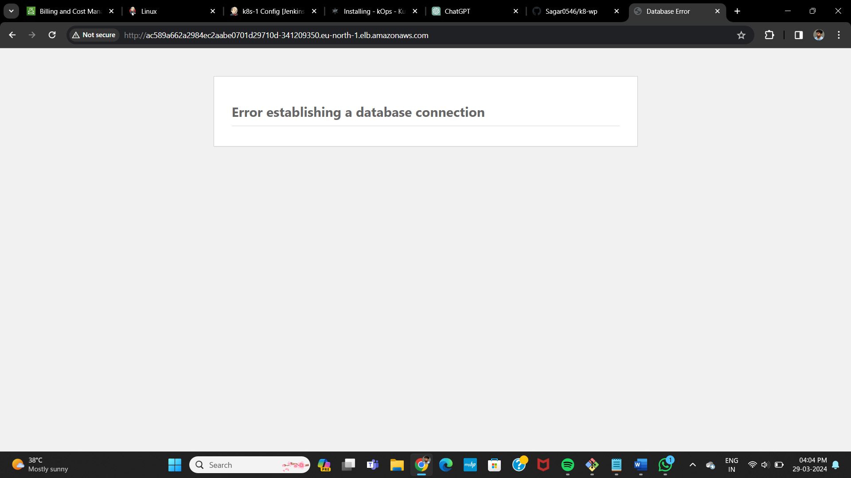

Method -8

rakesh Create one master and Slave-5 and SAGAR creates 1st and 2nd slave nodes in DIFFERENT AWS account and VAMSI creates 3rd and 4th slaves DIFFERENT AWS account and SAGAR deploy word press with bash script(slave-1) and SAGAR deploy word press with Docker Compose file (slave-2), and VAMSI deploy word press with Terraform (slave-3) and VAMSI deploy the word press with poll-scm, build periodically, webhooks (slave-4) and rakesh deploy the word press with k8’s (slave-5*).*

*Different Accounts*

*Method-3*

Vamsi Launch an EC2 instances (master and slave-5), slave-1 & slave-2 from Rakesh, slave-3 and slave-4 from Sagar.

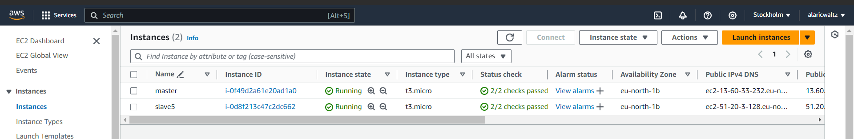

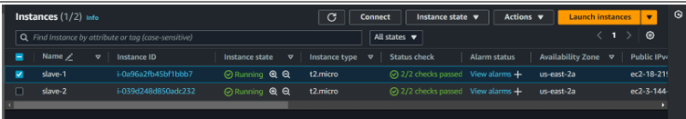

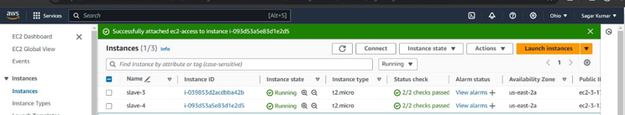

Now, make Master-Slave configuration with different accounts **master and slave-5 vivek, slave-1 & slave-2** from **Pavan, slave-3 and slave-4** from **Nishwanth.**

Install Jenkins in master instance and connect to the Jenkins Official landing page.

Now, make Master-slave configuration for slave-5.

